**WORKSHEET XVII (revised)**

**Riemann sums**

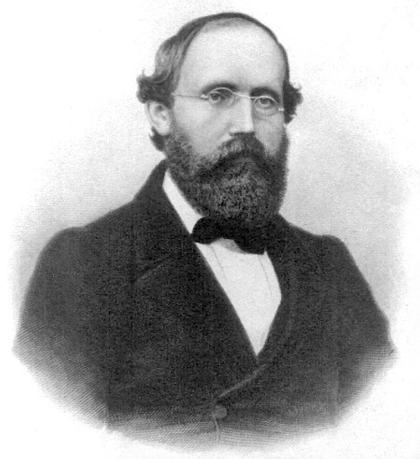

[**Bernhard Riemann**](http://en.wikipedia.org/wiki/Bernhard_Riemann) (1826 –1866)

**1.** Charlotte, the spider, lives on the x-axis. Suppose that, at time t = 1 minute, she is at x = 5 cm, and that her velocity (in cm/minute) at time *t* is given by:

v(t) = 4t + 1.

*Where* is Charlotte at time *t = 4 minutes*?

**2.** For each of the following functions and associated partitions, compute the left-endpoint sum, the right-endpoint sum, and the midpoint sum:

(a) f(x) = 2x + 5; P = {-2, -1, 0, 1}

(b) f(x) = 2x2 + 1; P = {-1, 0, 1, 2}

(c) f(x) = 1/x2; P = {1, 3/2, 2, 5/2, 3}

(d) f(x) = sin x; P = {0, /4, /2, 3 /4, }

(e) f(x) = x3; P = {1, 2, 3, 4}

**3.** Compute each of the following sums:







**4.** Find a formula for





**5.** Using [Archimedes](http://www-history.mcs.st-and.ac.uk/Biographies/Archimedes.html)’ *Method of Exhaustion*, find the area under the parabola

f(x) = x2 that lies above the interval [0, 1] on the x-axis.

**6.** How would you define the *average value* of a continuous function f(x) on an interval [a, b]? Using your definition, find (or estimate) the *average value* of each of the following functions:

(a) f(x) = x2 over [0, 1]

(b) g(x) = 3x + 1 over [7, 11]

(c) h(x) = |x – 2| over [0, 3]

(d) F(x) = sin x over [0, ]

**7.** Suppose that  and that ****. Find:

(a) 

(b) 

(c) 

(d) 

**8.** Albertine launches a model rocket from the ground at time t = 0. The rocket starts by traveling straight up in the air. The graph below illustrates the upward velocity of the rocket as a function of time.

(a) Sketch a graph of the *acceleration* of the rocket as a function of time.

1. Sketch a graph of the *height* of the rocket as a function of time.

(c) Give an estimate of the *maximum height* the rocket achieved.

**9.** Swann’s old rowboat has sprung a leak. Water is flowing into the boat at a rate, *r(t)*, given in the following table. Compute upper and lower estimates for the volume of water that has flowed into Swann’s boat during the 15 minutes. Draw a graph to illustrate the lower estimate.

|  |  |  |  |  |  |  |  |  |  |  |
| --- | --- | --- | --- | --- | --- | --- | --- | --- | --- | --- |
| |  |  |  |  |  | | --- | --- | --- | --- | --- | | *t* minutes | 0 | 5 | 10 | 15 | | r(t) liters/min | 12 | 20 | 24 | 16 | |

**10.** The graph below shows the *RATE OF CHANGE* of the quantity of water in the Water Tower of OZ, in liters per day, during the month of April, 2015. The tower contained 12,000 liters of water on April 1. *Estimate* the quantity of water in the tower on April 30. Show your work.



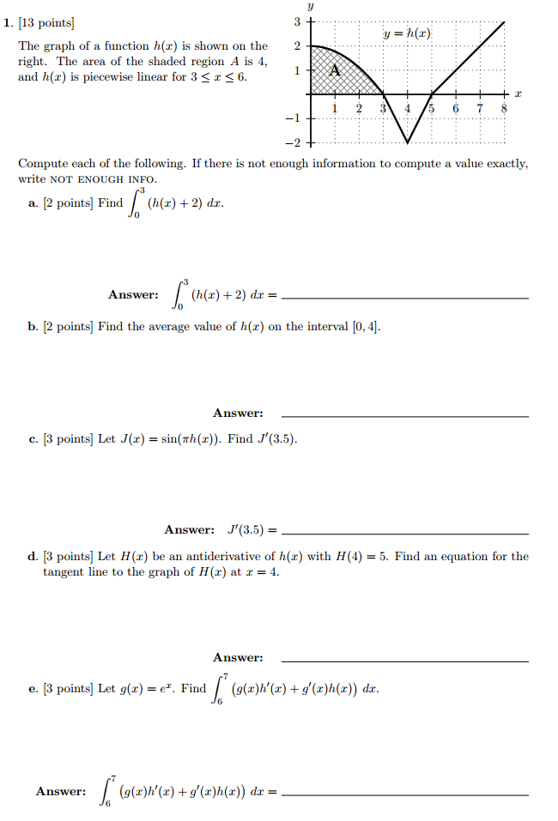

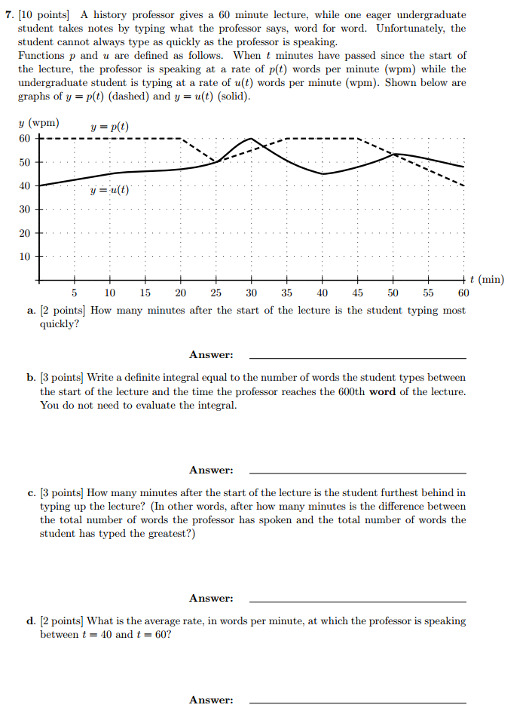

*I do hate sums. There is no greater mistake than to call arithmetic an exact science. There are hidden laws of number which it requires a mind like mine to perceive. For instance, if you add a sum from the bottom up, and then again from the top down, the result is always different.*

* **Mrs. La Touche**

[Course Home Page](http://www.math.luc.edu/~ajs/courses/161fall2015/index.pdf)          [Department Home Page](http://www.math.luc.edu/)        [Loyola Home Page](http://www.luc.edu/)