**WORKSHEET II**

***More about Functions: graphing rational functions; introduction to hyperbolic functions***

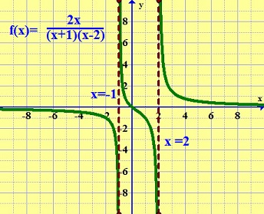

1.   *Sketch the graph* of each of the following rational functions. This includes locating zeroes, locating singularities, doing a sign analysis, and studying limiting behavior.

(A) y = x3(x – 1)4(x – 2)5

(B) 

(C) 

(D) 

2. Suppose that f(x) → ∞ and g(x) → ∞ as x → ∞. We say that *g goes to infinity faster than f* if  as x → ∞. Also, we say that “*f and g go to infinity at roughly the same rate*” if 

as x → ∞ where 0 < L < ∞.

For each of the following pairs of functions determine if one goes to infinity faster than the other or if they go to infinity at roughly the same rate.

(A) y = 3x2 + 11, y = x5 + x + 99

(B) y = 2x, y = x100

(C) y = 3x, y = ex

(D) y = ln x, y = x

(E) , 

(F) y = ln x, 

(G) y = (x2+1)4, y = (2x+1)3x5

(H) y = 4x, 

(I) y = ln x, y = cos x + ln x

(J) y = ln x, y = ln(ln x)

3. Define the *hyperbolic functions* sinh x, cosh x, tanh x and sech x. Sketch each of these functions.

(A) Prove the identity: cosh2 x – sinh2 x =1

(B) Prove the identity: 1 – tanh2 x = sech2 x

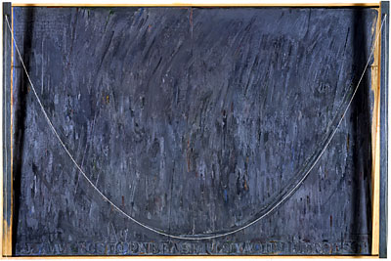

[**Jasper Johns**](http://www.pbs.org/wnet/americanmasters/database/johns_j.html)**: CATENARY (JACOB'S LADDER) –** 1999

***“****...he seemed to approach the grave as a hyperbolic curve approaches a line, less directly as he got nearer, till it was doubtful if he would ever reach it at all.”*

- Thomas Hardy, ***Far from the Madding Crowd***

[Course Home Page](http://www.math.luc.edu/~ajs/courses/161fall2015/index.pdf)          [Department Home Page](http://www.math.luc.edu/)        [Loyola Home Page](http://www.luc.edu/)