**WORKSHEET III**

**limits & continuity**



[***Fractal tree***](http://rosettacode.org/wiki/Fractal_tree)

**I** Evaluate each of the following limits or explain why the limit fails to exist.

**

**

**

**

**

**

**

**

**

**

**II**  State the *limit laws*.

**III** State the *Sandwich Theorem (*a.k.a. *Squeeze Theorem, Pinching Theorem, Two Gendarmes Theorem, Two Policemen and a Drunk Theorem)*.

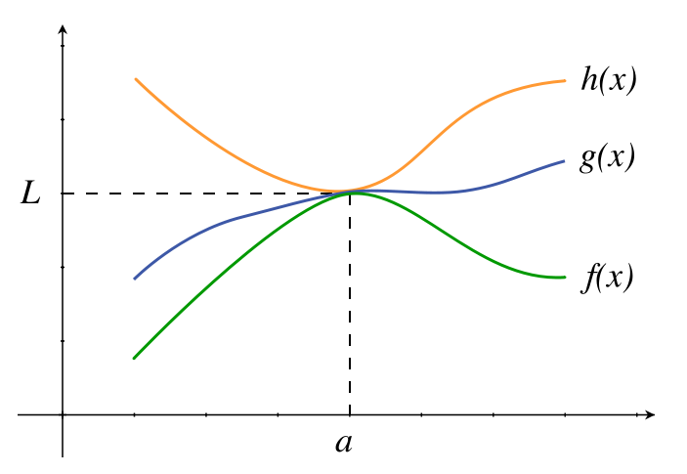

**IV** (A) Is the function f(x) = (sin x)/x *even* or *odd* or neither?

(B) Using the Sandwich Theorem prove that

(sin x)/x → 1 as x → 0.

**V** Define *continuity* of a function y = f(x) at x = a. What does it mean for a function to be *continuous*?

**VI** Consider each of the following functions and the given point on the x-axis. Does the function have a *continuous extension* at the given point? Explain.

**

**

**

**

**VII** For which value of *a* is the following function *continuous everywhere?*

**

**VIII** For which values of *a* and *b* is the following function *continuous everywhere?*

**

**IX** State the *Intermediate Value Theorem.* Using the IVT, prove that the polynomial f(x) = x4 + 4x3 – 20x + 11 must have a root between x = 0 and x = 1 .

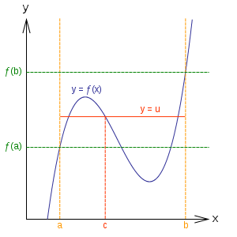

**X** Give examples of each of the following types of discontinuities: *removable, jump, infinite, and essential.*

For each of the following functions, determine the type of discontinuity at the given point.

1. y = (sin x) / x at x = 0
2. y = (x3 – 8) / (x – 2) at x = 2
3. y = sin (1/x) at x = 0
4. y = |x – 3| / (x – 3) at x = 3.
5. y = x sin(1/x) at x = 0
6. y = (cos x) / x at x = 0
7. y = (x7 – 1)/ (x – 1) at x = 1
8. y = (cosh x) / x at x = 0
9. y = (1 – cos x) / x at x = 0.

**

[Course Home Page](http://www.math.luc.edu/~ajs/courses/161fall2015/index.pdf)          [Department Home Page](http://www.math.luc.edu/)        [Loyola Home Page](http://www.luc.edu/)