**WORKSHEET IV**

**trigonometric limits & one-sided limits**

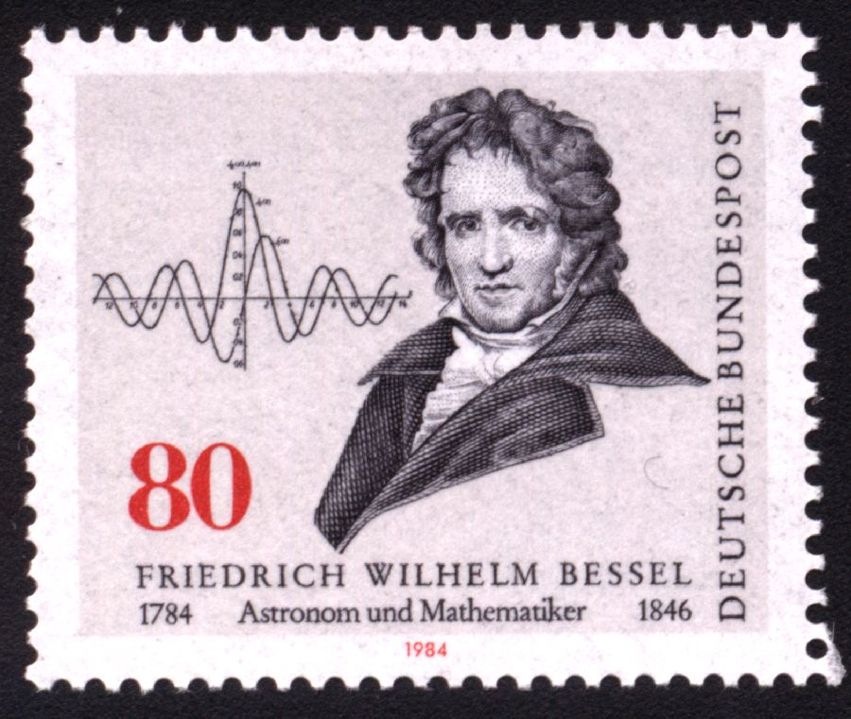

Evaluate each of the following limits or explain why the limit fails to exist.

**

**

**

**

**

**

**

**

**

**

**

**

**

**

**

**

**

**

*I used to love mathematics for its own sake, and I still do, because it allows for no hypocrisy and no vagueness…*

- Stendhal, **The Life of Henri Brulard**

[Course Home Page](http://www.math.luc.edu/~ajs/courses/161fall2015/index.pdf)          [Department Home Page](http://www.math.luc.edu/)        [Loyola Home Page](http://www.luc.edu/)