WORKSHEET V
Average rate of change
- Suppose that Albertine travels from Hell, Michigan, to Paradise, Michigan, on the upper peninsula. Along the way, every few minutes, she records the distance that she has traveled in miles. Suppose that she begins her trip at time t = 0 (corresponding to noon). Let s(t) be the distance she has traveled at time t. The following is Albertine’s graph of position (miles) vs time (hrs).
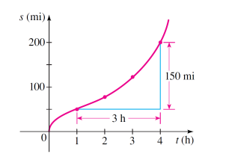

- Find Albertine’s average speed between 1 pm and 4 pm.
- Find her average speed between 2 pm and 3 pm.

- Find the average rate of change of the function f(x) = x² + 1 over the interval

- [0, 2] (b) [2, 3], (c) [-2, 0] (d) [1, 1 + h] where h > 0.

(e) Give a geometric interpretation for each of these calculations.

- If Swann drops a bowling ball from the top of the Eiffel Tower, then the distance it will fall (in feet) after t seconds is given by the function d(t) = 16 t².
Find the average speed of the ball between
(a) t = 1 and t = 4 seconds.
- t = a and t = a + h seconds, where a and h are positive.

- Let g(x) = 3x – 19. Find the average rate of change of this function from:
- x = 0 and x = 1
- x = 1 and x = 4
- x = a and x = a + h

- Let f(x) = mx + b. Find the average rate of change of f over the interval x = a and x = a+h.

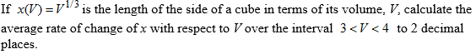

8.
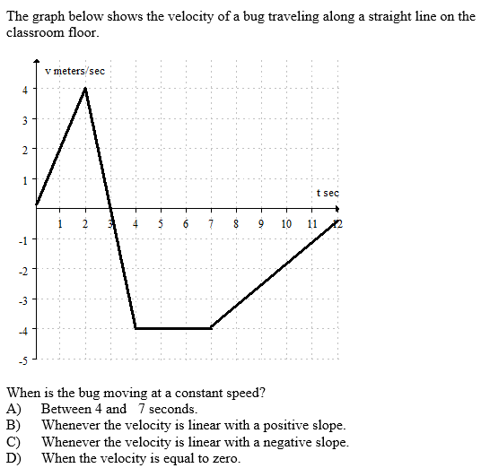

9.
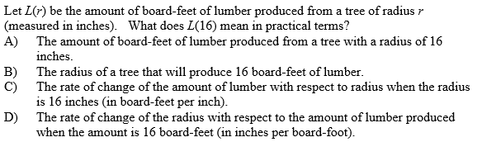

10. Below is the graph of a velocity function. The units on the vertical axis are in kilometers per hour and the units on the horizontal axis are in hours. Positive velocity means motion away from the starting position; negative velocity means motion toward the starting position.

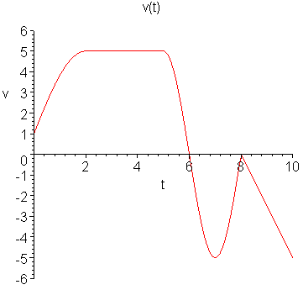

(a) Create a (brief) story about motion of a person or thing whose velocity is represented by this graph. Your story must include all of the "important" information included in the graph above, including position and times t = 0 and t = 10.)

(b) Sketch a possible graph of the position function of the person or thing in your story on the time interval t = 0 to t = 10.

11. Suppose that C(T) is the cost of heating Albertine’s house, in dollars per day, when the outside temperature is T degrees Fahrenheit.

What does C(19) = 8.67 mean in practical terms? (Use appropriate units.)

12. The cost C (in thousands of dollars) of building a house that is x square feet is given by the function C = F(x).

Explain the meaning of the statement: F(1600) = 140.

Course Home Page Department Home Page Loyola Home Page

