Class Discussion: October 25, 2017
U. Mich. probs

- Consider the prism with equilateral triangles of side length ℓ centimeters
for ends and a length of h centimeters, illustrated below.

The volume of this prism is
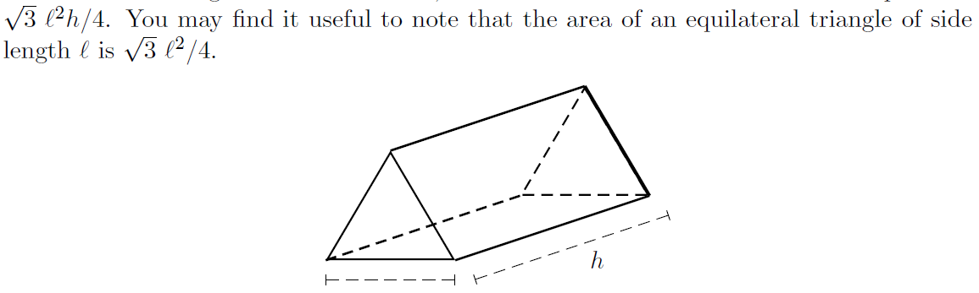
a. Give the equation of the surface area of this prism, listing units.

b. If the prism has a fixed volume of 16 cm3, find the values of ℓ and h which
minimize the surface area. Clearly justify that you have found the minimum.

- Consider a window the shape of which is a rectangle of height h surmounted by a
triangle having a height T that is two times the width w of the rectangle (see the figure below
which is not drawn to scale). If the total area of the window is 5 square feet, determine the
dimensions of the window which minimize the perimeter.
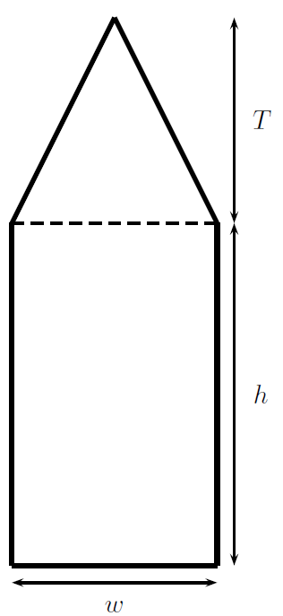
- Jason has a 50 ft by 30 ft house and wants to enclose his yard with a fence to keep
his dogs in, as shown below. On the south side of his yard, he plans for the fence to be extra
tall to shade his yard from the sun. Note that the fence does not extend around the sides of
Jason’s house. The extra tall fence (thick dashed line) costs $15 per foot, and the rest of the
fence (thin dashed line) costs $5 per foot. Jason is going to spend $4500 on his fence.

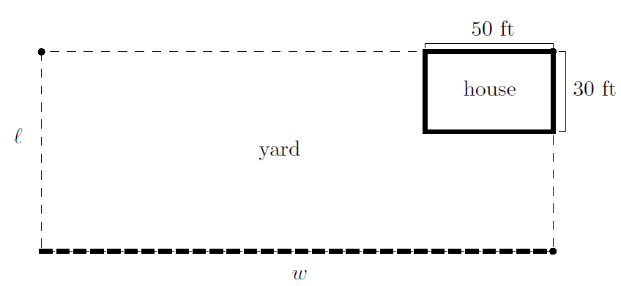

a. ℓ is the length of the fenced in yard, and w is the width, as shown above. Write
a formula for ℓ in terms of w. Your formula should not involve any other variables.

b. Write a formula for the total area A of the fenced yard (not including the
house), in terms of w. Your answer should not include ℓ. (This is the equation Jason
would use to find the values of w and ℓ maximizing the area he can enclose. You should
not do the optimization in this case.)

3. Caleb has an attic apartment, and his bedroom has a triangular wall that is 14
feet wide and 12 feet tall at its tallest point. He wants to build a rectangular bookcase to put against the wall, as shown below. .He is trying to maximize the area of the front of the bookcase.

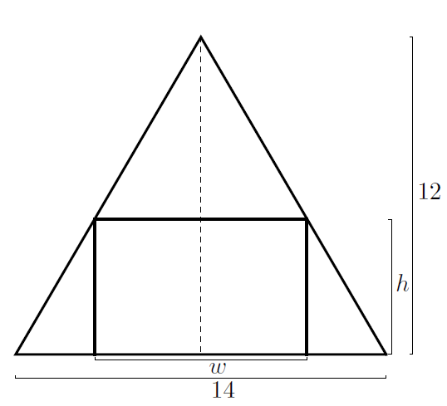
a. If the bookcase has width w and height h, write a formula relating w
and h.

b. Using your answer from (a), find an expression for the area of the front of the
bookcase in terms of the variable h.

