# MATH 161 class discussion 20 sept 2017

1. *(review)* Compute  Show your work.

2. The parabola *y = x2 + x + c* is tangent to the line *y = 3x*.  Find *c*.  (Include a picture in your explanation.)

3. Find a parabola, y = ax2 + bx + c, that passes through the point (1, 4) and whose tangent lines at x = -1 and x = 5 have slopes 6 and -2 respectively.

4. Find equations of any (and all) tangent lines to the parabola y = x2 + 1 that have *x-intercept* of -4/3. Sketch.

5. Archy lives on the x-axis. His position at time *t* (hours) is

*s(t) = 4t3 – 15t2 + 12t + 1* (cm).

6. Assume that Archie was born at time t = 0.

1. What is Archy’s *position* at time t = 1?
2. What is Archy’s instantaneous *velocity* at time t = 1?
3. When is Archy moving *toward the left*? (Give one or more time intervals.)

7*. (review)* The quantity, *Q* mg, of nicotine in the body *t* minutes after a cigarette is smoked is given by *Q = g(t).*

(a) Using a complete sentence, interpret the statement g(20) = 0.36.

(b) Using a complete sentence, interpret the statement g′(20) = -0.002.

(c) Using the information that you obtained above, estimate g(23).

8. Consider the function  .

Find any and all points (only their x-coordinates) at which the tangent line to y = f (x) is horizontal.

9. Given the following graph of y = f(x), use “geometric differentiation” to sketch the graph of dy/dx.

(If you are curious, the equation of this curve is y = x5 + sin (21x) – 4x3 )



10. Given f(x) = x3 – 6x2 + 9x – 5.

(a) Find the slope of the tangent line to the curve at x = -2. (You may assume that df/dx = 3x2 – 12x + 9.)

(b) What is the equation of this tangent line?

(c) What is the equation of the normal line at x = -2.

(d) Find all points where the curve has a horizontal tangent.

11. Does the curve y = x3 + x + 1 ever have a horizontal tangent line? If so, where?

1. Let G(x) = 2bx, where *b* is a non-zero *constant*.

Albertine, our friend, informs us that d/dx (2bx) = b 2bx ln 2.

Find G (2017)(x). *Show your reasoning! An answer with no justification will earn little or no credit.*

13. Let f(x) = x|x| be defined on the real line. Is f differentiable at x = 0? True or False? Explain.

14. Which of the following graphs (a) – (d) could represent the slope at every point of the function graphed in figure 2.6?

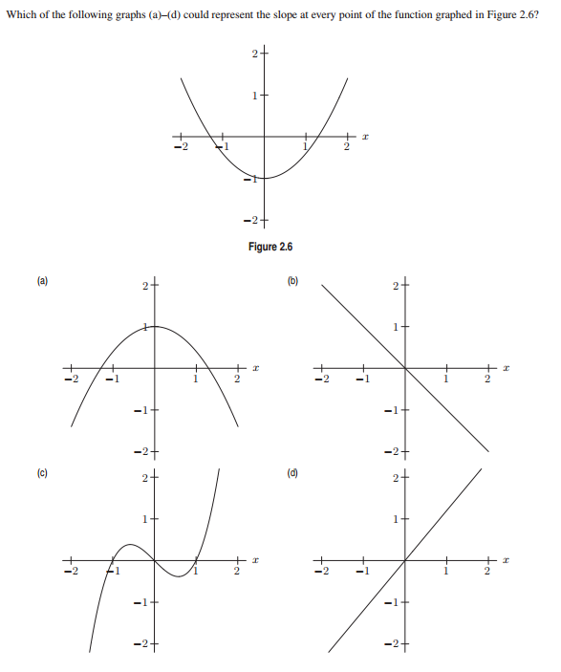

15. Using the process of “geometric differentiation,” sketch the graph of the derivative of the function y = G(x) whose graph is given below:



16.

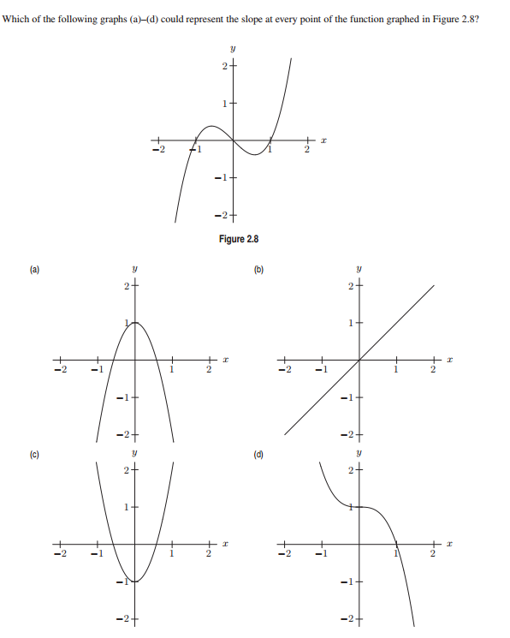

17. Assume that Charlotte, who chooses to live on the y-axis, is located at

*y(t) = 3 cos t + 4 sin t* cm at time *t* (measured in minutes).

(a) Find her *position* at times t = 0, t = /2, and t = 

(b) Find her *velocity* when t = 0, t = /2, and t =  minutes.

(c) Find her *acceleration* when t = 0, t = /2, and t = 

18. Archy lives on the x-axis. Graphs of his *position*, *velocity* and *acceleration* during the time interval -0.7 < t < 4.3 appear below. Which is which? Explain.



19. Let *f*(*x*) = *x*4 − *ax*2*.*

* 1. Find all possible critical points of *f* in terms of *a.*
  2. If *a <* 0*,* how many critical points does *f* have?
  3. If *a >* 0*,* find the *x* and *y* coordinates of all critical points of *f.*

20. Given f(x) = x6 – 3x5 on the interval [-1, 4].

* 1. Find all critical points of *f*.
  2. Determine on which intervals *f* is increasing.
  3. Find and classify all local and global extrema of *f*.

(d) Sketch the graph of *f* using the above information.

21. Given f(x) = $g\left(x\right)=\frac{x}{x+1 }$.

1. What is the domain of g?
2. Find all critical points of *g*.
3. Determine on which intervals *g* is increasing.
4. Find and classify all local and global extrema of *g*.
5. Sketch the graph of *f* using the above information.

22.

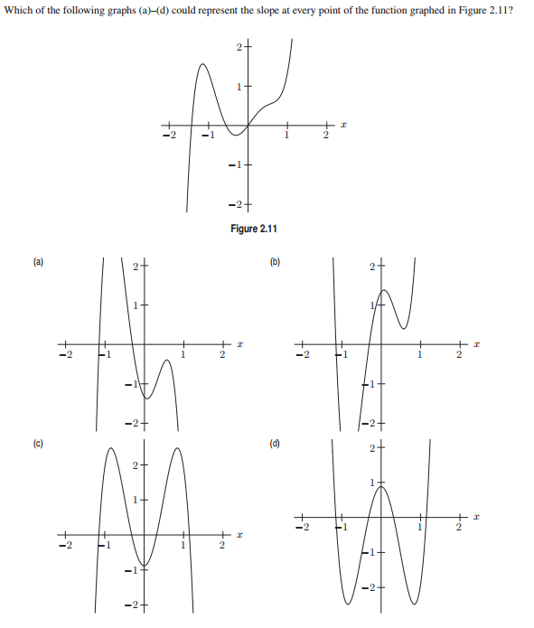

23.

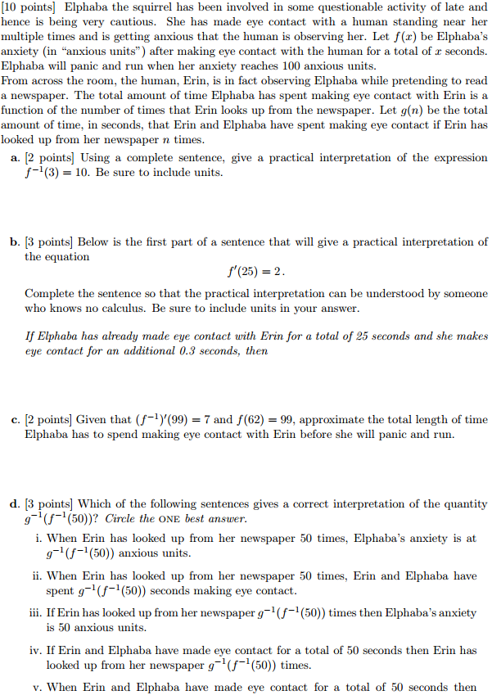

*When I was four years old they tried to test my IQ. They showed me a picture of three oranges and a pear. They asked me, "Which one is different and does not belong?" They taught me different was wrong.*

- Ani DiFranco