**Class Discussion I (28 Aug 2017)**

**WARM UP exercises** [Raymond Smullyan, **What is the Name of this Book?,** Dover (1978)]

1. **Who is this man?**
2. *Boris was looking at a portrait. Someone asked him, "Whose picture are you looking at?" He replied: "Brothers and sisters have I none, but this man's father is my father's son."*

*Whose picture was the Boris looking at?*

1. *What if the statement had been: "Brothers and sisters have I none, but this man's son is my father's son."*
2. **A question of international law.** *If a plane crashes right on the border of the United States and Canada, in which country would you bury the survivors?*
3. **The Lion and the Unicorn.** *When Albertine entered the Forest of Forgetfulness, she did not forget everything; only certain things. She often forgot her name, and the one thing she was most likely to forget was the day of the week. Now, the Lion and the Unicorn were frequent visitors to the forest. These two are strange creatures. The Lion lies on Mondays, Tuesdays, and Wednesdays, and tells the truth on the other days of the week. The Unicorn, on the other hand, lies on Thursdays, Fridays, and Saturdays, but tells the truth on the other days of the week.*

*One day Albertine met the Lion and the Unicorn resting under a tree. They made the following statements:*

*Lion: Yesterday was one of my lying days.*

*Unicorn: Yesterday was one of my lying days too.*

*From these two statements, Albertine (who is a bright Loyola first-year student) was able to deduce the day of the week. What day was it?*

|  |  |
| --- | --- |
| Résultats de recherche d'images pour « clip art lion black white » | Résultats de recherche d'images pour « clip art unicorn  black and white » |

**Precalculus exercises**

1. Let G(x) be a function with domain [0, 3] and range [0, 2]. The graph of G is displayed below.



Let A(x) = G(x – 5); B(x) = G(2x); C(x) = 3G(3x) + 1; and R(x) = – 3 G(–x/2) .

For each of the four functions, A, B, C, R, answer the following three questions.

1. Find the *domain* of this function.
2. Find the *range* of thisfunction.
3. Sketch the graph of this function. Be sure to indicate the *x* and *y* scales on your graph!

2. Albertine has inherited a cabin and a huge forest in southeastern Australia. She learns from her environmentalist friends that there are 1400 wombats remaining in her woods and 300 dingos, a natural predator of the wombat. Albertine is distressed to learn that the wombat population is declining by 1.3% per month while the dingo population is growing by 2.4% per month. *When* will the dingo population be *twice* that of the wombat population?

|  |  |
| --- | --- |
| Résultats de recherche d'images pour « clip art wombat » | Résultats de recherche d'images pour « clip art dingo » |

3. The Fifth-Thirty-Second Bank of GammaVille offers 4.1% interest per year *compounded weekly.* How much should Albertine deposit in such a savings account in order for her to have a balance of $ 75,000 after twenty years?



4. The number of hemlock trees in the southern Appalachian Mountains is declining as a result of an infestation of hemlock woolly adelgids (a kind of insect).

• There are H(d) *healthy* hemlock trees in the southern Appalachian Mountains *d* days after January 1, 2017.

• There are I(d) infested hemlock trees in the southern Appalachian Mountains *d* days after January 1, 2017.

Note that all hemlock trees are considered healthy unless they are infested.

(a) Let J(w) be the number of *healthy* hemlock trees in the southern Appalachian Mountains *w* weeks after January 1, 2017. Find a formula for J(w) in terms of any or all of the functions *H* and *I*.

(b) Let F(d) be the fraction of the hemlock trees in the southern Appalachian Mountains that are infested *d* days after January 1, 2017. Find a formula for F(d) in terms of any or all of the functions *H* and *I*.

(c) Let K(d) be the total number of hemlock trees in the southern Appalachian Mountains, in thousands, *d* days after January 1, 2017. Find a formula for K(d) in terms of any or all of the functions *H* and *I*.

(d) The number of hemlock trees *I* that are infested in the southern Appalachian Mountains is inversely proportional to the cube of the total amount of money *M* (in millions of dollars) that the government spends combating the spread of the adelgids. Write a formula for *I* in terms of *M*, assuming that there were 2,000 infested trees when the government had spent 3 million dollars.

(e) The number of hemlock woolly adelgids *A* (in millions) is also a function of the amount of money *M* (in millions of dollars) that the government spends to try to preserve the hemlock trees, and is given by:

$A\left(M\right)= \frac{4}{M}$ for M ≥ 4.

Find the equation of the horizontal asymptote of y = A(M), and interpret this horizontal asymptote in *practical terms*.

 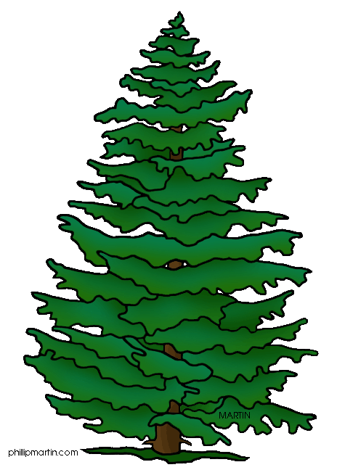

[Course Home Page](http://www.math.luc.edu/~ajs/courses/161fall2017/index.pdf)           [Department Home Page](http://www.math.luc.edu/)         [Loyola Home Page](http://www.luc.edu/)