Class Discussion: 30 August 2017

(calculator free)

1. *(algebra review)* For which non-zero value of *k* will the following quadratic equation have *only one* real root?

7x2 + kx + 3k = 0

1. Consider the following rational functions. For each function, determine the limiting behavior as x → ∞. Briefly explain how you arrived at your answers.
2. 

*Answer:* As x → ∞, y → __________

1. 

*Answer:* As x → ∞, y → __________

(c) 

*Answer:* As x → ∞, y → __________

3. Find an *equation* of a rational function whose graph is given below:

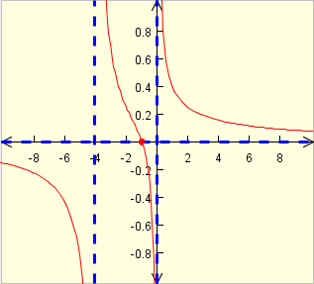

4. Sketch the graph of each of the following rational functions (that includes all the significant properties):









5. (*University of Michigan* problem)

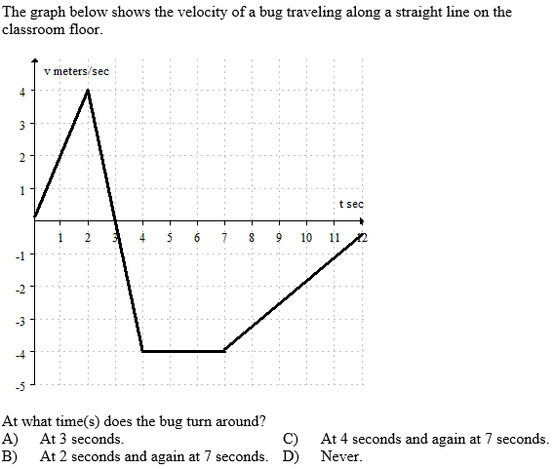

6. (*University of Michigan* problem)

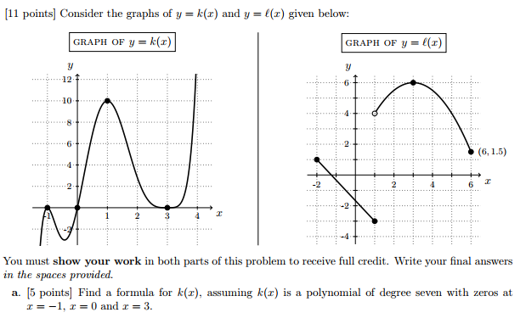



7. (*University of Michigan* problem

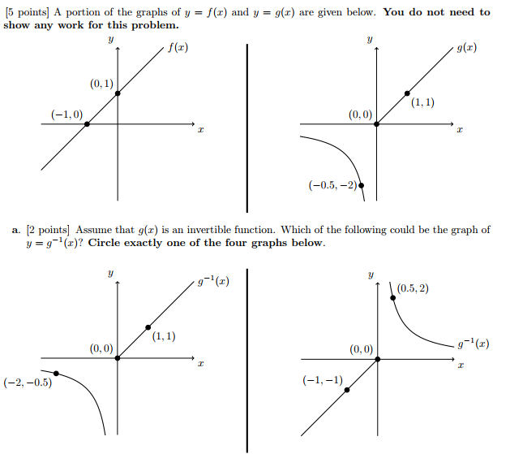

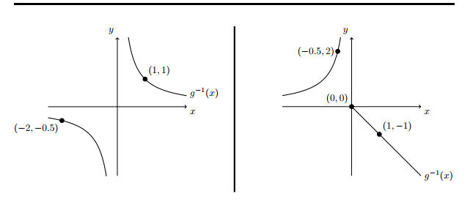

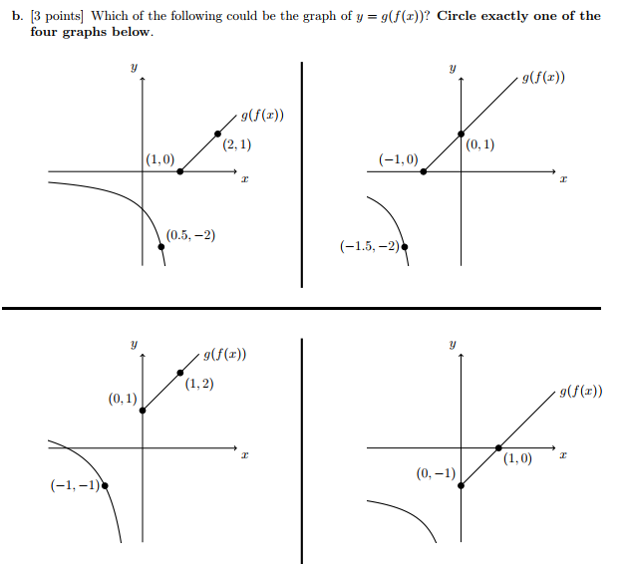

8. Compute each of the following limits. Explain your reasoning. Do not use calculators.

(a) 

(b) 

9. (*University of Michigan* problem)

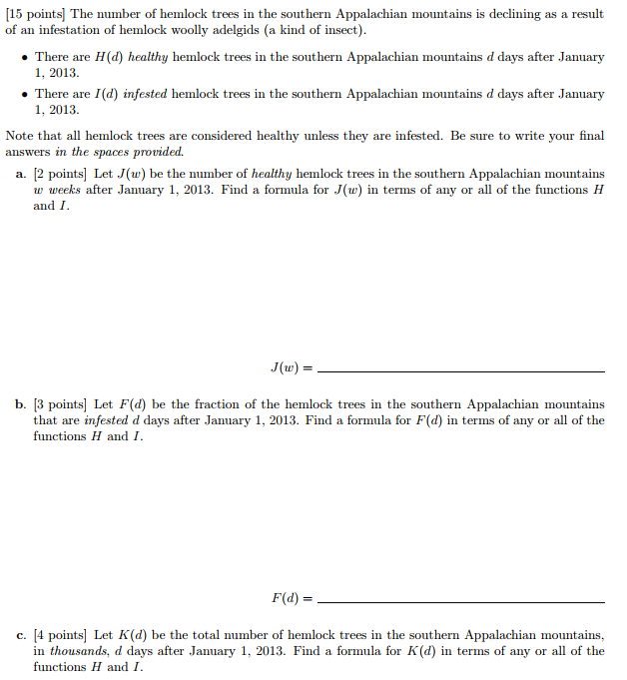



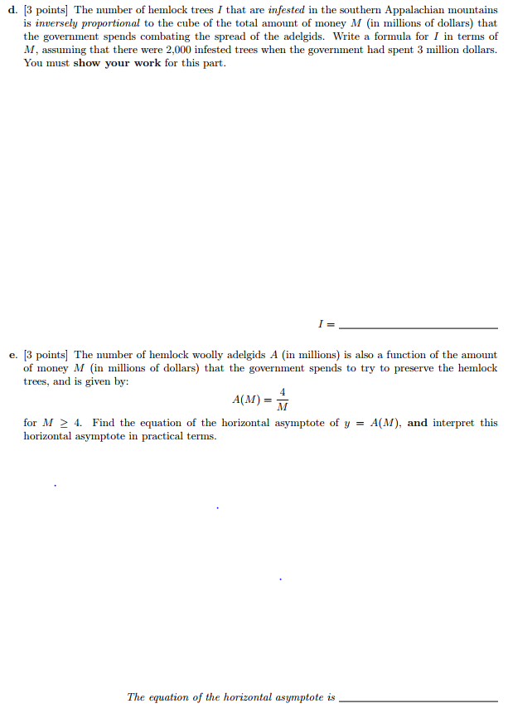

10. Consider the rational function *F* defined by 

(a) Find the lim F(x) as x → ∞ if it exists. Explain.

(b) Find the lim F(x) as x → -∞ exist? Explain.

11. Let y = g(x) be defined as follows



Sketch the curve.

12. Does the limit of g(x) as x→∞ exist?



If so, find it; if not explain!

[*To be pleased with one's limits is a wretched state.*](http://www.quotationspage.com/quote/26267.html)

**-** [**Johann Wolfgang von Goethe**](http://www.quotationspage.com/quotes/Johann_Wolfgang_von_Goethe/)(1749 - 1832)

