# MATH 161 Class Discussion 11 Sept 2017

1. Carefully state the *Squeeze Theorem*. Using the Squeeze Theorem compute each of the following limits:









2. (a) State carefully the *Intermediate Value Theorem*.

1. Using the Intermediate Value Theorem, explain why the polynomial function

g(x) = x5 – 4x3 + 3x – 1 has at least one real positive root *x*.

3. Compute . Show your work.

4. Compute  Show your work.

5. Carefully state the *Intermediate Value Theorem*. Let f(x) = 7 + 2x – x3 be defined on the interval [1, 3].

(a) Explain why *f* must assume the value 0 somewhere on this interval.

1. Must *f* assume the value -13 on the interval [1, 3]? Does the Theorem imply that *f* must assume the value 9.3 on the interval [1, 3]?

6. Compute  Show your work.

7. Compute  Have you made any assumptions about the constants *a* and *b*?

8. The cost of extracting *T* tons of ore from a copper mine is *C = F(T)* dollars. Using a complete sentence that avoids mathematical terminology, explain the meaning of F(2000) = 300,000. (Include appropriate units.)

9. Albertine travels from Chartres to Mt. Saint Michelle at an average speed of 50 km/hr. She returns to Chartres at an average speed of 60 km/hr. What is Albertine’s *average speed* during the roundtrip?

10. The expression

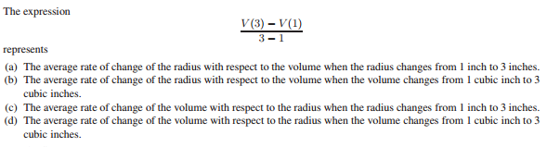

11. A paperback book (definitely not a valuable calculus textbook, of course) is dropped

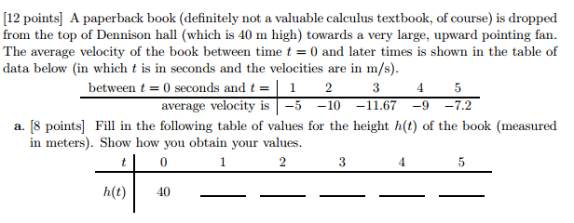

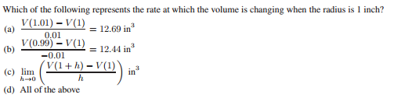

12.

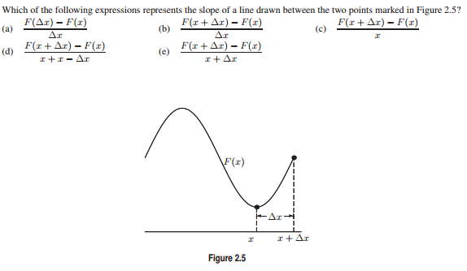

13.

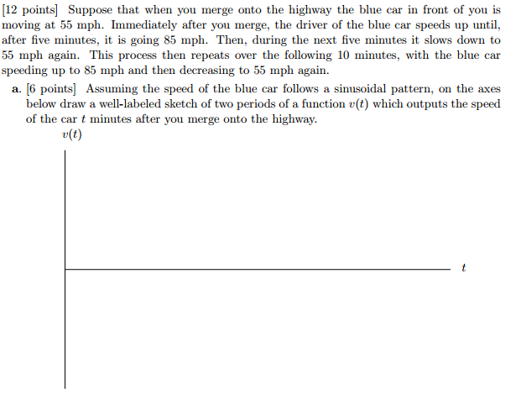

14. (University of Michigan problem)

.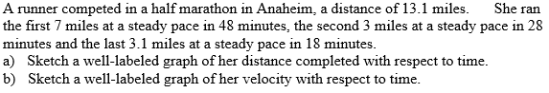

*Everything should be made as simple as possible, but not simpler.*

– Albert Einstein, **Reader’s Digest** (Oct. 1977)