MATH 161 Class Discussion 13 Sept 2017

1. The cost of extracting T tons of ore from a copper mine is C = F(T) dollars. Using a complete sentence that avoids mathematical terminology, explain the meaning of F(2000) = 300,000. (Include appropriate units.)

2. Albertine travels from Chartres to Mt. Saint Michelle at an average speed of 50 km/hr. She returns to Chartres at an average speed of 60 km/hr. What is Albertine’s average speed during the roundtrip?

3. The expression
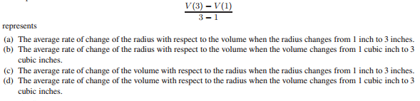

4. A paperback book (definitely not a valuable calculus textbook, of course) is dropped
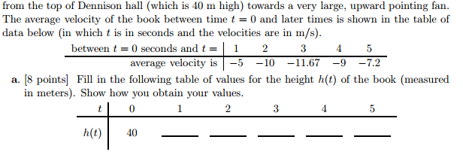
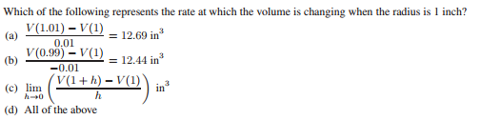

5.
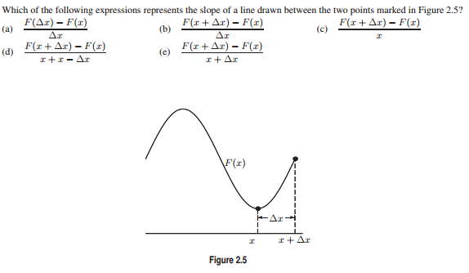
6.
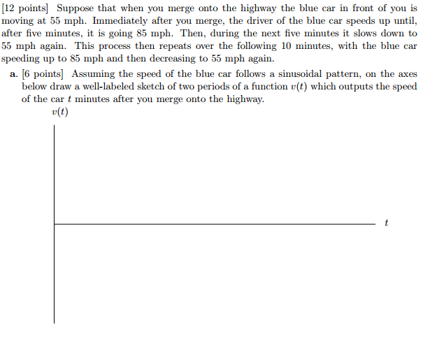

7. (University of Michigan problem)
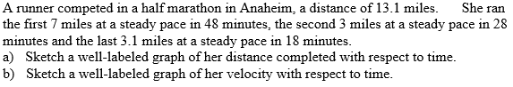

8.
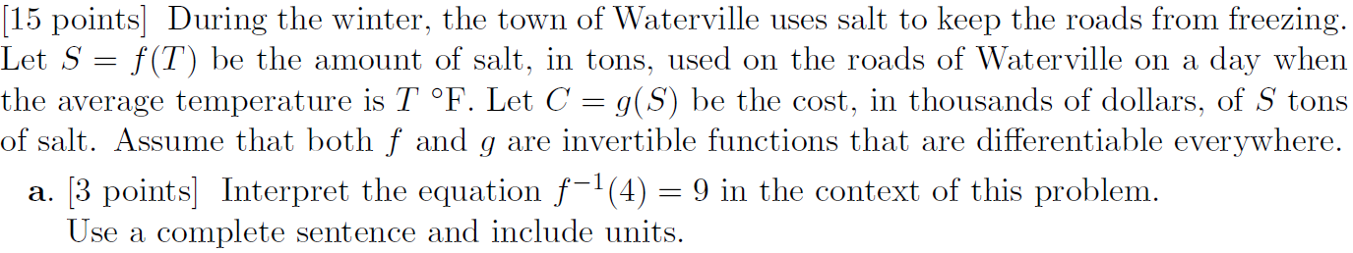
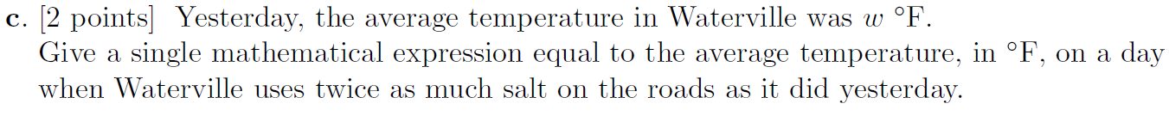

9.
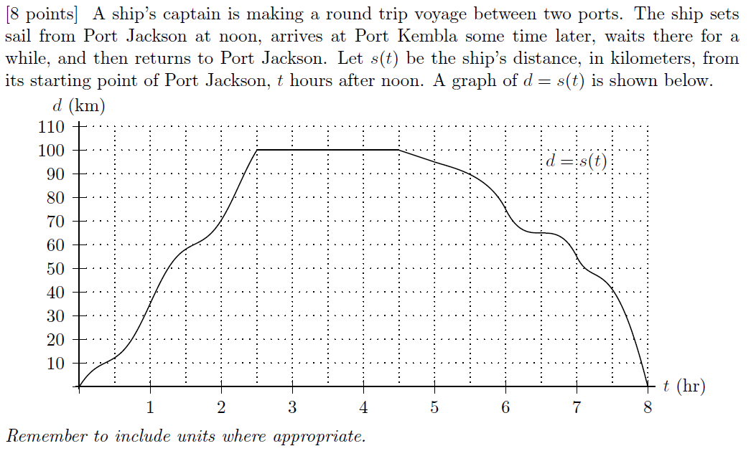
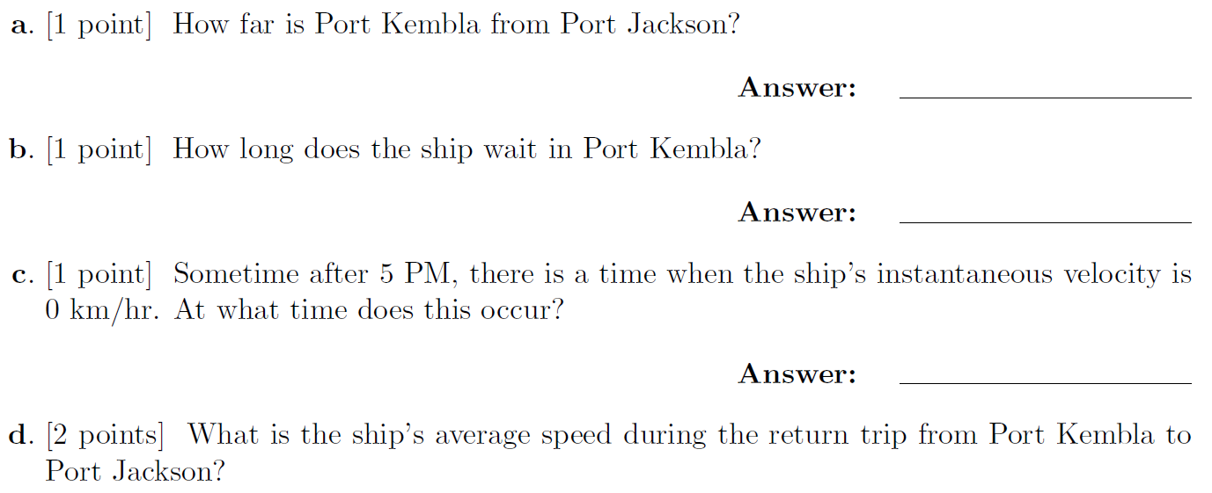

I turn away with fright and horror from the lamentable evil of functions which do not have derivatives.
– Charles Hermite (in a letter to Thomas Jan Stieltjes)
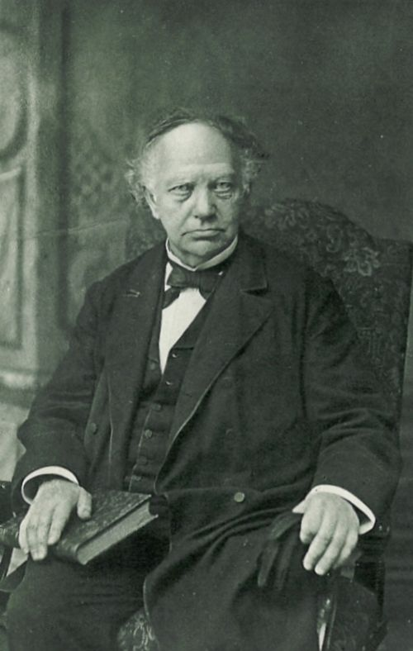
Charles Hermite (1822 – 1901)

