# MATH 161 class discussion: 8 Sept

1. Discuss the four types of *discontinuities*. Give examples of each.

2. A portion of the graph of a function *f* is shown below.

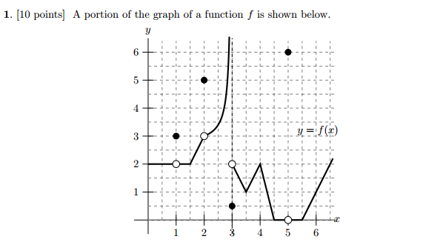

*Note:* You may assume that pieces or the function that appear linear are indeed linear. Use the graph above to evaluate each of the expressions below. If any of the quantities do not exist (including the case of limits that diverge to ∞ or -∞), write DNE.

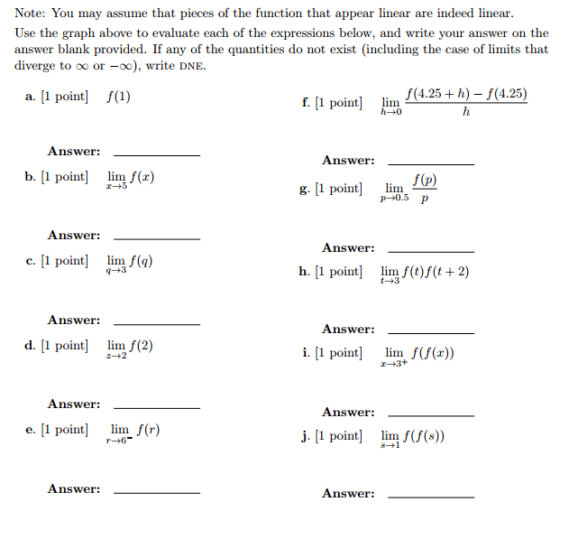

3. Carefully state the *Squeeze Theorem*. Using the Squeeze Theorem compute each of the following limits:









4. (a) State carefully the *Intermediate Value Theorem*.

1. Using the Intermediate Value Theorem, explain why the polynomial function

g(x) = x5 – 4x3 + 3x – 1 has at least one real positive root *x*.

5. Compute . Show your work.

6. Compute  Show your work.

7. Carefully state the *Intermediate Value Theorem*. Let f(x) = 7 + 2x – x3 be defined on the interval [1, 3].

(a) Explain why *f* must assume the value 0 somewhere on this interval.

1. Must *f* assume the value -13 on the interval [1, 3]? Does the Theorem imply that *f* must assume the value 9.3 on the interval [1, 3]?

8. Compute  Show your work.

9. Compute  Have you made any assumptions about the constants *a* and *b*?

10. Charlotte the spider lives on the x-axis. Assume that Charlotte was born at time *t = 0* days and dies at time *t = 13* days. Her position at time *t* (days) is given by  feet.

1. Find Charlotte’s *position* at time t = 4 days.
2. When does Charlotte find herself to the *left of the origin*?
3. Find Charlotte’s *average velocity* during her lifetime.
4. Find Charlotte’s *average velocity* during the time interval 4 ≤ t ≤ 4 + h. *Simplify* your answer.

11. Consider the following graph of the function f(x):

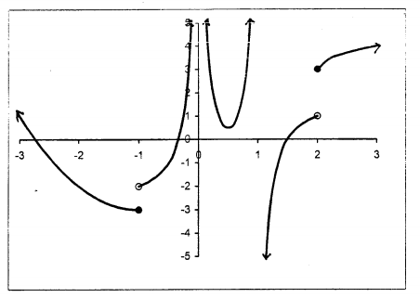

Which of the following statements are true? Select any and all.

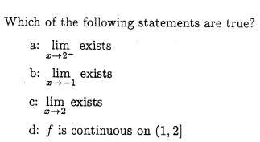

"Alice laughed: "There's no use trying," she said; "one can't believe impossible things."

"I daresay you haven't had much practice," said the Queen.

"When I was younger, I always did it for half an hour a day.

Why, sometimes I've believed as many as six impossible things before breakfast."

- Lewis Carroll, **Alice in Wonderland.**