**Class Discussion I (28 Aug 2017)**

**Precalculus exercises**

1. Let G(x) be a function with domain [0, 3] and range [0, 2]. The graph of G is displayed below.



Let A(x) = G(x – 5); B(x) = G(2x); C(x) = 3G(3x) + 1; and R(x) = – 3 G(–x/2) .

For each of the four functions, A, B, C, R, answer the following three questions.

1. Find the *domain* of this function.
2. Find the *range* of thisfunction.
3. Sketch the graph of this function. Be sure to indicate the *x* and *y* scales on your graph!

2. Albertine has inherited a cabin and a huge forest in southeastern Australia. She learns from her environmentalist friends that there are 1400 wombats remaining in her woods and 300 dingos, a natural predator of the wombat. Albertine is distressed to learn that the wombat population is declining by 1.3% per month while the dingo population is growing by 2.4% per month. *When* will the dingo population be *twice* that of the wombat population?

|  |  |
| --- | --- |
| Résultats de recherche d'images pour « clip art wombat » | Résultats de recherche d'images pour « clip art dingo » |

3. The Fifth-Thirty-Second Bank of GammaVille offers 4.1% interest per year *compounded weekly.* How much should Albertine deposit in such a savings account in order for her to have a balance of $ 75,000 after twenty years?



4. The number of hemlock trees in the southern Appalachian Mountains is declining as a result of an infestation of hemlock woolly adelgids (a kind of insect).

• There are H(d) *healthy* hemlock trees in the southern Appalachian Mountains *d* days after January 1, 2017.

• There are I(d) infested hemlock trees in the southern Appalachian Mountains *d* days after January 1, 2017.

Note that all hemlock trees are considered healthy unless they are infested.

(a) Let J(w) be the number of *healthy* hemlock trees in the southern Appalachian Mountains *w* weeks after January 1, 2017. Find a formula for J(w) in terms of any or all of the functions *H* and *I*.

(b) Let F(d) be the fraction of the hemlock trees in the southern Appalachian Mountains that are infested *d* days after January 1, 2017. Find a formula for F(d) in terms of any or all of the functions *H* and *I*.

(c) Let K(d) be the total number of hemlock trees in the southern Appalachian Mountains, in thousands, *d* days after January 1, 2017. Find a formula for K(d) in terms of any or all of the functions *H* and *I*.

(d) The number of hemlock trees *I* that are infested in the southern Appalachian Mountains is inversely proportional to the cube of the total amount of money *M* (in millions of dollars) that the government spends combating the spread of the adelgids. Write a formula for *I* in terms of *M*, assuming that there were 2,000 infested trees when the government had spent 3 million dollars.

(e) The number of hemlock woolly adelgids *A* (in millions) is also a function of the amount of money *M* (in millions of dollars) that the government spends to try to preserve the hemlock trees, and is given by:

$A\left(M\right)= \frac{4}{M}$ for M ≥ 4.

Find the equation of the horizontal asymptote of y = A(M), and interpret this horizontal asymptote in *practical terms*.

 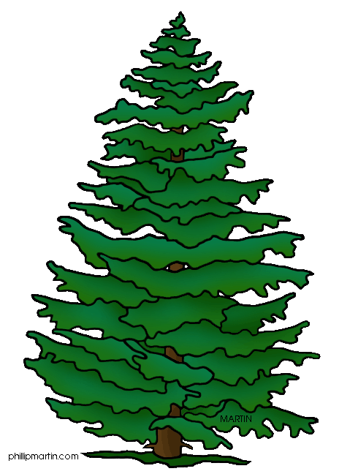

[Course Home Page](http://www.math.luc.edu/~ajs/courses/161fall2017/index.pdf)           [Department Home Page](http://www.math.luc.edu/)         [Loyola Home Page](http://www.luc.edu/)