Math 161: group work

Oct 2, 2017

1. Let G(x) = (2x – 9)44(3x + 4)15. Find all the critical points of G. Classify the critical points using the first derivative test. Sketch.

2. Let g(x) = x5 e3x. Find all the critical points of g. Classify the critical points using the first derivative test. Sketch.

3. Using *implicit differentiation*, find dy/dx for each of the following implicitly defined curves:

(a) xy + x + y = y sin x

(b) tan x + sec y = x + y + 2016

(c) xy4 – tan x = ey + 1234

4. Find d2y/dx2  if xy – 2x = y sin x

5. Find an equation of the tangent line to the *bifolium*

4x4 + 8x2y2 – 25x2y+ 4y4 = 0

at the point P = (2, 1).



1. Differentiate each of the following functions:
2. y = arcsin(3x)

(b) y = arccos(5x – 13)

(c) y = (arcsec x) / x

(d) y = arctan x + 3 arcsin x

(e) y = arctan( (x – 1)/(x + 1))

1. Let y = u3 + 1 and u = 5 arcsin x. Compute dy/dx
2. Let z = arctan u and u = ex. Compute dz/dx.

14. (a) Can you find a formula for d/dx (f (x) g(x) h(x))? (Called *Leibniz rule*.)

(b) Can you extend this result to a product rule for four or more factors?

(c) Using your result from (b), compute d/dx {5(x3) (cos x) (ln x) ex }

(d) Find any and all critical points of the function: y = (x2 + 3) (x – 5) ex

15. Using *logarithmic differentiation*, find dy/dx if:

1. 
2. 
3. 
4. 
5. 

16. (a) Let y = (arc tan t)7. Compute dy/dt.

(b) Let g(x) = cos(ln x) Compute g(100)(x) and g(101)(x).

(c) Let x = (sinh (4t))1/2. Compute dx/dt.

(d) Let z = (ln(a + bx))c, where *a*, *b*, and *c* are constants. Compute dz/dx.

(e) Let G(x) = x5 cosh x. Compute dG/dx.

16.



17. (a) Compute dy/dx given the curve implicitly defined by the equation:



(b) Find equations of the tangent and normal lines to the curve

(y – x)2 = 2x + 4 at the point P = (6, 2).

18.

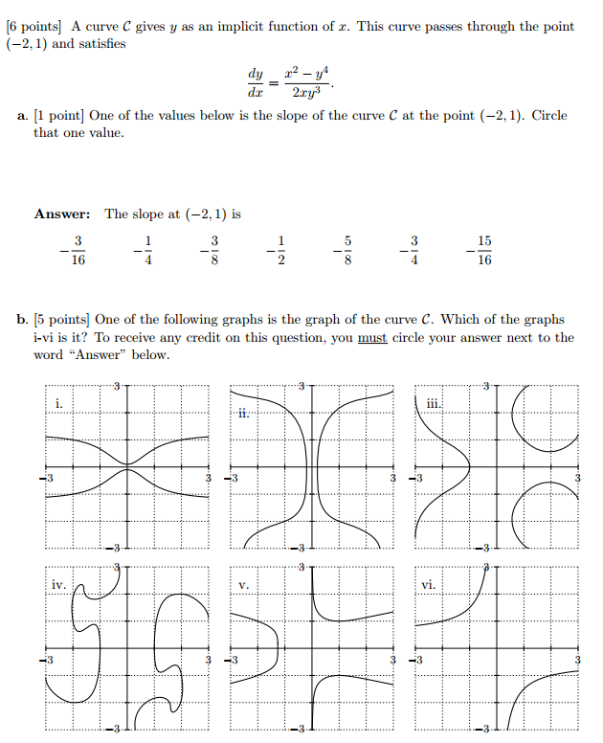

*To most outsiders, modern mathematics is unknown territory. Its borders are protected by dense thickets of technical terms; its landscapes are a mass of indecipherable equations and incomprehensible concepts. Few realize that the world of modern mathematics is rich with vivid images and provocative ideas.*

* **Ivars Peterson**