Essay Topics for Math 161
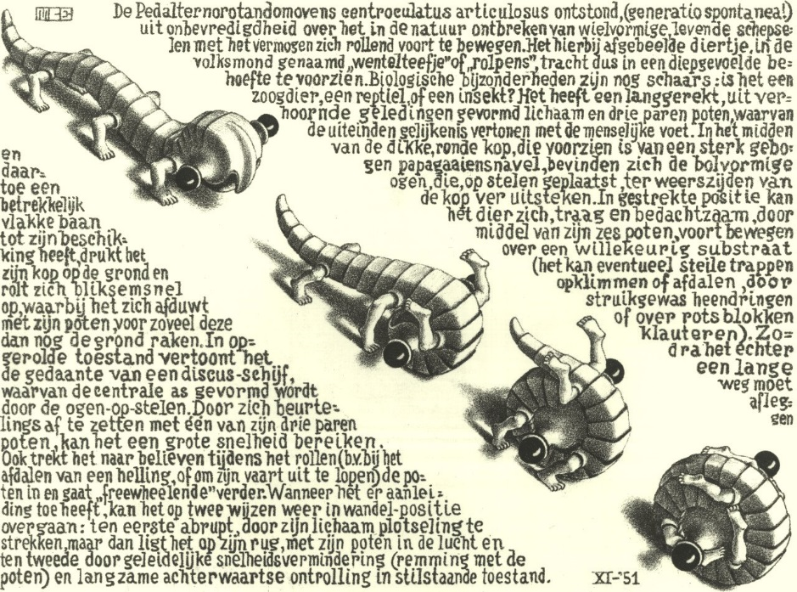
Curl Up, M. C. Escher
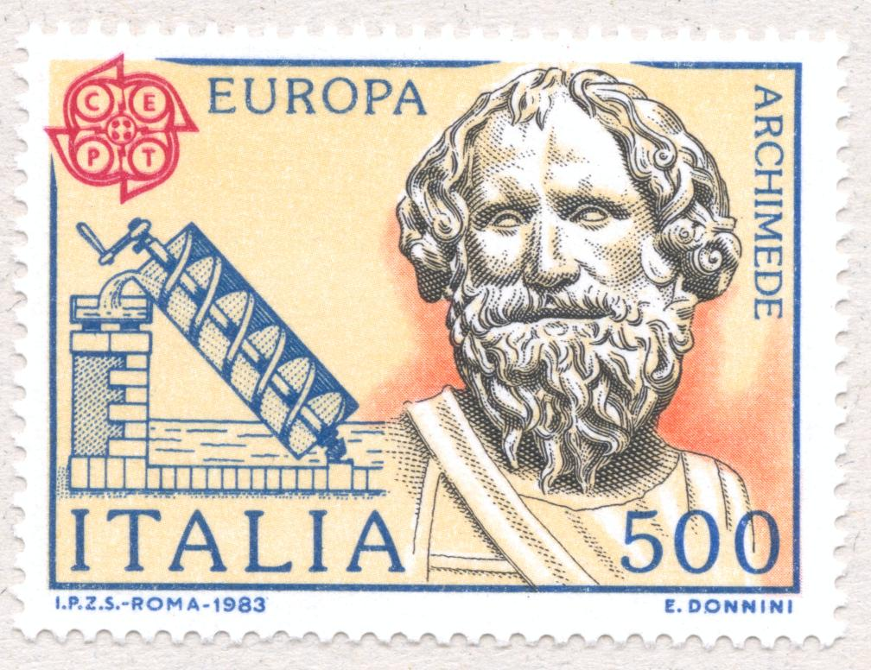
Write a 3 - 5 page essay on one of the following topics. Your paper will be evaluated based upon content, style, grammar, and originality. Be certain to give credit to all of your sources (including those on the web) at the end of the paper. Quality is far more important than quantity. Avoid dullness.
Due date: 6 December 2017
1. Read: John Allen Paulos, Innumeracy: Mathematical Illiteracy and Its Consequences, Hill and Wang paperback (2001). In reviewing Paulos' best-selling book, Douglas Hofstadter, author of Gödel, Escher, and Bach, wrote: "To combat [innumeracy] John Allen Paulos has concocted the perfect vaccine: this book, which is in many ways better than an entire high school math education! Our society would be unimaginably different if the average person truly understood the ideas in this marvelous and important book. It is probably hopelessly optimistic to dream this way, but I hope that Innumeracy might help launch a revolution in math education that would do for innumeracy what Sabin and Salk did for polio." Do you agree with Hofstadter's statement? Justify your position, preferably drawing from personal experience.

2. Read: George Pólya, How To Solve It, Ishi Press (2009). In this highly readable book, renowned mathematician Polya describes a four-step problem solving procedure. Describe this process in your own words. Using exercises from your homework assignments as examples, show how Polya's process can be applied to design solutions to calculus problems.

3. We have already seen the value of identifying symmetry in the graphing of functions. Develop the theme of symmetry in mathematics, art, architecture, chemistry, human anatomy, or any other discipline. You may wish to read and incorporate ideas from Herman Weyl’s beautiful (and short) book, Symmetry, Princeton University Press (1983).

4. D’Arcy Thompson’s On Growth and Form, CreateSpace (2011), has been called by Nobel laureate P. Medawar "the finest work of literature in all the annals of science that have been recorded in the English tongue." Others have called him “the first bio-mathematician." The central thesis of On Growth and Form is that zoologists of his time overemphasized the role of evolution, and underemphasized the roles of physics and mathematics as determinants of the form and structure of living organisms. Perhaps the most famous part of the work is Chapter IX (of the abridged version), "On the Theory of Transformations, or the Comparison of Related Forms." Here Thompson explores the degree to which differences in the forms of related animals could be described by means of relatively simple mathematical transformations. Choose a topic or an example from Thompson that particularly intrigues you; describe and discuss this example in your paper. Explain why you find this topic remarkable.
5. Discuss the discovery of the solution to the cubic equation, drawing from the lives of Tartaglia and Cardano. You may wish to read portions of the lively text by Orstein Ore, Cardano: The Gambling Scholar, Dover (1965).

6. Read Nate Silver’s critically acclaimed book, The Signal and the Noise: Why So Many Predictions Fail -- But Some Don't, Penguin Press (2012) in which“Silver examines the world of prediction, investigating how we can distinguish a true signal from a universe of noisy data. Most predictions fail, often at great cost to society, because most of us have a poor understanding of probability and uncertainty. Both experts and laypeople mistake more confident predictions for more accurate ones. But overconfidence is often the reason for failure. If our appreciation of uncertainty improves, our predictions can get better too. This is the ‘prediction paradox’: The more humility we have about our ability to make predictions, the more successful we can be in planning for the future.” Discuss how this book has influenced your views toward predicting the future.

7. Read Jonathan Swift’s Gulliver’s Travels (or at least several chapters). Write an essay in the style of Swift describing your adventures in visiting a new land that developed a reasonably advanced civilization that does not include calculus.
8. The renowned Argentine writer Jorge Luis Borges was fascinated by the infinite. Read several of the short stories in Borges’ Labyrinths: Selected Stories and Other Writings. Discuss the relationship between the study of the infinite in the differential calculus and Borges’ vision of the infinite. Alternatively, write a short story in the style of Borges that engages the reader in a particular encounter with the differential calculus.

9. In addition to Borges’ fascination with the infinite, there continue to be many examples of how our culture is fascinated by tales of the infinite. For example, consider the recent song, The Bottomless Hole, by the Handsome Family. Explore and discuss other contemporary examples of our culture’s fascination with the infinite.

10. Stephen Jay Gould, in his brilliant work, The Mismeasure of Man, Norton (1996), argues forcefully how misuse of science and mathematics have been used as an instrument of discrimination, using the I.Q. test as a major example. Read and discuss your personal reaction to this work that is regarded by many as “a major contribution toward deflating pseudobiological ‘explanations’ of our present social woes.”
11. Explore the life of a student growing up in 19th century England learning algebra from the text Hall & Knight. This may be historical fiction, or you may wish to view this as an actual historic portrait.

12. Read: Sheila Tobias, Overcoming Math Anxiety, W. W. Norton & Co. (1995). The first edition of this book, written in 1978, made "math anxiety" a household term. In the revised version, Tobias explains her view that math anxiety is a political issue and that math competence doesn't have to be determined by gender or class. Do you agree with Tobias' thesis? Justify your position. Give examples from your own experience.

Be sure to consider more recent research, such as that of Dr. Sian L. Beilock, math anxiety expert at The University of Chicago’s Psychology Department: When Math Hurts: Math Anxiety Predicts Pain Network Activation in Anticipation of Doing Math

13. Write a creative and imaginative short story in which calculus plays a central role.
14. In the first paragraph of chapter I of Mathematics in Western Culture, Morris Kline states: "The assertion that mathematics has been a major force in the molding of modern culture, as well as a vital element of that culture, appears to many people incredible or, at best, a rank exaggeration. This disbelief is quite understandable and results from a very common but erroneous conception of what mathematics really is." Develop this idea using calculus as your primary example.
15. Read David Berlinski’s clever and entertaining book, A Tour of the Calculus (Vintage Books, 1995). Consider Berlinski’s fanciful descriptions about how theorems are created:

- Chapter 18, Wrong Way Rolle: “And since this is all nonsense, fabricated from scratch, I might as well have him composing his theorem – Rolle’s theorem – in an attic garret, his mistress blowing gently on the beside candles in order to coax him to bed …”

- Leibniz Mediates in His Room at Night (pg. 109)

Try to compose such a sketch featuring the birth of a calculus theorem or technique that we have (or will) study this semester.

16. Wearing Gauss’s Jersey by Dean Hathout (a high-school sophomore when he wrote this book in 2013)) discusses 66 problems of Gauss. You may wish to create a short story in which you travel back in time to meet Gauss, and to discuss some of these problems with him. (Let’s assume that you do not need a translator.)

17. Read David Foster Wallace’s idiosyncratic book, Everything and More: A Compact History of Infinity, W. W. Norton (2003). You will find fascinating discussions of the paradoxes of infinity. Explore his thesis that “However good calculus is at quantifying motion and change, it can do nothing to solve the real paradoxes of continuity….” (p. 145).
18. You may wish to choose a topic not listed here. If so, you must obtain prior approval from your instructor.

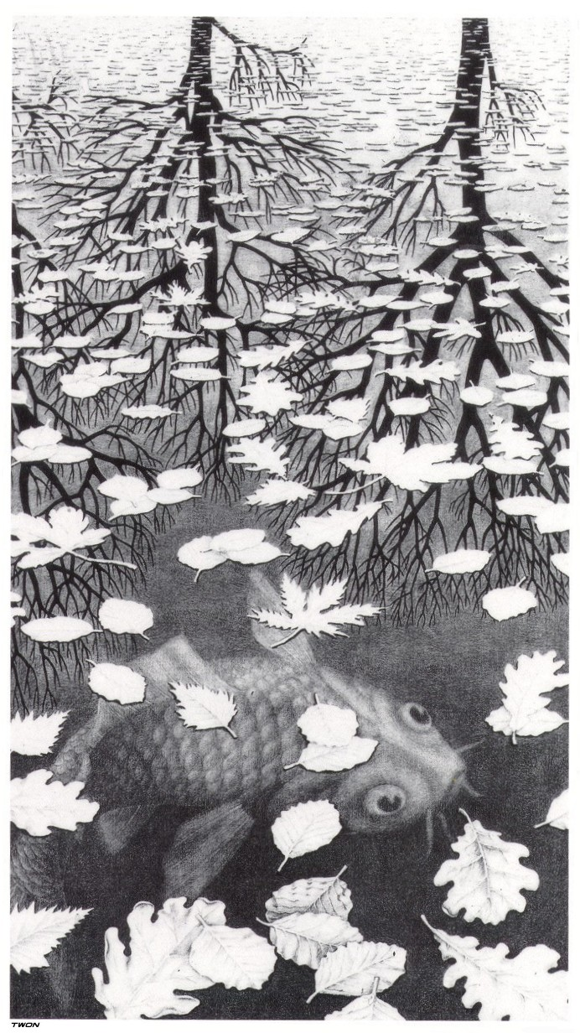
Three Worlds, M. C. Escher

