# Practice FINAL EXAM A

# 

# PART I (*6 pts each*) *Answer any 17 of the following 21 questions.* You need not justify your answer. You may answer more than 17 to obtain extra credit.

1. 

2. 

3.  where *a* and *b* are positive constants.



Compute *h*′(e).

5. 

1. Solve the initial value problem:

 given that y = 2017 when x = 1.

7. Find an anti-derivative of 

1. Find an anti-derivative of:



9. 

10. Suppose that 



11. Find the *average value* of the function y = sec2 x over the interval [0, /4]. (Give the precise result without rounding.)

12. Find the value of *c* such that the conclusion of the Mean Value Theorem is verified for the function  on the interval [2, 5]. Express your answer to the nearest hundredth.

13. 

14. Let *a* and *b* be non-zero constants. 

Find the *slope of the tangent line* to y = f(x) at x = 0. (Your answer may include the constants *a* and *b*.)

15. Let *a* and *b* be non-zero constants. Then 

16. Suppose that  Find g(5).

 Find dy/dx when x = 1.



 (*Hint:* Convert this limit into a Riemann integral.)



21. Charlotte, the spider, lives on the x-axis. Suppose that at time t = 1 minute, she is at x = 5 cm, and that her velocity (in cm/minute) at time *t* is given by:

v(t) = 4t3 – 6t2 + 1. *Where* is Charlotte at time *t = 2 minutes*?

**PART II** *(12 pts each)*

## Answer any 13 of the following 14 problems. You may answer more than 11 for extra credit.

1. Find the equation of the *tangent line* to the curve defined implicitly by



at the point P = (2, 1).

2. Gilberte, who is 5 feet tall, walks away from an 18 foot lamppost. She observes that when she is 8 feet from the base of the lamppost, her shadow is increasing at a rate of 6 ft/min. Find Gilberte’s speed when she is 8 feet from the base of the lamppost.

3. Using an *appropriate tangent line approximation*, estimate the value of . Have you obtained an *overestimate* or an *underestimate*? Explain. Sketch!

4. We wish to approximate a root of g(x) = x4 + x – 1. Note that

g(0) < 0 and g(1) > 0.

(a) How do we know that there must exist a solution to g(x) = 0 in the interval (0, 1)?

(b) Let our initial guess for the root be x0 = 0.5. Using Newton’s method, compute x1 and x2 (to at least 3 significant digits).

5. Graph the function  Identify any and all local and global extrema and points of inflection.

6. Madam Verdurin is building an open planter in the shape of a rectangular box with a square base. The base is made of metal that costs $7 per square foot. The sides are made of wood that costs $3 per square foot. The planter must hold at least 8 cubic feet of dirt. Find the dimensions of the *least expensive* planter that Madame Verdurin can build.

7. The graph below shows the *RATE OF CHANGE* of the quantity of water in the Water Tower of OZ, in liters per day, during the month of April, 2009. The tower contained 12,000 liters of water on April 1. *Estimate* the quantity of water in the tower on April 30. Show your work.



8. Using the FTC, find the area bounded by the two parabolas:

*y = x2 – 5x* and *y = 20 + x – x2*. *Sketch.*

9. Use a *left-endpoint* Riemann sum with *n = 4* rectangles to approximate the area under the curve  between x = 0 and x = 2. Draw a picture to illustrate what you are computing. Is this an *underestimate* or an *overestimate* of the area? *Explain!*

10. The function y = F(x) is defined below:



For which value(s) (if any) of *k* is the function everywhere continuous? Explain!

11. Graph the cubic polynomial g(x) = x3 + x2 – 8x + 5. Identify any and all local and global extrema and points of inflection.

12. *(University of Michigan)*

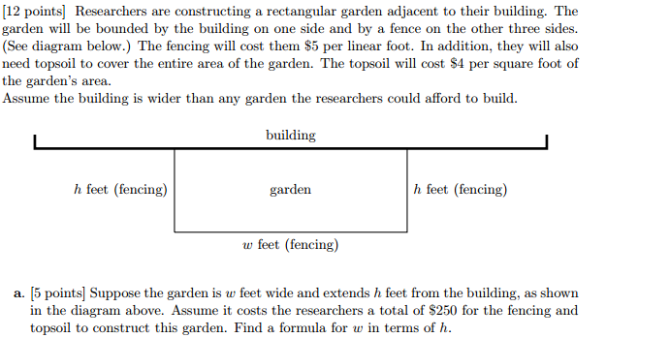

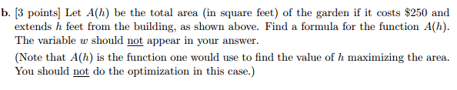



13. Albertine launches a model rocket from the ground at time t = 0. The rocket

starts by traveling straight up in the air. The graph below illustrates the upward velocity of the rocket as a function of time.

(a) Sketch a graph of the *acceleration* of the rocket as a function of time.

1. Sketch a graph of the *height* of the rocket as a function of time.
2. Give an estimate of the *maximum height* the rocket achieved.

14. Oil from an offshore rig located 3 miles from the shore is to be pumped to a location on the edge of the shore that is 9 miles east of the rig. The cost per foot of constructing a pipe in the ocean from the rig to the shore is *twice the cost per foot* of construction on land. Determine how the pipe should be laid to *minimize the total cost*.



*With an absurd oversimplification, the "invention" of the calculus is sometimes ascribed to two men, Newton and Leibniz. In reality, the calculus is the product of a long evolution that was neither initiated nor terminated by Newton and Leibniz, but in which both played a decisive part.*

- Richard Courant and Herbert Robbins

# *The quarrel [between Newton and Leibniz] is simply the expression of evil weaknesses and fostered by vile people. Just what would Newton have lost if he had acknowledged Leibniz's originality? Absolutely nothing! He would have gained a lot. And yet how hard it is to acknowledge something of this sort: someone who tries it feels as though he were confessing his own incapacity. ... It's a question of envy of course. And anyone who experiences it ought to keep on telling himself: "It's a mistake! It's a mistake! -- "*

# - Ludwig Wittgenstein (1947)