# MATH 161 Practice FINAL EXAM B

# PART I (*3 pts each*) *Answer any ten of the following eleven questions.* You need not justify your answer. You may answer all eleven to obtain extra credit.

1. 

2. 

3. .

4. Let . Compute h′(1).

5. 

6. Assume that *a*, *b*, and *c* are non-zero constants. Then



7. Find an *anti-derivative* of



1. Find an anti-derivative of:



9. Let G(x) = e9x + 13. Find a general formula for G(k)(0), the kth derivative of *G* evaluated at x = 0, where k > 1.

1. Suppose that *f* is defined and twice differentiable on the interval (0, 98). If f ' (9) = 0 and f ''(9) = 43, what, if anything, can you conclude about the point x = 9? (For example, is it a point of inflection, a local maximum, a global minimum, etc?)

$$11. \frac{d}{dx} x^{\ln{x}}$$

**PART II** *(7 pts each)*

## Answer any 9 of the following 11 problems. You may answer more than eight for extra credit.

1. Use implicit differentiation to finddy/dx , where *y* is given implicitly as a function of *x* by the following equation:



2. Show that the tangents to the curve at the points x =  and x = -, respectively, are perpendicular.

3. The impedance Z (ohms) in a series circuit is related to the resistance R (ohms) and reactance X (ohms) by the equation. If R is increasing at 3 ohms/sec and X is decreasing at 2 ohms/sec, at what rate is Z changing when R = 10 ohms and X = 20 ohms?

4. Given the function f (x) = x ln(2x) – x on the closed interval $\left[\frac{1}{2e } , \frac{e}{2}\right]$, find the global extrema, and points of inflection and use this information to sketch the graph.

5. For which value or values of the constant *k* will the curve y = x3 + kx2 + 3x – 4 have exactly one horizontal tangent?

6. Using an appropriate substitution, evaluate the following definite integral:



7. Sketch the graph of the function $y=\frac{{(x+1)}^{2}}{1+x^{2}}$. Locate any and all local extrema and points of inflection.

8. You are designing a 1000 cm3 cylindrical can whose manufacture will take waste into account. There is no waste in cutting the aluminum for the side, but the top and bottom of radius *r* will be cut from squares that measure 2r units on a side. The total amount of aluminum used up by the can will therefore be

A = 8r2 + 2rh.

Find the ratio of *h* to *r* for the most economical can.

1. It costs Albertine *c* dollars to manufacture and distribute backpacks. If the backpacks sell at *x* dollars each, the number sold is given by



where *a* and *b* are positive constants. What selling price will yield a maximum profit for Albertine?

1. Using the FTC, find the area bounded by the curve y = x2(x – 4)2 and the x-axis. Sketch.
2. *(University of Michigan)*

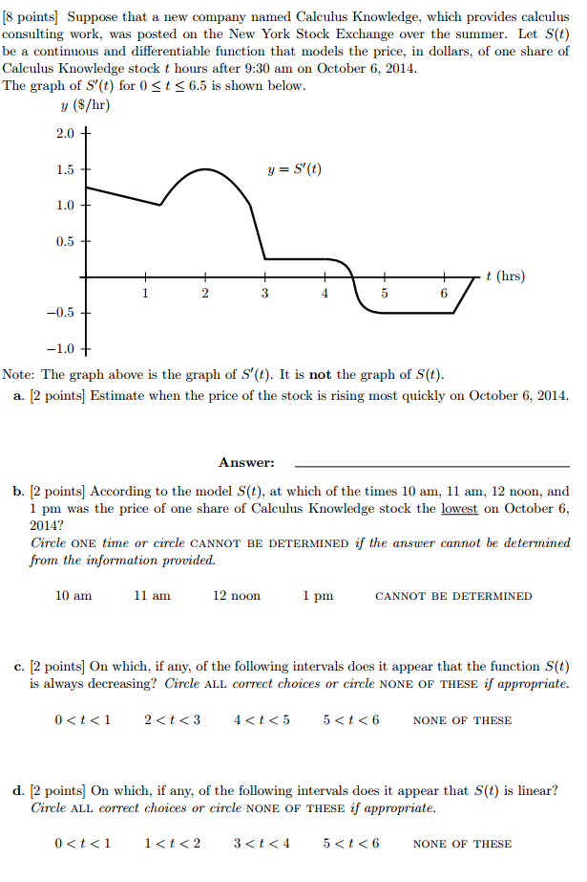

*In the beginning (if there was such a thing), God created Newton’s*

*laws of motion together with the necessary masses and forces. This*

*is all; everything beyond this follows from the development of*

*appropriate mathematics methods by means of deduction.*

- Albert Einstein

