SURVIVAL SHEET: Math 161

Fall 2017

Required Text: James Stewart, Calculus: Single Variable with Early Transcendentals, 8th edition, Cengage Learning (2016), packaged with WebAssign or WebAssign stand-alone.
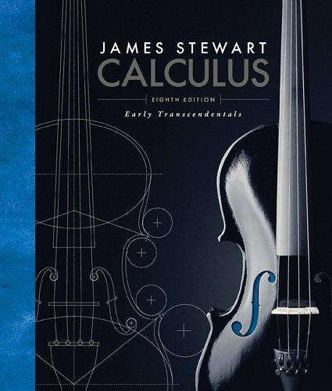

Calculator: The TI-83 Plus or TI-84 Plus graphing calculator or equivalent is required. The TI-89 and more powerful calculators are not permitted. Indeed, some quizzes and tests may be “calculator free.”
Software: Mathematica 11
Instructor: A. Saleski, 612 BVM Hall (contiguous with IES) building # 37 on map (6349 N. Kenmore Ave., Chicago, IL 60660)
e-mail: asalesk@luc.edu OR alan.saleski@gmail.com; office phone: (773) 508-3577
Course URL:
http://www.math.luc.edu/~ajs/courses/161fall2017/index.pdf
WebAssign: https://www.webassign.net/luc/login.html
Office Hours: MWF 10:30 – 11:00 am; 3:00 – 3:30 pm TTh 4:00 – 5:00 pm or by appointment

Ground Rules: The final grade is computed according to the following recipe:
quizzes | 19 %
tests | 31 %
homework (WebAssign) | 8 %
Mathematica labs | 4 %
groupwork | 3%
essay/project | 4 %
final exam | 31 %
extra credit | (max of 4%)
Grading standards
Supplemental Instruction (SI): TBA

Tutoring Services:
“The Center for Tutoring and Academic Excellence offers FREE tutoring services to all LUC students! Our tutoring model includes small group tutoring and tutor-led study halls. The small groups meet once per week throughout the whole semester and are led by a trained peer tutor who has successfully completed study in the course material. Students are placed into a group with other students who are taking that same course and who share the same professor! Drop-in Study Halls are offered throughout the week for many LUC courses and begin the first week of classes. Our study hall schedule can be found online at: www.luc.edu/tutoring. To learn more about our services or to request small group tutoring, please visit the CTAE online at www.luc.edu/tutoring or drop by the Center during normal business hours, M–F 9am – 7pm. We are located in the Sullivan Center, 2nd floor, Room 245. Hope to see you soon!”

Important Dates:
- Quizzes: (all Fridays) September 1, 8, 15, 22; October 6, 13, 27; November 3, 10; December 1
• Tests: (all Fridays) September 29; October 20; November 17
- Holidays:
- Labor Day: Monday, September 4th

- mid-semester break: Monday & Tuesday, October 9th – 10th
- Thanksgiving break: Wednesday – Sunday, November 22rd – November 26th

• Total Solar Eclipse: Aug 21

- Last day To Withdraw without a WF:
midnight, Friday, November 3rd
• Last day of Class: Friday, December 8th
• Final Exam, Monday, December 11th (1:00 – 3:00 pm)
• Loyola Calendar (Fall 2017)

Remarks:

- Quizzes will be based upon recent class discussion, recent homework and, occasionally, assigned videos and readings. Each quiz will last about 15 minutes. There will be no make-up quizzes unless the student makes prior arrangements with the instructor. The lowest two of the ten quiz grades will be dropped.

- Each test will require, roughly, one hour. Make-up tests will be given only for non-frivolous reasons. In such cases, the student should make prior arrangements with the instructor, if at all possible.

- WebAssign homework will be accepted within two weeks beyond the posted deadline. (You have only to click on “request extension” in WebAssign.)

- The minimum penalty for cheating is failure in the course. A student who improperly aids another with a homework assignment, a test, the final exam, or with a Mathematica lab is considered to be equally culpable. If you receive help on a lab assignment from anyone other than the instructor (this includes another student, a TA, a tutor, a family member, website, or friend), you should acknowledge this fact in a comment at the beginning of your lab. Smart-phones, fitbits, headphones, etc, are not permitted during quizzes/tests/final.

Incidents of academic dishonesty will be reported to the appropriate Dean.

- Extra credit may be earned in many ways, including: finding errors or dead links on webpages, critiquing appropriate films or outside lectures, and reviewing appropriate articles or books.

The institutionalized values school instills are quantified ones. School initiates young people into a world where everything can be measured, including their imaginations, and, indeed, man himself. But personal growth is not a measurable entity. It is growth in disciplined dissidence, which cannot be measured against any rod, or any curriculum, not compared to someone else's achievement. In such learning one can emulate others only in imaginative endeavor, and follow in their footsteps rather than mimic their gait. The learning I prize is immeasurable re-creation.
- Ivan Illich, Deschooling Society

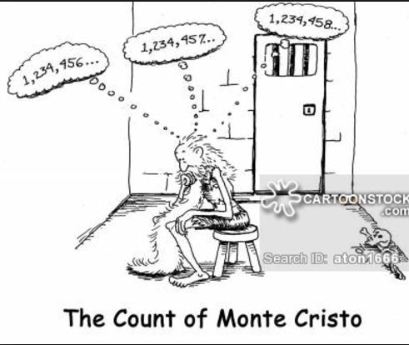

Course Home Page Department Home Page Loyola Home Page

