Math 161 - 004

Calculus I

Fall 2017

MWF 11:30 am – 1:25 pm

(236 Dumbach Hall)
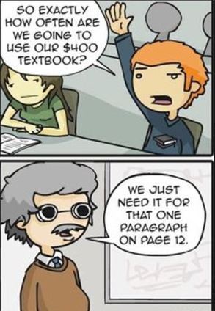
- Ground Rules
- Syllabus
- WebAssign
- Homework & Reading Assignments
- Class Discussion Exercises
- GroupWork
- Worksheets
- Piazza
- Tutoring Services and Schedule
- Quiz Solutions (qz 1, qz 2, qz 3, qz 4, qz 5, qz 6, qz 7, qz 8, qz 9, qz 10)
- Practice Tests (test 1, test 2, test 3)
- Test Solutions (test 1, test 2)
- Practice Finals (final A, final B)
- final exam review topics
- Mathematica Examples (basic ops nb or PDF; implicit & parametric eqns nb or PDF; area nb or PDF)
- Mathematica Labs (Lab I, Lab II, Lab III)
- Calculus test banks: University of Michigan; NYU; Washington University St. Louis
- MIT OCW for Calculus
- Essay topics
- Useful References (Greek alphabet; Mathematica tutorials & websites; supplementary texts and calculus websites)
- History of Calculus
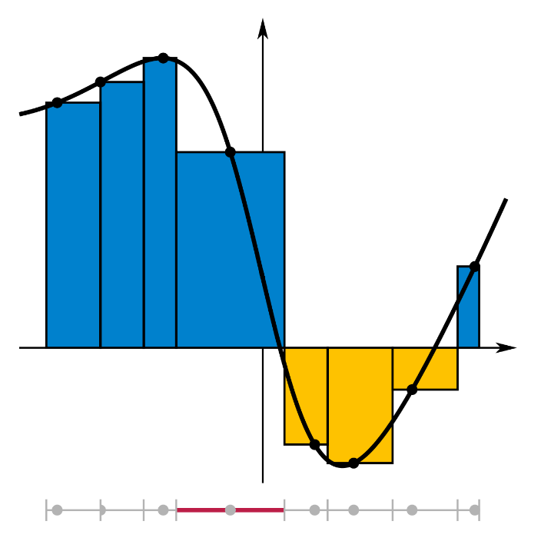

Department Home Page Loyola Home Page

