# MATH 161 Practice exercises for Test I





Using *only the definition of derivative (i.e., limit of Newtonian difference quotient)*, compute dy/dx.

2. Using *only the definition* of the derivative, find an equation of the tangent line to the curve  at x = 2.

3. Using *only the definition of the derivative*, find the *slope of the tangent line* to the curve



at x = 1. Show your work!

4. Compute (showing your work):



5. Consider the graph of the function  given below:

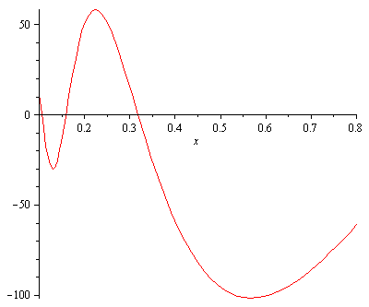

Using the method of “geometric differentiation,” sketch the graph of the function

y = g′(x).

6. *Estimate* the derivative of the following function at x = 3 by constructing an appropriate table. (Give your answer correct to two significant digits.)



7. Using *only the definition of the derivative*, find the *slope of the tangent line* to the curve



at x = 1. Show your work!

8. Consider the rational function *F* defined by 

Find the *domain* of *F*.

9. Using the process of “geometric differentiation,” sketch the graph of the derivative of the function

y = G(x) whose graph is given below.

FYI: This is the graph of y = f(x) =



10. Compute each of the following limits or explain why the limit fails to exist. Justify your reasoning. (A calculator solution earns only partial credit.)









11. Charlotte the spider lives on the x-axis. Assume that Charlotte was born at time t = – 2 days and dies at time t = 13 days. Her position at time *t* (days) is given by  inches.

Find Charlotte’s *average velocity* during her lifetime.

12. Let G(x) = x sin x. Using an appropriate table, *estimate* the slope of the tangent line to y = G(x)

at x = 3. (*Hint:* Begin by writing down the definition of G′(3). Be certain to set your calculator to radian mode.)

13. Sketch the graph of the rational function . Be certain to display any and all vertical and horizontal asymptotes.

14. *Without* using a calculator, compute



15. Calculate each of the following limits or explain why the limit fails to exist.











*(Hint: In (d) and (e), relate the limit to the definition of a particular derivative.)*

16. (a) State carefully the *Intermediate Value Theorem*.

1. Using the Intermediate Value Theorem, prove that the polynomial function

g(x) = x4 – 7x2 + x + 5 has at least one real negative root x.

17. Assume that Charlotte, who chooses to live on the y-axis, is located at *y(t) = 3 cos t + 4 sin t* cm at time *t* (measured in minutes).

(a) Find her *position* at times t = 0, t = /2, and t = 

(b) Find her *velocity* when t = 0, t = /2, and t =  minutes.

(c) Find her *acceleration* when t = 0, t = /2, and t = 

18. Consider the function defined by:



Is there a value of *c* for which this function is continuous at x = 0? Explain.

19. Archy lives on the x-axis. Graphs of his *position*, *velocity* and *acceleration* during the time interval -0.7 < t < 4.3 appear below. Which is which? Explain.



20. Let f(x) = sin(3x). Suppose that Albertine can prove that d/dx (sin 3x) = 3 cos 3x and that

d/dx cos 3x = -3 sin 3x. Compute f (1789)(x).

21. (a) 

(b) 

22. (a) Does continuity imply differentiability? Explain!

(b) Does differentiability imply continuity? Explain!

23. Sketch a continuous, differentiable graph with the following properties:

* + local minima at 2 and 4
  + global minimum at 2
  + local and global maximum at 3
  + no other extrema

24. Let *f*(*x*) = *x*4 − *ax*2*.*

* 1. Find all possible critical points of *f* in terms of *a.*
  2. If *a <* 0*,* how many critical points does *f* have?
  3. If *a >* 0*,* find the *x* and *y* coordinates of all critical points of *f.*

25. Given f(x) = x6 – 3x5 on the interval [-1, 4].

* 1. Find all critical points of *f*.
  2. Determine on which intervals *f* is increasing.
  3. Find and classify all local and global extrema of *f*.

(d) Sketch the graph of *f* using the above information.

26. Given the function f (x) = x ln(2x) – x on the closed interval, find the global extrema and use this information to sketch the graph. Identify all local and global extrema. *Sketch.*

27. By using an appropriate tangent line approximation to a curve, estimate the value of  Is your answer an *underestimate* or an *overestimate*? *Sketch!*

28. (a) Compute dy/dx given the curve implicitly defined by the equation:



(b) Find equations of the tangent and normal lines to the curve

(y – x)2 = 2x + 4 at the point P = (6, 2).

29.  *[University of Michigan]* A model for the amount of an antihistamine in the bloodstream after a patient takes a dose of the drug gives the amount, a, as a function of time, t, to be a(t) = A(e –t − e −kt). In this equation, *A* is a measure of the dose of antihistamine given to the patient, and *k* is a transfer rate between the gastrointestinal tract and the bloodstream. *A* and *k* are positive constants, and for pharmaceuticals such as antihistamine, k > 1.

(a) Find the location t = Tm of the non-zero critical point of a(t).

(b) Explain why t = Tm is a global maximum of a(t) by referring to the expression for a(t) or

30. *[University of Michigan]* Given below is the graph of a function h(t). Suppose j(t) is the local linearization of h(t) at t = 7/ 8.

a. Given that h′( 7 /8 ) = 2/ 3 , find an expression for j(t).

b. Use your answer from (a) to approximate h(1).

c. Is the approximation from (b) an over- or under-estimate? Explain.

d. Using j(t) to estimate values of h(t), will the estimate be more accurate at t = 1 or at t = 3 /4 ? Explain.

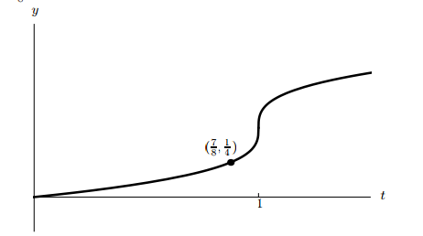

31. The derivative of a continuous function g is given by



Determine all critical points of g, and classify each as a local max, local min, or neither. Carefully explain your reasoning for each classification.

32. Using an appropriate tangent line approximation, estimate the value of each of the following quantities:

(a) (1.00013)1/9

(b) (0.99999)5

(c) e0.0007

(d) 48.9931/2

33*.* Given f(x) = x4 – 4x3 – 8x2 + 1 on the interval [-5, 5].

1. Find all critical points of *f*.
2. Determine on which intervals *f* is increasing.
3. Using the information obtained above, sketch the graph of y = f(x).

34. Given f(x) = x(x – 2)4 on the real line.

(a) Find all critical points of *f*.

(b) Determine on which intervals *f* is increasing.

(c) Sketch the graph of *f* using the above information.

35*.* Given H(x) = x + 2 sin x on the interval [0, 4].

(a) Find all critical points of *H*.

(b) Determine on which intervals *H* is increasing.

(c) Sketch the graph of *H* using the above information.

36. Given G(x) = x2 / (x2 + 3) on the real line.

(a) Find all critical points of *G*.

(b) Determine on which intervals *G* is increasing.

(c) Sketch the graph of *G* using the above information.

37. For each of the following functions, determine *where* the tangent line is horizontal. (The x-coordinates of these critical points are sufficient.)

Here, since we haven’t yet studied, the Chain Rule, you may need to be given formulae for differentiating y = (ax + b)n and y = ecx.







38. For each of the following curves, determine all local extrema. y = xe2x

1. y = x3/3 – x2/2 – 2x + 1
2. y = x + sin x on the interval [-2/3, 2 /3]
3. y = x(1 – x)2
4. y = x2(x2 – 2)

39. Sketch the curve y = 2x + cos x on the interval [0, 6]. Find all local/global extrema.

40. For which value or values of the constant *k* will the curve

y = x3 + kx2 + 3x – 4

have *exactly one* horizontal tangent?

41. Find the global extrema of y = cos x – 3x on [0, 2].

42. Sketch the graph of the function g(x) = x2(x – 1)2 on the interval [0, 2]. Locate any (and all) local and global extrema.

43. Sketch the graph of y = e2/x. Locate any local or global extrema.

44. Suppose that the derivative of the function

y = f(x) is y′ = (x – 1)2(x – 2).

Find and classify all local extrema.

45. Suppose that the derivative of the function y = g(x) is

y′ = x2(x – 2)3(x + 3).

Find and classify all local extrema.

46. Find the values of constants *a, b*, and *c* so that the graph of

y = (x2 + a) / (bx + c) has a local *minimum* at x = 3 and a local *maximum* at (-1, -2).

 Hint: Use the squeeze theorem.

48. Questions about 4 types of discontinuities and continuous extensions.

49. The quantity, *Q* mg, of nicotine in the body *t* minutes after a cigarette is smoked is given by *Q = g(t).*

(a) Using a *complete sentence*, interpret the statement g(20) = 0.36 *without using any mathematical terminology.*

(b) What are the units of dg/dt ?

(c) Using a *complete sentence*, interpret the statement g′(20) = -0.002 *without using any mathematical terminology.*

(d) *[1 pt]* Using the information that you obtained above, *estimate* g(23). *(As usual, show your work!)*



50. A scientist is growing a very large quantity of mold. Initially, the mass of mold

grows exponentially, but after many hours, the mass stabilizes at 24 kilograms.

Suppose that *t* hours after the scientist begins, the mass of mold, in kilograms, can be modeled

by the function M defined by the equation

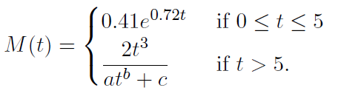

a. Find the value of k between 0 and 5 so that M(k) = 1. Then interpret the equation M(k) = 1 in the context of this problem. Use a complete sentence and include units.

b. Assuming that M is a continuous function of *t*, determine $\lim_{x→∞}{M(t)}$ and the values of *a, b,* and *c.*