# Practice Problems for TEST III

*Subject to revision*

1. Find an anti-derivative of each of the following functions. Show your work!







*Hint:* Express this as a function of sin x multiplied by cos x.

 *Hint:* Similar to (c).

2. Find the *indefinite integral* of each of the following functions. Show your work!







3. Solve the following initial value problem:

 given that y = 3 when t = 0.

4. We wish to approximate the value of



1. Sketch the curve *g(x) = 1 – 2-x* over the interval [1, 5].

Using *two rectangles* of equal base length, compute each of the following estimates:

(b) left-hand endpoints

(c) right-hand endpoints

1. midpoints

5. *Verify* the following anti-differentiation formula:



6. Using only the area interpretation of the definite integral, compute each of the following. (Sketch!)







7. Compute each of the following. *Simplify* your answers as much as possible.













8. Evaluate



by interpreting this definite integral in terms of areas. Sketch!

9. State the *two versions* of the Fundamental Theorem of Calculus.

10. Albertine has purchased a Chevy Bolt that can accelerate from 0 ft/sec to 88 ft/sec in 5 seconds. The car’s velocity is given below:

|  |  |  |  |  |  |  |
| --- | --- | --- | --- | --- | --- | --- |
| *t (seconds)* | 0 | 1 | 2 | 3 | 4 | 5 |
| *v(t) (ft/second)* | 0 | 30 | 52 | 68 | 80 | 88 |

Using five rectangles, find upper and lower bounds (that is, over and under-estimates) for the distance traveled by Albertine’s car in 5 seconds.

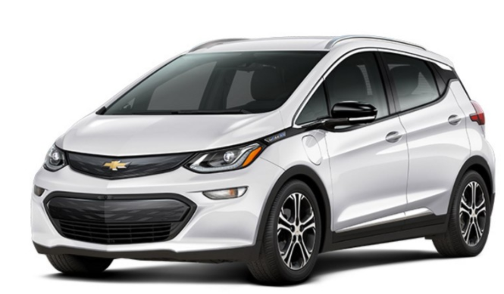

11. Using the method of judicious guessing evaluate:



12. Find an anti-derivative of each of the following functions. Show your work!

(a) tan x

(b) tan2 x

(c) sin2 x

*Hint:* Recall that 

(d) cos2 x

*Hint:* Recall that 

(e) sec4 x

*Hint:* Write sec4 x = (sec2 x)(sec2 x) and then apply a basic identity.

13. Solve the initial value problem:



given that y(1) = 13.

14. Evaluate each of the following indefinite integrals:

* 1. 
  2. 
  3. 

15. Evaluate each of the following definite integrals using *only the geometric* *interpretation* of the definite integral. Explain your solution.

(a) 

(b) 

(c) 

(d) 

16. Calculate each of the following sums. Simplify each answer.

(a) 

(b) 

(c) 

|  |
| --- |
|  |

17. Find the *average value* of the function f(x) = 4 sin 2x over the interval [0, ].

18. Compute the *average value* of the curve y = cos2 4x over the interval [0, ].

19. Evaluate each of the following.

(a)  *(and simplify)*

(b)  *(and simplify)*

(c) 

20. Consider the following table of data:

|  |  |  |  |  |  |
| --- | --- | --- | --- | --- | --- |
| x | -1.00 | -0.25 | 0.50 | 1.25 | 2.00 |
| F(x) | 0.0000 | 2.6522 | 4.8755 | 6.8328 | 8.6790 |

Approximate the area below the graph of y = F(x) above the interval [-1, 2] using:

(a) left endpoints. *Sketch.*

(b) right endpoints. *Sketch.*

21. Solve the following initial value problem:



given that y(0) = 11.

22. Verify the following integration formula:



23. At time *t*, in seconds, the velocity, *v*, in miles per hour, of Albertine’s new Prius is given by

v(t) = 5 + 0.8t2  for 0 < t < 8.

Use Δt = 2 to estimate the distance traveled during this time. Find the left endpoint and right endpoint sums, and the average of the two. *Sketch!*

24. Using the method of judicious guessing, find an *antiderivative* for each of the following functions. *Be certain to show your reasoning!*

(a) 

(b) 

(c) 

(d) 

25. Evaluate the following limit



26. (a) State **Rolle’s Theorem**.

1. Using Rolle’s Theorem, prove that the function

g(x) = (x – 2) ln (x + 1) + x sin(4x)

has *at least one* critical point between x = 0 and x = 2? Explain!

27. (a) State the **Mean Value Theorem**.

(b) Show how the Mean Value Theorem applies to the function

*f(x) = 4 + ln x* on the interval [1, e3]. Sketch! Find explicitly the *c* value.

28. Explain why any two anti-derivatives of a function F(x) must differ by a constant.

29. *(U. Michigan)* A car, initially going 100 feet per second, brakes at a constant rate (constant negative acceleration), coming to a stop in 8 seconds. Let t be the time in seconds after the car started to brake.

(a) Sketch a graph of the velocity of the car from t = 0 to t = 8, being sure to include labels.

(b) Exactly how far does the car travel? Make it clear how you obtained your answer.

30. *(U. Michigan)* Suppose dg/dx > 0 on the interval [3, 5], g(3) = 12, and g(5) = 20. We want to use a *Riemann sum* with equal-size subdivisions to approximate



If we want to guarantee that the error in our estimate is *no larger than* *¼*, then what is the minimum number of subdivisions that we must use?

31. State *three corollaries* to the Mean Value Theorem.

32. *(U. Michigan)* The rate at which a coal plant releases CO2 into the atmosphere *t* days after 12:00 am on January 1, 2017 is given by the function *E(t)* measured in tons per day. Suppose that 

(a) Give a practical interpretation of 

(b) Give a practical interpretation of E(15) = 7.1.

(c) The plant is upgrading to “clean coal” technology which will cause its July 2017 CO2 emissions to be one fourth of its January 2017 CO2 emissions. How much CO2 will the coal plant release into the atmosphere in July?

(d) Using a left-hand sum with four subdivisions, write an expression which approximates 

33. *(U. Michigan)* Suppose dg/dx > 0 on the interval [3, 5], g(3) = 12, and g(5) = 20. We want to use a Riemann sum with equal-size subdivisions to approximate



If we want to guarantee that the error in our estimate be no larger than ¼, then what is the *minimum* number of subdivisions that we must use?

34. A warehouse orders and stores boxes. The cost of storing boxes is proportional to *q*, the quantity ordered. The cost of ordering boxes is proportional to 1*/q*, because the warehouse gets a price cut for larger orders. The total cost of operating the warehouse is the sum of ordering costs and storage costs. What value of *q* gives the minimum cost?

35. For a science fair project, Albertine needs to build cylindrical cans with volume 300 cubic centimeters. The material for the side of a can costs 0.03 cents per cm2*,* and the material for the bottom and top of the can costs 0.06 cents per cm2*.* What is the cost of the least expensive can that she can build?

36. *[University of Michigan]* A hoophouse is an unheated greenhouse used to grow certain types of vegetables during the harsh midwest winter. A typical hoophouse has a semi-cylindrical roof with a semi-circular wall on each end (see figure below). The growing area of the hoophouse is the rectangle of length ℓ and width w (each measured in feet) which is covered by the hoophouse. The cost of the semi-circular walls is $0.50 per square foot and the cost of the roof, which varies with the side length ℓ, is $1 + 0.001ℓ per square foot.

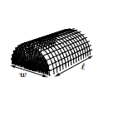

a. Write an equation for the cost of a hoophouse in terms of ℓ and w. (Hint: The surface area of a cylinder of height ℓ and radius r, not including the circles on each end, is A = 2πrℓ.)

b. Find the dimensions of the least expensive hoophouse with 8000 square feet of growing area.

37. If two resistors of R1 and R2 ohms are connected in parallel in an electric circuit to make an R-ohm resistor, the value of R can be found from the equation



If R1 is decreasing at the rate of 1 ohm/sec and R2 is increasing at the rate of 0.5 ohm/sec, at what rate is R changing when R1 = 75 ohms and R2 = 50 ohms?

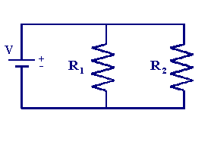

38. State the *Extreme Value Theorem.* What happens if the closed interval is replaced by an open interval? Is continuity necessary?

39. The sum of a positive number and its reciprocal is to be as small as possible. What is the number?

40. Find the point on the line y = 2x + 5 that is *closest* to the origin.

41. Find the points on the hyperbola x2/4 – y2/9 = 1 that are *closest* to the point (-1, 1).

42. Given the graph of y = F′(x) below, sketch the graphs of y = F′′(x) and y = F(x).

*y = F′(x)*



43. A plasma TV screen of height 36 inches is mounted on a wall so that its lower edge is 12 inches above eye-level of an observer. How far from the wall should the observer stand so that the viewing angle ** subtended at her eye by the TV screen is as large as possible?



|  |  |
| --- | --- |
| 44. A grain silo has the shape of a right circular cylinder surmounted by a hemisphere. If the silo is to have a volume of 504 ft3, determine the radius and height of the silo that requires the least amount of material to build. |  |

1. (a) State **Rolle’s Theorem**.

(b) Using Rolle’s Theorem, prove that the function

g(x) = (x – 2) ln (x + 1) + x sin(4x)

has *at least one* critical point between x = 0 and x = 2? Explain!

46. (a) State the **Mean Value Theorem**.

(b) Show how the Mean Value Theorem applies to the function

*f(x) = 4 + ln x* on the interval [1, e3]. Sketch! Find explicitly the *c* value.

47. Explain why any two anti-derivatives of a function F(x) must differ by a constant.

48. Define the function G on the interval [-1, 2] as follows:



(a) Explain why *G* satisfies the hypotheses of the Mean Value Theorem on the interval [-1, 2]. Sketch!

(b) Determine the value of *c* for the function *G* on the interval [-1, 2] that is guaranteed by the Mean Value Theorem.

49. Below is the graph of the derivative, F′(x), of a function F(x).

1. Sketch the graph of F′′(x).
2. Sketch the graph of F(x). Indicate local max/min, regions of increase/decrease, regions where *F* is concave up/down, and all inflection points.



50. Suppose that Charlotte, living on the x-axis, finds herself at the origin at time t = 0. In addition, assume that that her velocity (in ft/min) at time *t*, 0 ≤ t ≤ 10, is given by:



Where is Charlotte at time t = 3 minutes? t = 6 minutes? t = 10 minutes?

51. Compute and simplify fully:



1. Verify that the function  satisfies the hypotheses of the MVT on the interval [-1, 1]. Then find all numbers *c* that satisfy the conclusion of the MVT. *Sketch*.

53. (a) Use a *left-endpoint* Riemann sum with n = 4 rectangles to approximate the area between the curve f*(x) = ln x* and the x-axis over the interval [4, 6]. Draw a picture to illustrate what you are computing. Is this an *underestimate* or an *overestimate* of the area?

(b) Repeat (a) using right-endpoints

54. The graph below shows the ***velocities*** of two joggers, Albertine and Marcel, in meters per minute as they jog along the Champs-Élysées. Albertine and Marcel begin jogging from the same point at the same time.



(a) How far does Albertine jog in this 10 minute interval?

(b) How far does Marcel jog in this 10 minute interval?

(c) Who is jogging *faster* at time t = 6 minutes?

(d) Which jogger is *ahead* (i.e. has traveled the greater distance) at time t = 6 minutes? Why?

55. (Stewart) Which of the following graphs represents the set of solutions to the differential equation

x ? (You need not justify your answer.)

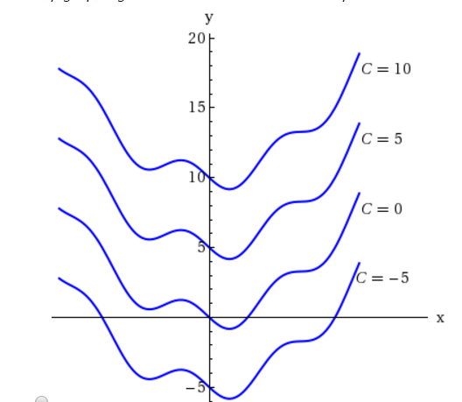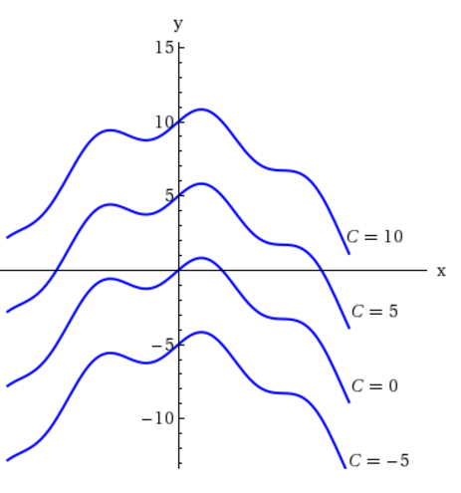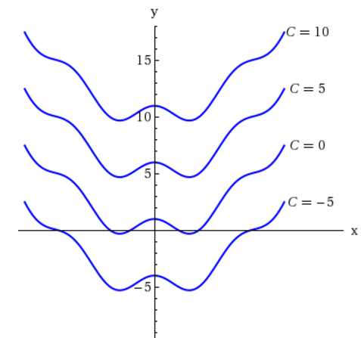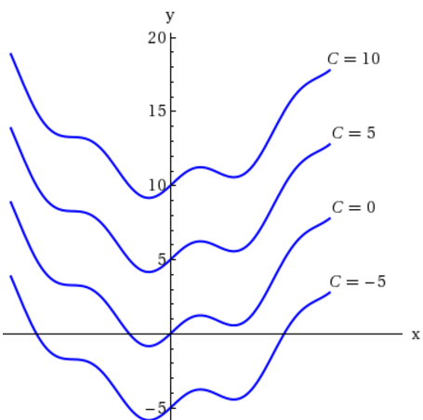

56. A car is moving along a straight road from *A* to *B*, starting from *A* at time *t* = 0. Below is the velocity (positive direction is from *A* to *B*) plotted against time.

How many kilometers away from *A* is the car at time *t* = 9? *Explain!*

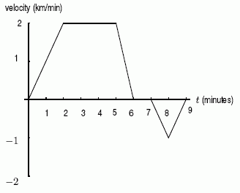

57. Consider the area between the two functions shown in figure below. Which of the following graphs (a) through (d) represents this area as a function of *x*?

1

2

1

2

3

4

*x*

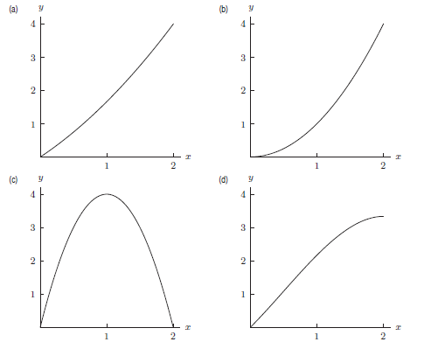

58. Consider the area between the two functions shown in the figure below. Which of the following graphs (a)–(d) represents this area as a function of *x*? *Explain!*

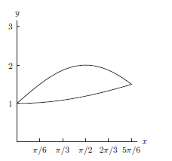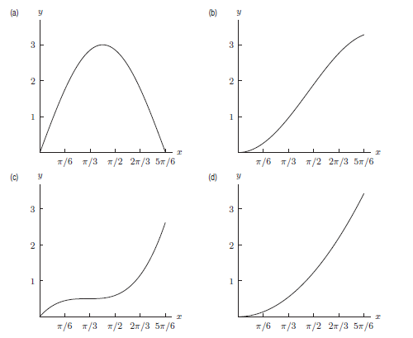

|  |
| --- |
|  |
|  |

59. Consider the area between the two functions shown in the figure below. Which of the following graphs (a)–(d) represents this area as a function of *x*? *Explain!*

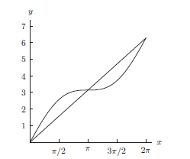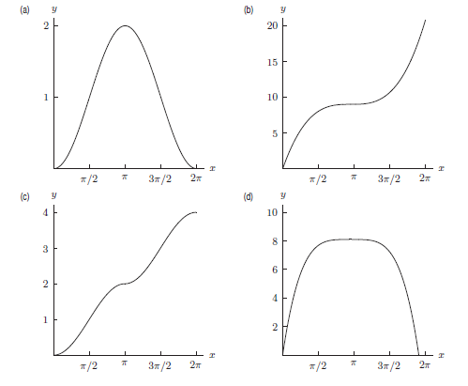

60. Compute the *average value* of the function over the interval



[1, e2]. *Simplify your answer. Sketch.*

61. Compute:





62. Let *W*(*t*) be the temperature, in degrees Fahrenheit, of a cake *t* minutes after it is put in the oven. Assume *W*(10) = 220.

1. Give a practical interpretation of the statement

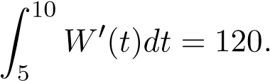

*Use complete sentences.*

1. Give a practical interpretation of the statement

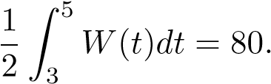

*Use complete sentences.*

1. Write a single mathematical equation describing the following statement:
2. Assuming all of the above statements in (a)-(c) are true, what will the temperature of the cake be five minutes after it is put in the oven.

*Learning without thought is labor lost; thought without learning is perilous.*

- Confucius