# MATH 161 Solutions: QUIZ II 8th September 2017

**(Calculator Free)**

1. *[10 pts]* The graph of a rational function is shown below. Assume that

zeroes: x = 0, x = 3

singularities: x = -2, x = -4

limiting behavior: y → 3 as |x| → ∞

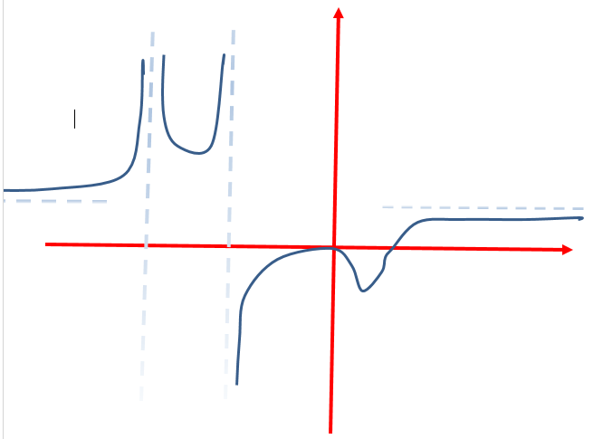

Find an equation of a rational function that incorporates all of this information. (Note that this problem has more than one correct answer.)

***Solution:***

*Given the information about the zeros, we find that x and x + 3 must be factors of the numerator.*

*Given the information about the singularities, x + 2 and x + 4 must be factors of the denominator.*

*Since the zero at x = 0 does not create a sign change, we find that x2 or any even power of x, must be a factor of the numerator. Since the singularity at x = -4 also results in no sign change, we find that (x + 4)2 or any even power of x + 4, must be a factor of the denominator.*

*So our first guess is:*



*Noting that the value of y as x → ∞ is 1, we have only to make one change:*



*Of course, there are infinitely many other functions that would satisfy the requirements.*

2. *[6 pts each]* Compute each of the following limits. *Explain your reasoning*.



*Solution: Observe that:*





*Solution: Observe that, as long as x ≠ 2:*





*Solution: Observe that, as long as x ≠ 5:*





*Solution: We begin by rationalizing the numerator of the algebraic expression. Then we assume that, as long as x ≠ 0:*



3. *[8 pts*] Does $\lim_{x→1}{g\left(x\right)}$ exist given that



If so, find it; if not explain! (*Hint:* Factor first.)

*Solution: Let’s begin by factoring, noting that the denominator is a difference of two squares.*



*Now, as x →1, we can cancel the x – 1 factor occurring both in the numerator and the denominator.*

*So, for x ≠ 1:*

**

*Now, as x →1, g(x) → 2/4 = ½ .*

*Thus $\lim_{x→1}{g\left(x\right)}$ exists and equals* ***½****.*

*Extra Credit:* *University of Michigan* calculus problem (first exam, 7 Oct 2014)

Consider the function y = h(x) defined by:

$$h\left(x\right)=\left\{\begin{aligned}\frac{60\left(x^{2}-x\right)}{\left(x^{2}+1\right)\left(3-x\right)} for x<2 \\ \\ 9 for x=2 \\ \\ 5e^{ax}-1 for x>2\end{aligned}\right.$$

***Solution:*** *In order for $\lim_{x→2}{h(x)}$ to exist, it must be true that $\lim_{x→2+}{h(x)}\underset{ x→2-}{=lim}{h(x)}$*

*Now = 60(22 − 2) /((22 + 1)(3 − 2)) = 24 and $\lim_{x→2+}{h(x)}$ = 5e 2a − 1.*

*So it follows that 5e 2a − 1 = 24.*

*Solving for a, we have 5e 2a − 1 = 24; e 2a = 5; thus a = ln(5)/2 ≈ 0.804.*

