# **MATH 161 Solutions: QUIZ III**

# **15 September 2017**

1. (a) *[4 pts ]* *Carefully* state the *Intermediate Value Theorem*.

*Theorem: Let y = f(x) be a continuous function on an interval [a, b]. Let z be any number between f(a) and f(b). Then there exists a number c in the interval [a, b] for which f(c) = z.*

(b) *[5 pts]* Using the IVT explain why the function f(x) = x + 3 – 2 sin x must have *at least one real root.*

***Solution:*** *Note that f(0) = 3 > 0 and G() = 3 + 3 – 2 sin x > 6 – 2 = 4 > 0*

*Also note that f is continuous on the interval [0, ]. Since G(4) < 0 < G(), the IVT guarantees the existence of a root of the equation G(x) = 0 in the interval [0, ].*

**2**. *[5 pts]* Using the *Squeeze Theorem*, show that the function



has a limit as x → 0 and find the value of this limit. (You need not state the general theorem; only show how it can be applied here.)

***Solution:*** *First, a brief review of the Squeeze theorem.*

*Theorem: Let v(x), z(x), u(x) be functions defined on an interval (a, b) except possibly at the point p, where p(a, b)*

*In addition, assume that*

**

*Then*

**

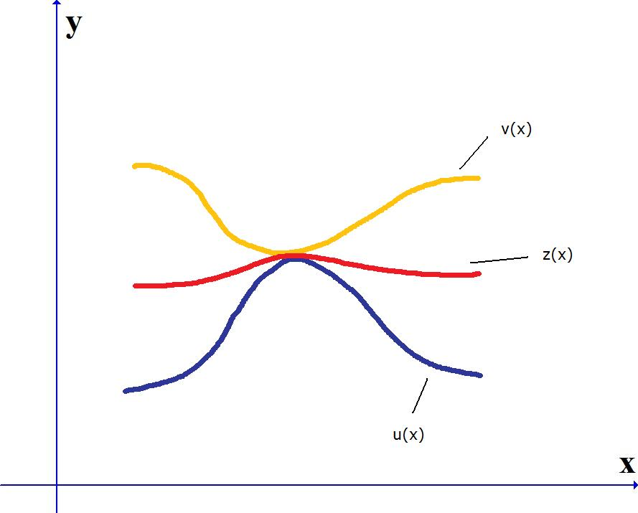

*Returning to the original question:*

*Using the Squeeze Theorem, find .*

*Solution:*

**

*Now, as x → 0, 3x4 → 0 and - 3x4 → 0.*

*Thus, invoking the Squeeze Theorem, we obtain:*

**

3. *[12 pts]* Compute each of the following limits. As usual, show your work.

(A) 

***Solution:*** *Since* *we can use the limit law for quotients:*

**

(B) 

***Solution:*** 

(C) 

***Solution:*** *Since* we can use the limit law for quotients:



4. *[6 pts]*  For the graph of y = f (x) in the figure below, arrange the following numbers from ***smallest to largest:***

**A** The slope of the curve at A.

**B**  The slope of the curve at B.

**C** The slope of the curve at C.

**AB** The slope of the line *AB*.

1. The number 0.
2. The number 1.

Explain the positions of the number 0 and the number 1 in your ordering. Any unclear answers will not receive credit.

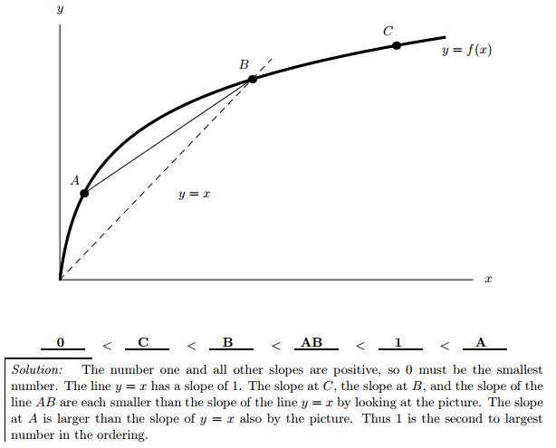



**5.** *[2 pts]*  To find the derivative of at *x* = 8 algebraically, one must evaluate the following expression.



$$\left(A\right) \lim_{h→0}{\frac{2{(8+h)}^{2}+5\left(8+h\right)-(2∙ 8^{2}+5∙ 8-9)}{h}}$$

(B) (C)



(D) All of the above are correct. (E) None of the preceding is correct

* *Explain how you arrived at your answer!*

***Solution:*** *The correct answer is (E):* **None of the preceding is correct**.

*Note that (A) is not correct since it is missing -9: The correct version of (A) is:*

$$\lim_{h→0}{\frac{2{(8+h)}^{2}+5\left(8+h\right)-9-(2∙ 8^{2}+5∙ 8-9)}{h}}$$

***6.*** *[2 pts]* Given the following data about a function *f*(*x*), the equation of the tangent line at *x* = 5 is approximated by

|  |  |  |  |  |  |  |  |
| --- | --- | --- | --- | --- | --- | --- | --- |
| *x* | 3 | 3.5 | 4 | 4.5 | 5 | 5.5 | 6 |
| *f*(*x*) | 10 | 8 | 7 | 4 | 2 | 0 | -1 |

(A) (C)



(B) (D)



* *Explain how you arrived at your answer!*

***Solution:*** *Approximating the slope of the curve y = f(x) at x = 5:*

$f^{'}\left(5\right)≈\frac{f\left(5.5\right)-f\left(5\right)}{5.5-5}=\frac{0-2}{0.5}$ = -4 or $f^{'}\left(5\right)≈\frac{f\left(4.5\right)-f\left(5\right)}{4.5-5}=\frac{4-2}{-0.5}$ = -4

$$So the slope of the tangent line to y=f\left(x\right) at x=5 is approximately-4.$$

$$Note that f(5)=2.$$

*Using point-slope form: y – 2 = -4(x – 5)*

*So the correct choice is (C).*

***7***. *[University of Michigan]* Odette, a dare devil, jumps off the side of a bungee jumping platform while attached to a magically elastic bungee cord. Just a few moments after the jump begins, a timer is started and her position is recorded. At *t* seconds after the timer begins, her distance in feet below the platform is given by the function

*J* (*t*) = −150 cos(0*.*125*π*(*t* + 3)) + 150*.*

A portion of the graph of *y* = *J*(*t*) is shown below.

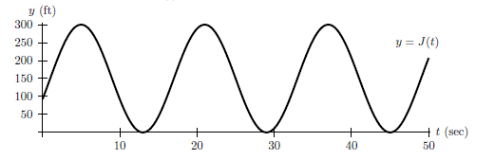

*Throughout this problem, do not make estimates using the graph.*

1. *[2 pts]* Compute the *average* velocity of the bungee jumper during the first 16 seconds after the timer begins.

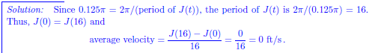



1. *[3 pts]* Compute the *average speed* of the bungee jumper during the first 16 seconds after the timer begins.

*Hint:* Recall that *average speed* over an interval of time is given by $\frac{distance traveled}{time elapsed}.$

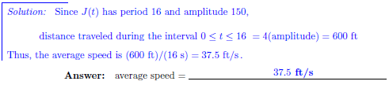

1. *[4 pts]* Use the *limit definition* of instantaneous velocity to write an explicit expression for the instantaneous velocity of the bungee jumper 2 seconds after the timer begins. *Your answer should not involve the letter J. Do not attempt to evaluate or simplify the limit.*



1. *[2 pts]* Find all values of *t* in the interval 0 ≤ *t* ≤ 30 when the instantaneous velocity of the bungee jumper is 0 feet per second.

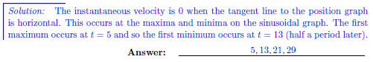



*The more you know, the less sure you are.*

**-** [Voltaire](http://plato.stanford.edu/entries/voltaire/)