MATH 161 Solutions: quiz v

Problems 1 – 3 are worth 1 pt each
Hint: It may be helpful to think about $\frac{d}{dx} f(g\left(x\right))$

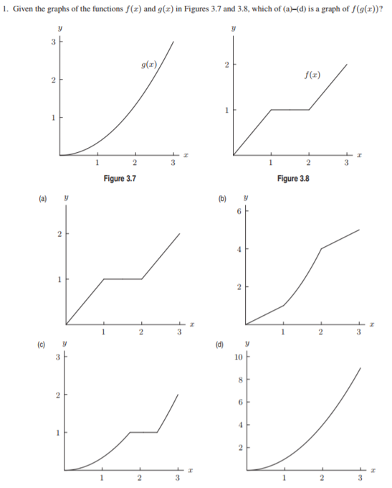
Solution: (c)
Because $\frac{d}{dx}f\left(g\left(x\right)\right){=f}^{'}\left(g\left(x\right)\right)g^{'}\left(x\right), we note that f\left(g\left(x\right)\right)has a horizontal tangent whenever g^{'}\left(x\right)=0 or f'(g\left(x\right))=0.$
Now $f^{'}\left(g(x)\right)=0 for 1<g\left(x\right)<2, and this approximately corresponds to 1.7<x<2.5.$

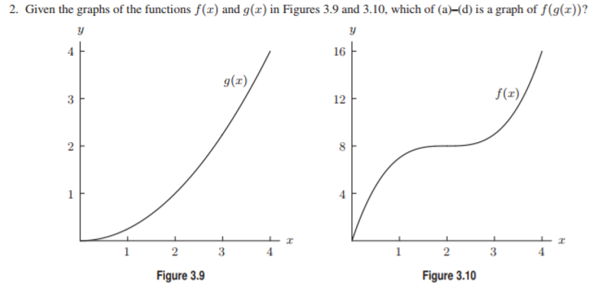
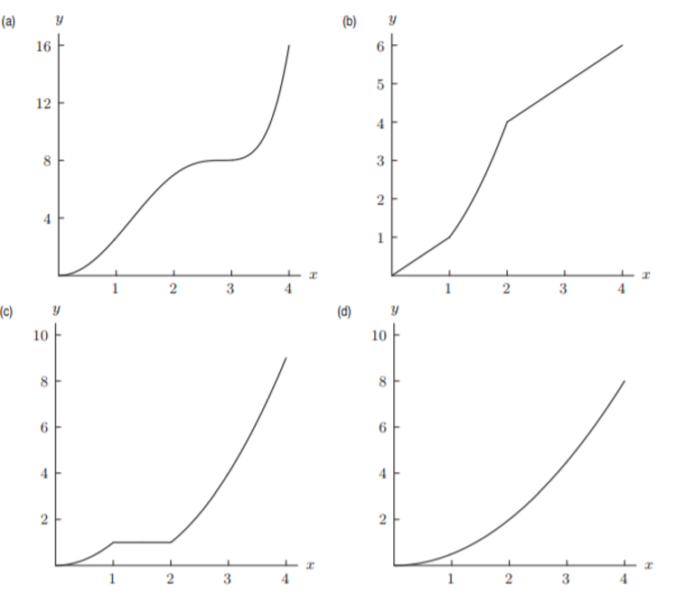

Solution: (a)
Because $\frac{d}{dx}f\left(g\left(x\right)\right){=f}^{'}\left(g\left(x\right)\right)g^{'}\left(x\right), we note that f\left(g\left(x\right)\right)has a horizontal tangent whenever g^{'}\left(x\right)=0 or f'(g\left(x\right))=0.$
Now $f^{'}\left(x\right)=0 only when x=2, so the composite function has horizontal tangents only when g^{'}\left(x\right)=0 or when g\left(x\right)=2.$

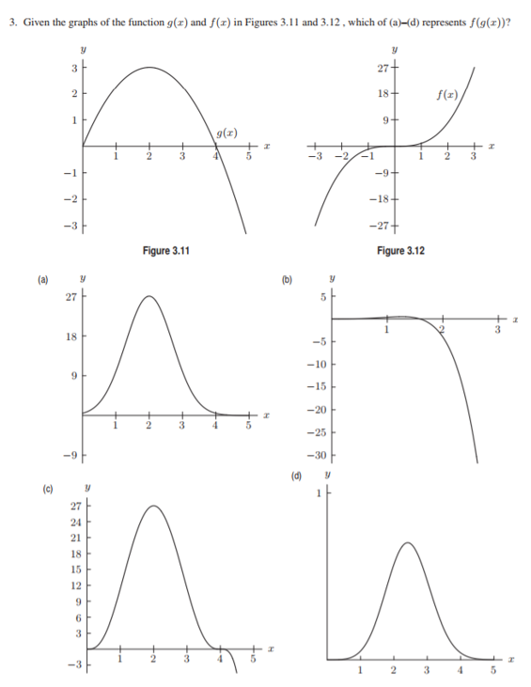

Solution: (c)
Because $\frac{d}{dx}f\left(g\left(x\right)\right)=f^{'}\left(g\left(x\right)\right)g^{'}\left(x\right), we note that f\left(g\left(x\right)\right)has a horizontal tangent whenever g^{'}\left(x\right)=0 or g\left(x\right)=0.$
This happens when x = 0, 2, and 4. Also, f(g(x)) is negative for x > 4. Alternatively f(g(4)) = f(0) = 0 identifies answer (c).

4. [3 pts each] Find an anti-derivative of each of the following:

(a) 1 + 3x² – 9x⁵

Answer: $x+x^{3}- \frac{3}{2} x^{6}$

- 3 sin (5x)

Answer: $-\frac{3}{5}cos⁡(5x)$

- 1 +3e^{x} + 4 cos x

Answer: $x+3e^{x}$ + 4 sin x

- $\frac{4}{x}$

Answer: $4\ln{x}$

- $\frac{3}{1+x^{2}}$

Answer: $3\arctan{x}$

- 1 + sec² x

Answer: $x+\tan{x}$

5. [5 pts] Find any and all critical points of the function $f(x)={\left(2x-3\right)}^{3}e^{x}$

Solution:

$$f^{'}\left(x\right)={\left(2x-3\right)}^{3} e^{x}+3{\left(2x-3\right)}^{2}2e^{x}={\left(2x-3\right)}^{2} \left(2x-3+6\right)e^{x}=$$

$${(2x+3)\left(2x-3\right)}^{2}e^{x}$$

Hence the critical points are x = -3/2 and x = 3/2.

6. [5 pt each] Using implicit differentiation, find the equation of the tangent line to the curve y⁴ + xy = 4 at the point P = (3, 1)

Solution: d/dx (LHS) = d/dx (RHS)
$$4y^{3}y^{'}+xy^{'}+y=0$$
Substituting x = 3 and y = 2: $$4y^{'}+3y^{'}+1=0$$

Hence dy/dx = -1/7 and the tangent line is:

y – 1 = - (1/7) (x – 3)

7. [3 pts each] Find the derivative of each of the following functions. You need not simplify.

- $y=\frac{x}{\sqrt{x-1}}$

Solution:
$\frac{dy}{dx}=\frac{\sqrt{x-1}-x\frac{d}{dx}{(x-1)}^{1/2}}{x-1}=\frac{\sqrt{x-1}-x\frac{1}{2}{(x-1)}^{-1/2}}{x-1}$=

$\frac{\sqrt{x-1}-x\frac{1}{2}{(x-1)}^{-1/2}}{x-1}$=$\frac{ \sqrt{x-1}-x\frac{1}{2}{(x-1)}^{-1/2}}{x-1}$= $\frac{ 2\left(x-1\right)-x}{{\left(x-1\right)}^{3/2}}=\frac{x-2}{{\left(x-1\right)}^{3/2}}$

- y = arctan(1+e^{2x})

Solution: $\frac{dy}{dx}=$ $\frac{{2e}^{2x}}{1+e^{4x}}$

- $y=ln(\sin{x)}$

Solution: $\frac{dy}{dx}=$ $\frac{\cos{x}}{\sin{x}}=\cot{x }$

- y = sec(1 + 3ln x)

Solution: $\frac{dy}{dx}=$ $\frac{3}{x}sec⁡(1+3\ln{x)}\tan{x(1+3\ln{x)}}$

