# MATH 161 Solutions: QUIZ VII

# 

# 27 October 2017http://ts1.mm.bing.net/th?&id=HN.608049266438177658&w=300&h=300&c=0&pid=1.9&rs=0&p=0

*I hear and I forget.*

*I see and I remember.*

*I do and I understand.*

- Chinese Proverb.

*1. [20 pts]* Find two *non**-negative* real numbers whose sum is 13 such that the product of one number and the square of the other number is a *maximum*.

**Reminder:** Introduce your variables; state what is given; state your objective. *Find an equation of one-variable which must be maximized.* Also find the *constraints* placed upon your variable. Do not omit steps. Express answers to the nearest tenth.

*Solution:*

*We are given the constraints: x > 0, y > 0, and x + y = 13.*

*Our goal is to maximize the product, P = xy2.*

*Also note that 13 > x > 0, and 13 > y > 0 (Why?)*

*Solving for y in terms of x: y = 13 – x and then substituting into the formula for P yields:*

*P = x(13 – x)2 with domain (0, 13).*

*Since*

*dP/dx = (13 – x)2 + x (-2)(13 – x) =*

*(13 – x) (13 – x – 2x) =*

*(13 – x)(13 – 3x),*

*the critical point is x = 13/3.*

*(Note that x = 13 is not a critical point as it is an endpoint.)*

*Performing a sign analysis on dP/dx, we see that,*

*P is rising on (0, 13/3) and falling on (13/3, 13).*

*Thus P achieves a global maximum at x = 13/3; now y = 13 – x = 26/3.*

*So P is maximized when one number is* ***13/3*** *and the other is* ***26/3****.*

*FYI here is the graph of y =P(x):*



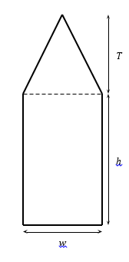*2. [20 pts]* Consider a window the shape of which is a rectangle of height *h* surmounted by a triangle having height *T* that is **three times** the width *w* of the rectangle (see the figure below which is not drawn to scale). If the *total* area of the window is **8 square feet**, determine the dimensions of the window which minimize the perimeter.

**Reminder:** Introduce your variables; state what is given; state your objective. *Find an equation of one-variable which must be minimized.* Also find the *constraints* placed upon your variable. Do not omit steps. Sketch the graph of the function of one variable that you must then minimize. Use *appropriate units.* Express answers to the nearest tenth.



*Solution:*

*Let w = width, T = altitude of the triangle and h = height of the window, each in feet, as shown above. Let A = area of the window*

***Given:*** *A = 8 and T = 3w.*

***Goal:*** *Minimize perimeter, P.*

*Area = wh + ½ wT = wh + (3/2) w2*

*So wh + (3/2) w2 = 8 (**)*

*Let x be the common side of the isosceles triangle.*

*Then T2 + (w/2)2 = x2.*

*Since T = 3w,*

*x2 = 9w2 + w2/4 = (37/4) w2 and so   
The perimeter, P(w, h) = w + 2h + $w\sqrt{37}$*

*Solving for h in the Area equation (**) we obtain:*

$h=\frac{8 - \frac{3}{ 2 }w^{2}}{w} =\frac{8}{w}-\frac{3}{ 2 }w$

*Constraint on w:*

*Since h ≥ 0, we have: $\frac{8}{w}-\frac{3}{ 2 }w$ > 0 $⇒ w^{2}<\frac{16}{3} ⇒0<w<\frac{4}{3}\sqrt{3} ≈2.31$*

*So what remains is to find the global min of the curve*

$P\left(w\right)=$***w + 2h + $w\sqrt{37}$***

$$=w+2\left(\frac{8}{w}-\frac{3w}{2}\right)+w\sqrt{37} = \frac{16}{w}+w\left(\sqrt{37}-2\right)$$

$$subject to the constraint 1.29<w<2.31 feet$$

*Here is the graph of P = P(w) graphed on a larger domain (for clarity).*



*Next we anticipate one critical point, which, if such is the case, would be the global minimum.*

$\frac{dP}{dw}=-\frac{16}{w^{2}}+\left(\sqrt{37}-2\right)$*w*

*Setting $\frac{dP}{dw}=0, we find w=\sqrt[3]{\frac{16}{\sqrt{37}-2}}≈1.58 feet$*

Extra Credit: *[University of Michigan]*  The figure below is comprised of a ***rectangle* *and four* *semi-circles***. Units of length are given in meters.

|  |  |
| --- | --- |
|  | 1. *[2 pts]* Find a formula for the enclosed area, *A*, of the figure in terms of *x* and *y*.   *Solution: A = xy + (x/2)2 +  (y/2)2 =*  ***xy + ( /4) (x2 + y2)*** |

1. *[2 pts]* Find a formula for the perimeter, *P*, of the figure in terms of *x* and *y*. (*Note*

The perimeter does *not* include the dashed lines.)

*Solution: P =  x +  y =* *** (x + y)***

1. *[10 pts]* Find the values of *x* and *y* which will *maximize* the area if the perimeter is 200 meters.

*Solution: Solving for y in part (b): y = P/ – x = 200/ – x*

*Substituting this expression for x in part (a):*

*A = (200/ – x) x + ( /4) x2 + ( /4) (200/ – x)2*

*= (200/ x – x2 + ( /4)x2 + ( /4) (200/ – x)2*

*= ( /2 – 1) x2 + (200/ – 100)x + 10000/*

*Note that the domain of A is given by 0* ≤ *x ≤ 200/*

*Computing dA/dx:*

*dA/dx = ( – 2) x + (200/ – 100) =*

*( – 2) x + 100/ (2 – ) =*

*( – 2)(x – 100/)*

*The critical point of A is x = 100/. Note that when x < 100/, dA/dx < 0 and when x > 100/, dA/dx > 0. Hence A achieves a local* ***minimum*** *at the critical point. Hence the maximum of A must be achieved at an end point. Because of symmetry, the value of A at each end point is the same.*

***Thus the maximum value of A is achieved when the figure reduces to a circle.***

*Here is a graph of A as a function of x.*

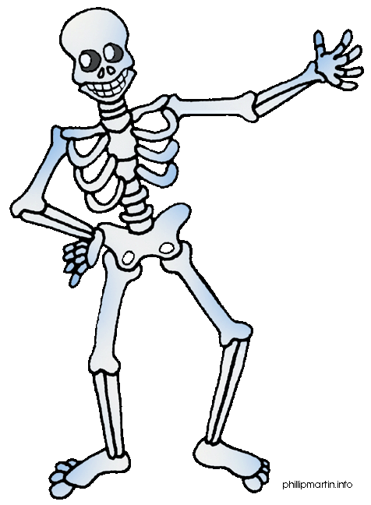





*Happy Halloween!*