# MATH 161 Solutions: Quiz VIII 3November 2017

1. *[2 pts]* What does the following figure represent? *Explain briefly.*

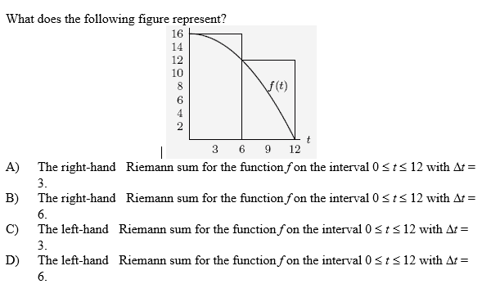

*Answer:* ***(D)*** *is the correct answer. The two rectangles are of width 6 and each is left-hand.*

1. *[2 pts each]* Using the given graphs, draw rectangles representing each of the following Riemann sums for the function on the interval [0, 12]. *Calculate the value of each Riemann sum.* (You may leave your answer in non-simplified form if you have no time to perform the addition.)
2. Left end-point sum with $∆t=3$.

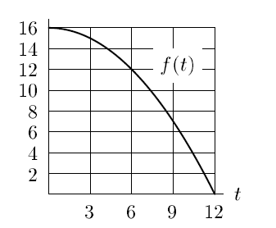

*Solution:*

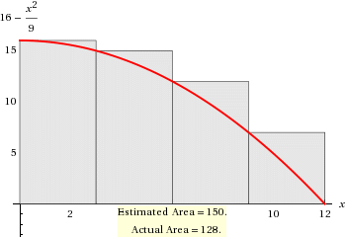

***This is an overestimate.***

1. Right end-point sum with $∆t=3$.



*Solution:*

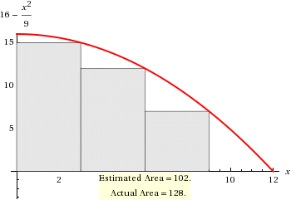

***This is an underestimate.***

1. Left end-point sum with $∆t=6$.



*Solution:*

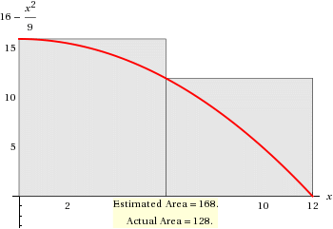

***This is an overestimate.***

1. Right end-point sum with $∆t=6$.



*Solution:*

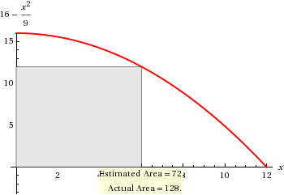

***This is an underestimate.***

1. *[3 pts each]* Compute each of the following sums. *Show your work!* ***Simplify*** *your answers as much as possible.*

(a) 

*Solution:*

**

(b) 

*Solution:*



(c) 

*Solution:*



*This is called a “telescoping” sum.*

1. *[University of Michigan]* *[6 pts]* Find the (*exact* value of the) area beneath the following function over the interval [0, 10]. *Show your work!* If time permits, do the arithmetic.

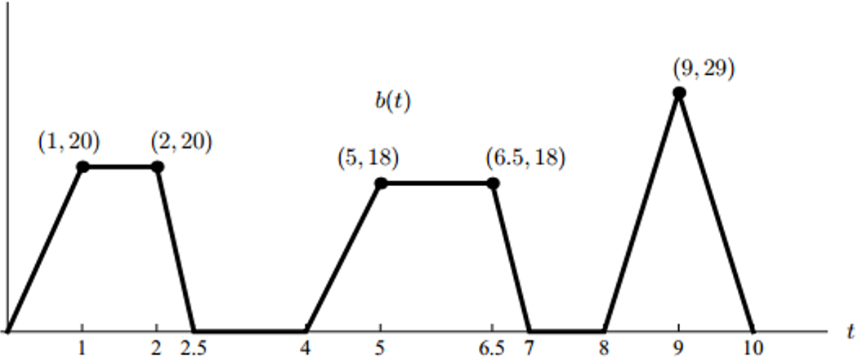

*Solution: Adding the areas of each of the two trapezoids and the triangle yields:*

*A = 35 + 40.5 + 29 = 104.5 square units*

*Alternatively, one can compute the area of five triangles and two rectangles.*

5. *[5 pts]* Evaluate

*Solution:*



6. *[5 pts]* Albertine *claims that* the following anti-differentiation formula is correct:



Determine whether Albertine is correct or mistaken. *You must show your work to earn credit.*

*Solution: Differentiating the right-hand side (using the product rule)*



*Hence Albertine is correct!*

7. *[5 pts]* Solve the following initial value problem:



*Solution: $Using judicious guessing,$*

$y= \int{\left({(1+3x)}^{48}+x+5\right) dx=\frac{{(1+3x)}^{49}}{49(3)}+\frac{x^{2}}{2}}+5x+C$*.*

*Using the initial condition, $\frac{1}{98}= \frac{{(1+3(0))}^{49}}{49(3)}+\frac{0}{2}+5\left(0\right)+C=\frac{1}{49(3)}+C$*

*Hence C= $\frac{1}{98}- \frac{1}{49\left(3\right)}=\frac{1}{2\left(49\right)}- \frac{1}{49\left(3\right)}=\frac{1}{49}\left(\frac{1}{2}-\frac{1}{3}\right)=\frac{1}{49\left(6\right)}=\frac{1}{294}$.*

*Finally, the solution to the initial value problem is*

$y= \frac{{(1+3x)}^{49}}{147}+\frac{x^{2}}{2}+5x+\frac{1}{294}$*.*

***Common integration is only the memory of differentiation.***

**- Augustus de Morgan**

