# MATH 161 Solutions: TEST III 18 November 2017

*revised: 27 November*

***Instructions:*** Answer any 9 of the following 12 problems. You may answer more than 9 to earn extra credit.



*Thus mathematics may be defined as the subject in which we never know what we are talking about, nor whether what we are saying is true.*

– [Bertrand Russell](http://plato.stanford.edu/entries/russell/)

1. *[University of Michigan]* No matter what is done with the other exhibits, the octopus tank at the Lincoln Park Zoo must be rebuilt. (The current tank has safety issues, and there are fears that the giant octopus might escape!) The new tank will be 10 feet high and box-shaped. It will have a front made out of glass. The back, floor, and two sides will be made out of concrete, and there will be no top. The tank must contain at least 1000 cubic feet of water. If concrete walls cost $2 per square foot and glass costs $10 per square foot, use calculus to find the dimensions and cost of the least-expensive new tank. *[Be sure to show all work.]*



**GIANT OCTOPUS (Enteroctopus)**

*Solution:*

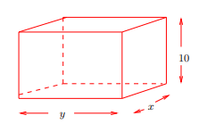

Let *x* be the width of the tank, and let *y* be the length of the tank (both in feet).

The height of the tank is given as 10 feet.

We know that the volume of the tank must be at least 1000 cubic feet, so let V denote the desired volume of the tank, where V ≥ 1000.

Then, for a fixed value of V, we know that 10xy = V, so that x and y are related by the equation $x=\frac{V}{10y}$. Now assuming that one of the y × 10 sides is the front of the tank (i.e., the glass panel), the total cost of the tank is given by:

C = 10(10y) + 2[(2)10x + 10y + xy] = 120y + 40x + 2xy.

Substituting for x, we can write C as a function of one variable:

$C(y)=120y+\frac{4V}{y}+\frac{V}{5}$.

Since the cost function increases as V increases, in order to minimize the cost of building the tank we must have V be as small as possible, so we set V = 1000.

Our cost equation is now:

$$C(y)=120y+\frac{4000}{y}+200.$$

Taking the derivative:

$\frac{dC}{dy }=120-\frac{4000}{y^{2}}$

and setting the derivative equal to 0:

$120-\frac{4000}{y^{2}}=0$

We find that the cost function has a unique positive critical point at

$$y=\sqrt{\frac{100}{3}} ≈5.774 feet$$

Since the second derivative $\frac{d^{2}C}{{dy}^{2}}=\frac{8000}{y^{3}}>0 for all y>0, we know$ that C(y) is concave up on (0, ∞). By the second-derivative test, our unique critical point must be a local (and in this case, global) minimum.

Solving for x, we find x ≈ 17.321 feet.

Thus, the glass side is the small side, and the dimensions and cost are:

**Dimensions: 5.774 $×$ 17.321** x **10 feet**

**Minimum Cost: $ 1585.7**

2. *[University of Michigan]* It is estimated that the rate at which people in the land of Oz will visit a new theme park is given by



where A and B are both constants and r(t) is measured in people/day, and t = 0 corresponds to opening day.

(a) Write an integral that gives the total number of people visiting the park in the first year it is open. Do not try to evaluate the integral!

*Solution:*

The total number of people visiting the park in the first year is $\int_{0}^{365}{r\left(t\right)dt}$

(b) Suppose that A = 100 and B = 5. Given that



use the Fundamental Theorem of Calculus to evaluate how many people visit the park during the first year it is open. Make sure you clearly indicate your use of the theorem.

*Solution:*

*Let R(t) = 200 ln ($1+Be^{-0.5t})-200\ln{(}Be^{-0.5t})$.*

*Then $R'$ (t) = r(t), so the First Fundamental Theorem of Calculus says that*

*365 0 r(t) dt = R(365) − R(0) = 36, 141. $\int_{0}^{365}{r\left(t\right)dt}=R\left(365\right)-R\left(0\right)=36,141.$*

*So 36,141 people visit the theme park during its first year.*

3. *(a)* (MIT) Express the area A between the two curves as a (single) Riemann integral. *Sketch!* Do not evaluate.

y = 1 + x2, y = 3 + x

*Solution:*

Solving for points of intersection:

1 + x2 = 3 + x

x2 – x – 2 = 0

(x – 2) (x + 1) = 0

x = -1, 2



*Hence the area between the two curves is represented by the Riemann integral:*



(b)Compute the *average value* of the function $f\left(x\right)=\frac{{(lnx)}^{3}}{x}$ over the interval [1, e2]. *Simplify your answer. Sketch.*

*Solution:*



4. *[University of Michigan]* The following two parts are independent..

*Find*  

*Solution: Using the basic properties of the Riemann integral:*

$$3\int_{-1}^{1}{f\left(x\right)dx= 2+}\int_{-1}^{1}{\left(4g\left(x\right)-x\right) dx}=2+4\int_{-1}^{1}{g\left(x\right)dx+}\int_{-1}^{1}{x dx=}$$

$$2+4\left(7\right)+0=30$$

Thus $\int_{-1}^{1}{f\left(x\right)dx= 10}$

(b) Let $F\left(x\right)=\int_{0}^{x}{e^{-t^{2}}}dt$

1. Find $F'\left(1\right)$

*Solution: Using the FTC, version 2:*

$$F'\left(x\right)=e^{-x^{2}}$$

So $$F'\left(x\right)=\frac{1}{e}$$

1. Find $F''\left(1\right)$

*Solution:*

So

5. (a) Verify that $f\left(x\right)=\frac{x}{x+2}$ satisfies the hypotheses of the Mean Value Theorem on the interval [1, 4] and then find all of the values, c, that satisfy the conclusion of the theorem.

*Solution: Since f(x) is a rational function with a single singularity at x = -2, f(x) is continuous on [1, 4] and differentiable on (1, 4). Thus y = f(x) satisfies the hypotheses of the MVT.*

*Next, $f^{'}(x)=\frac{\left(x+2\right)\left(1\right)-x\left(1\right)}{{\left(x+2\right)}^{2}} = .$*

To find the desired value(s) of c, we must solve: $f^{'}(c)=\frac{f\left(4\right)-f(1)}{4-1}$. Equivalently:

$$\frac{2}{{\left(c+2\right)}^{2}}=\frac{\frac{2}{3}-\frac{1}{3}}{3}=\frac{1}{9}$$

So, cross multiplying: ${\left(c+2\right)}^{2}$ = 18, from wich we find $c+2=±\sqrt{18}=±3\sqrt{2}.$

Hence $c=-2±3\sqrt{2}$ We must reject the negative root, $c=-2-3\sqrt{2}$ since it does not lie in (1, 4). Now $-2+3\sqrt{2}≈2.24$ $lies withing the interval \left(1, 4\right), and the c that we seek is: c=-2+3\sqrt{2}$

(b) Let f(x) = tan x. Show that f(π) = f(2π) = 0 but there is no number c, where  < c < 2 such that f ′(c)=0. Why does this not contradict Rolle's theorem?

*Solution:*

First f() – f() = tan  – tan 2 = 0 – 0 = 0. Yet there is no solution to the equation

(d/dx) tan x = sec2 x = 0, since |sec t| ≥ 1 for all t.

This does not contradict Rolle’s theorem because f(x) is not defined at 3/2; so of course f is not continuous on [, 2].

(c) Show that there is no value *c*, where 1 < c < 4, such that

$$f^{'}\left(c\right)=\frac{f\left(4\right)-f(1)}{4-1}$$

Why is this not a contradiction of the Mean Value Theorem?

*Solution:*

*We are asked whether the equation $$f^{'}\left(c\right)=\frac{f\left(4\right)-f(1)}{4-1}$$*

has a solution in the interval (1, 4)?

Equivalently, is there a solution to the equation -2(c – 3)-3 = where 1 < c < 4 ?

Cross-multiplying: -8(c – 3)-3 = 1

Yet c = -1 does not lie in the given domain of f(x)..

This does not contradict the MVT since y = f(x) is undefined at x = 3, and so is not continuous on [1, 4].

6. (a) Solve the initial value problem:

$$\frac{dy}{dt}=\sin{4t +\frac{1}{\cos^{2}t}}$$

subject to the condition: y(/4) = 5.

*Solution:*

Using the method of judicious guessing we solve the differential equation:

$\frac{dy}{dt}=\sin{4t +\frac{1}{\cos^{2}t}}=\sin\left(4t\right)+\sec^{2}{x}$, to obtain:

$$y=-\frac{1}{4}\cos\left(4t\right)+\tan{t +C.}$$

To find C, we apply the initial conditions:

$$5=-\frac{1}{4}\cos\left(4\left(\frac{π}{4}\right)\right)+\tan{\frac{π}{4} +C.}$$

Hence $C=5+\frac{1}{4} \left(-1\right)-1 ⇒C=\frac{15}{4}$

Finally, our solution is: $y=-\frac{1}{4}\cos\left(4t\right)+\tan{t +\frac{15}{4}}$

(b) Find the **exact** value of c such that



*Solution:*

$$\int{x^{3/2} dx}=\frac{x^{5/2}}{5/2}=\frac{2}{5} x^{5/2}$$

*Hence $\int_{0}^{c}{x^{3/2}} dx=\frac{2}{5} c^{5/2}$ so we must solve the equation*

$$\frac{2}{5} c^{5/2}=\frac{4}{5}$$

Or equivalently .

7. (a) Find

*Solution: Using the FTC, second version:*

$$\frac{d}{dx} {\int_{3}^{x}{(ln⁡(t}}^{5}+t+9)-\sin\left(\cos{t)}+1 \right)dt$$

$${=\ln{(x}}^{5}+x+9)-sin⁡(\cos{x)}+1 )$$

(b) Evaluate $\int_{0}^{5 }{\left|7-2x\right| dx}$

*Solution: Splitting the region into two triangles:*

$$\int_{0}^{5 }{\left|7-2x\right| dx}=\frac{1}{2}\left(\frac{7}{2}\right)\left(7\right)+\frac{1}{2}\left(\frac{3}{2}\right)\left(3\right)=\frac{49}{4}+\frac{9}{4}=\frac{29}{2}=14.5$$

(c) Evaluate $\int_{0}^{5 }{\left(1+2\sqrt{25-x^{2}}\right) dx}$

*Solution:*

$\int_{0}^{5 }{\left(1+2\sqrt{25-x^{2}}\right) dx}=\int_{0}^{5 }{1 dx}+2\int_{0}^{5 }{\sqrt{25-x^{2}} dx}$ =

$$5+2\left(\frac{1}{4}\right)π{(5)}^{2}=5+\frac{25}{2}π$$

(d) **REVISED:** Evaluate $\int_{-4}^{4 }{\left(3+\frac{x^{5}\cos^{2}{x} }{4+3\sin^{4}x}\right) dx}$

*Solution: Using properties of the Riemann integral:*

$\int_{-4}^{4 }{\left(3+\frac{x^{5}\cos^{2}{x} }{4+3\sin^{4}x}\right) dx}=\int_{-4}^{4 }{3 dx}+\int_{-4}^{4 }{\frac{x^{5}\cos^{2}{x} }{4+3\sin^{4}x} dx=\int_{-4}^{4 }{3 dx}=3\int_{-4}^{4 }{1 dx}}=3\left(8\right)=24$

Since $f\left(x\right)=\frac{x^{5}\cos^{2}{x} }{4+3\sin^{4}x}$ is an *odd* function and we are integrating over [-4, 4].

8. *[University of Michigan]* The graph of f(x) shown below consists of lines and semicircles.

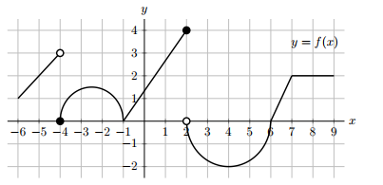Use the graph above to calculate the answers to the following questions. Give your answers as ***exact values***.

If any of the answers can’t be found with the information given, write “NEI”

1. Find the average value of f(x) on [−4, 2].

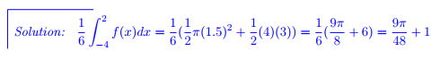

1. Find the value of





(c) Find the value of T, where 4 < T ≤ 9, such that



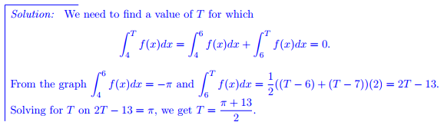

9. Express the area between y = sin x and y = cos x from 0 to  as a Riemann integral or a sum of two Riemann integrals (without using absolute value). *Do not evaluate!*

For your convenience a graph is given below. Use ***exact*** values, not guesses from the graph.



*Solution: Solving sin x = cos x over [0, π] we find tan x = 1. Hence x = π/4. Now the area is given by:*

10. *[University of Michigan]* Three happy wizards leave a magic show and return home to watch the Simpsons. In this episode, Homer needs to deliver Lisa’s homework to her at school, and he must do so before Principal Skinner arrives. Suppose Homer starts from the Simpson home in his car and travels with velocity given by the figure below. Suppose that Principal Skinner passes the Simpson home on his bicycle 2 minutes after Homer has left, following him to the school. Principal Skinner is able to sail through all the traffic and travels with constant velocity 10 miles per hour.

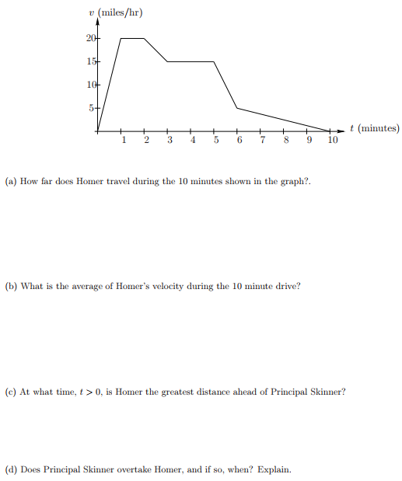

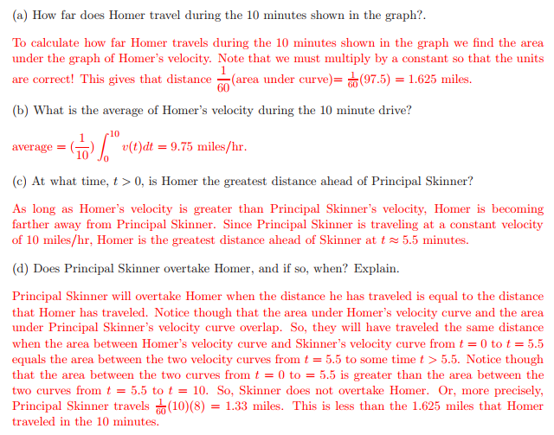

11. Parts (a) and (b) are independent of each other.

1. Find an anti-derivative of

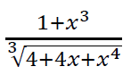

*Solution: Begin by noticing that the numerator, 1 + x3, is almost the derivative of 4 + 4x + x4.*

So we are looking at an expression of the form $g^{-\frac{1}{3 }} g'$.

Using our method of judicious guessing, our first guess is

${guess \#1= \left(4+4x+x^{4}\right)}^{\frac{2}{3}}$.

Now d/dx ${guess \#1= \frac{2}{3}\left(4+4x+x^{4}\right)}^{\frac{2}{3}}\left(4+4x^{3}\right)={ \frac{8}{3}\left(4+4x+x^{4}\right)}^{\frac{2}{3}}\left(1+x^{3}\right)$

Next our second, and final guess is:

$${guess \#2= \frac{3}{8}\left(4+4x+x^{4}\right)}^{\frac{2}{3}}$$

1. Suppose that y = h(x) is a twice differentiable function *defined for 0 < x < 2π* and that



Find all points of inflection of y = h(x) and list intervals where *h* is *concave up* and *concave down* *on its domain*.

*Solution: Performing a sign analysis on $\frac{d^{2}y}{{dx}^{2}} ,$ we see that the only transition points in the*

*domain (0, 2) are  and 4.*

*Now >0 on (0, ) and on (4, 2). Also < 0 on (, 4).*

*This means that h is concave up on the intervals (0, ) and (4, 2) and that h is concave down*

*on (, 4). Consequently, h has* ***inflection points at x =  and at x = 4.***

12. *[University of Michigan]* Suppose that H(c) is the average temperature, in degrees Fahrenheit, that can be maintained in Oscar’s apartment during the month of December as a function of the cost of the heating bill, c, in dollars. In complete sentences, give a practical interpretation of each of the following:

1. H(50) = 65

*Answer:*





$H^{'}\left(50\right)=2$

*Answer:*





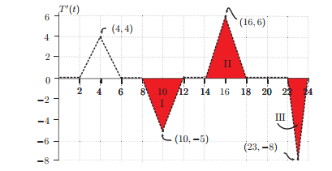

1. When Oscar gets home from work at 6 pm the temperature in his apartment is 67 degrees. What was the temperature when he left for work at 8 am?

Solution:

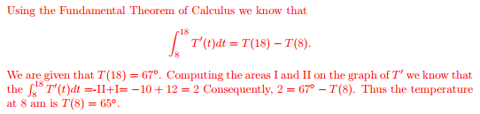

1. If the temperature at 6 pm is 67 degrees, what is the minimum temperature in the apartment on December 18th?

Solution:

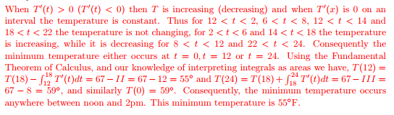

Extra Credit:

*[University of Michigan]* For Valentine’s Day, Marcel decides to make a heart-shaped cookie for Albertine to try to win her over. Being mathematically-minded, the only kind of heart that Marcel knows how to construct is composed of two half-circles of radius *r* and an isosceles triangle of height *h*, as shown below. Marcel happens to know that Albertine’s love for him will be determined by the dimensions of the cookie she receives; if given a cookie as described above, her love L will be

L = hr2, where r and h are measured in centimeters and L is measured in pitter-patters, a standard unit of affection. If Marcel wants to make a cookie whose area is exactly 300 cm2, what should the dimensions

be to maximize Albertine’s love?

