Worksheets: MATH 161

Worksheet I (review of graphing polynomials and rational functions; trig functions; logarithmic functions; inverse functions; odd & even functions)]

Worksheet II (limits, continuity, Intermediate Value Theorem, Sandwich Theorem)

Worksheet III (average rate of change)

Worksheet IV (interpreting the derivative)

Worksheet V (trigonometric limits)

Worksheet VI (short cuts: including product and quotient rules)

Worksheet VII (higher-order derivatives)

Worksheet VIII (curve sketching: a prelude; Extreme Value Theorem)

Worksheet IX (linearization)

Worksheet X (chain rule; implicit differentiation; logarithmic differentiation; inverse trig functions)

Worksheet XI (related rates)

Worksheet XII (curve sketching; concavity)

Worksheet XIII (hyperbolic functions)

Worksheet XIV (optimization)

Worksheet XV (introduction to area and Riemann sums)

Worksheet XVI (MVT, Anti-derivatives, Indefinite integrals & initial value problems)

Worksheet XVII (the Riemann integral)

Worksheet XVIII (the FTC, the Net Change Theorem)

Worksheet XIX (area between curves)

Worksheet XX (l’Hôpital’s rule)

Work! God wills it. That, it seems to me, is clear.
- Gustave Flaubert (letter to Louise Colet, 1845)

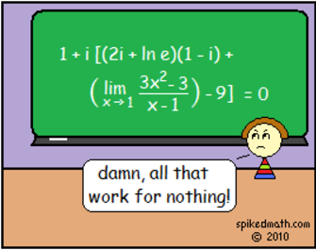

Course Home Page Department Home Page Loyola Home Page

