**WORKSHEET I**

***Brief review of functions: polynomials, rational functions, trig functions, log functions, inverse functions, odd & even functions.***

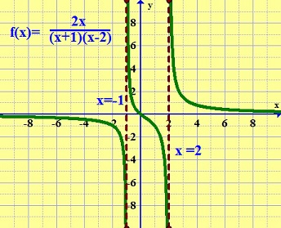

1.   *Sketch the graph* of each of the following rational functions. This includes locating zeroes, locating singularities, performing a sign analysis, and studying limiting behavior.

(A) y = x3(x – 1)4(x – 2)5

(B) y = x2(x – 1)4(x2 + 3)5

(C) 

(D) 

(E) 

(F) 

(G) 

2. Find an appropriate rational function y = f(x) which has the following graph. Assume that each tick mark on the axes represents 1 unit.

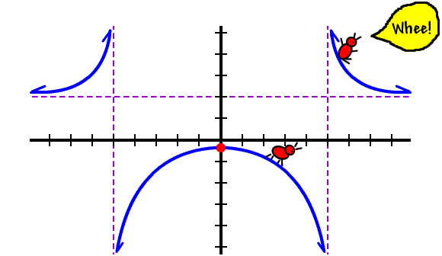

3*. [University of Michigan precalculus final exam]*  In this problem, the constants *a, b, c,* and *d* are all positive and different from each other. Consider the function:



(a) What is the y-intercept of *G*? If there is no y-intercept, write *NONE*.

(b) Find all zeroes of *G*. If there are no zeroes, write *NONE*.

(c) Give the equation(s) of all vertical asymptote(s) of *G*. If there are none, write *NONE*.

(d) Give the equation(s) of all horizontal asymptote(s) of *G*.

If there are none write *NONE*.

(a) y = ln x

(b) y = ln(x + 3) – 1

(c) y = ln(13x)

4. Let f(x) = 2x2 + x + 2017. Compute and simplify the expression



5. What does it mean for a function to be *one-to-one*? Which of the following are one-to-one?

(a) y = t2 + 2t + 1

(b) y = t5 + 4t3 + 2017

(c) y = x4 with domain [0, ∞).

(d) y = sin x

(e) 

(f) y = cos x with domain [0, ].

6. Consider the following graph of a function f and its inverse f -1.

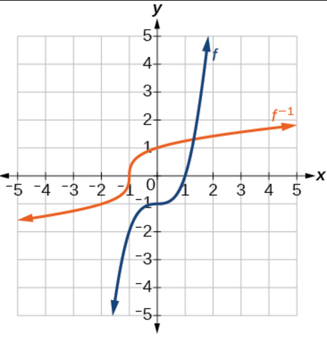

7. Now for each of the following graphs, sketch the graph of its inverse provided the inverse exists!

1. 
2. 
3. 
4. 
5. 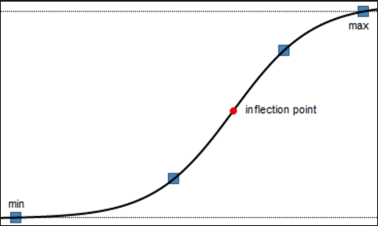
6. 
7. 

8. Can you guess the equations for some of the functions above? In particular, for (a), (c), (f), and (g)?

9. Determine which of the following functions possess an inverse. If there is an inverse, find it. If not, explain!

(a) y = ln x

(b) y = 1 + x3

(c) y = 3 ln x

(d) y = esin x

(e) y = x3(x – 1)4

10. For each of the following 6 graphs, determine if the function is odd, even, or neither.

|  |  |
| --- | --- |
| (a) | (b) |
| (c)  (c) | (d) |
| (e) | (f) |
| (g) |  |

11. For each of the following functions, determine if it is even, odd, or neither.

(a) y = x4(1 + x6)3

(b) 

(c) 

(d) 

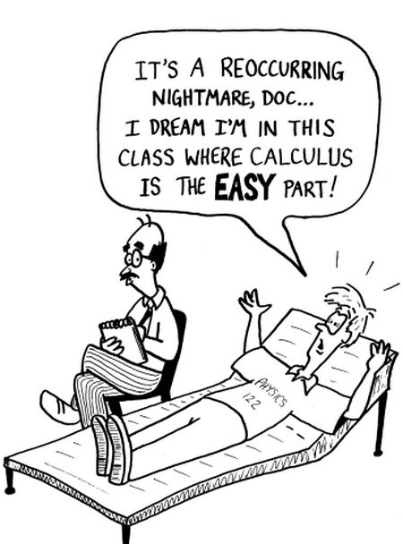

[Course Home Page](http://www.math.luc.edu/~ajs/courses/161fall2017/index.pdf)          [Department Home Page](http://www.math.luc.edu/)        [Loyola Home Page](http://www.luc.edu/)