**WORKSHEET X**

**Chain Rule, Implicit Differentiation, Logarithmic Differentiation,**

**Inverse Trig functions**

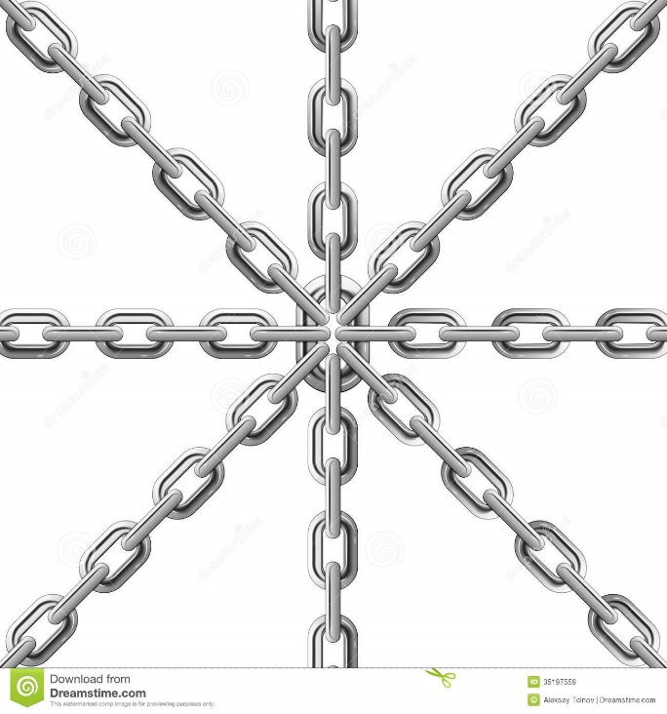

**I** Compute dy/dx using the Chain Rule:

**

**

**

**

**

**

**

**

**

**

**II**  For each of the following curves, find all *critical points* (i.e., points for which dy/dx = 0).

**

**

**

**

**

**III**  1. Given y = tan2 (u/8) and u = 1 + 2x2 – 4x3 + 3, find dy/dx when x = 1.

2. Sketch the curve y = (2x – 1)4(3x + 1)5 and locate all zeroes, perform a sign analysis, study limiting behavior and locate all critical points.

3. Sketch the curve y = ex(x – 1)4 and locate all zeroes, perform a sign analysis, study limiting behavior and locate all critical points.

4. Show that the derivative of ln x is 1/x. (*Hint:* Let y = ln x; then x = ey.)

5. Find dy/dx if y = ln(sec x + tan x) and simplify your answer.

6. Find dx/dt if x(t) = ln(ln(t)).

**IV** Using implicit differentiation, find dy/dx:

**

**

**

**V** 1. Prove the power rule for *rational* exponents, *viz.*

(d/dx) xp = pxp-1 if *p* is rational.

2. Find d2y/dx2 if y2 + xy = 1.

3. Consider the curve defined implicitly by: x2 + xy – y2 = 1. Verify that the point P = (2, 3) lies on this curve. Find the equations of the *tangent* and *normal* lines to this curve at the point *P*.

4. Find equations for the *tangent* and *normal* lines to the *cissoid of Diocles* (from 200 B.C.):

y2(2 – x) = x3 at Q = (1, 1).

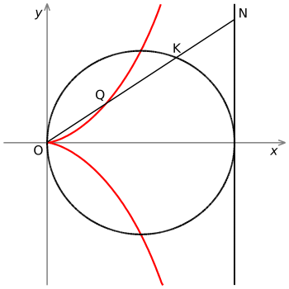

**VI** Using implicit differentiation, find dy/dx for each of the following inverse trig functions.

y = arcsin x, y = arctan x, and y = arcsec x.

**VII** Find dy/dx for each of the following:

**

**

**

**

**VIII** Using logarithmic differentiation, find dy/dx for each of the following:

**

**

**

*It is often better to be in chains than to be free.*

- Franz Kafka, **The Trial**



[Course Home Page](http://www.math.luc.edu/~ajs/courses/161fall2017/index.pdf)          [Department Home Page](http://www.math.luc.edu/)        [Loyola Home Page](http://www.luc.edu/)