WORKSHEET XI
Related Rates*
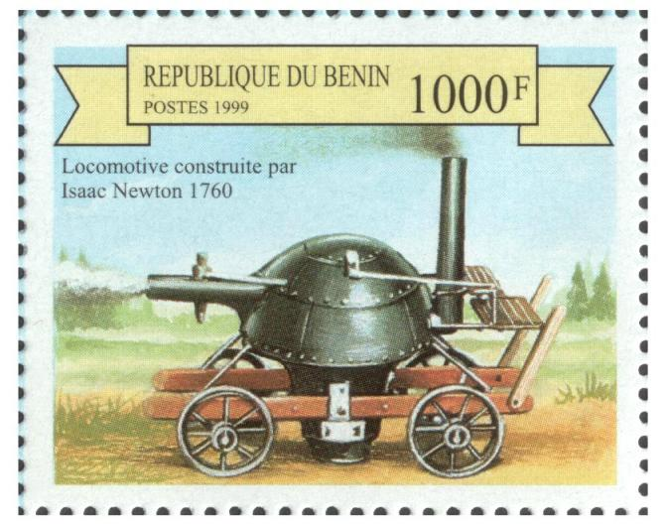
1. If the original 10 cm edge length x of a cube decreases at the rate of 5 cm/min, when x = 4, at what rate does the cube’s
(a) surface area change?
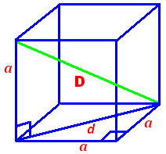
(b) volume change?
(c) main diagonal change?

2. Albertine (6 ft tall) is slowly walking away (at a rate of 20 ft/min) from a lamppost that is 10 ft tall. Determine the rate at which the length of her shadow changes at the moment when she is 12 ft from the base of the lamppost.
3. A cone-shaped coffee filter of radius 6 cm and depth 10 cm contains water, which drips out through a hole at the bottom at a constant rate of 1.5 cm³ per second.
(a) If the filter starts out full, how long does it take to empty?
(b) Find the volume of water in the filter when the depth of the water is h cm.
(c) How fast is the water level falling when the depth is 8 cm?
4. A spherical snowball is melting. Its radius is decreasing at 0.2 cm per hour when the radius is 15 cm. How fast is its volume decreasing at that time?
5. A ruptured oil tanker causes a circular oil slick on the surface of the ocean. When its radius is 150 meters, the radius of the slick is expanding by 0.1 meter/minute and its thickness is 0.02 meter. At that moment:
(a) How fast is the area of the slick expanding?
(b) The circular slick has the same thickness everywhere, and the volume of oil spilled remains fixed. How fast is the thickness of the slick decreasing?
6. A gas station stands at the intersection of a north-south road and an east-west road. A police car is traveling toward the gas station from the east, chasing a stolen truck which is traveling north away from the gas station. The speed of the police car is 100 mph at the moment it is 3 miles from the gas station. At the same time, the truck is 4 miles from the gas station going 80 mph. At this moment:
(a) Is the distance between the car and truck increasing or decreasing? How fast? (Distance is measured along a straight line joining the car and the truck.)
(b) How does your answer change if the truck is traveling at a speed of 70 mph instead of 80 mph?
7. For the amusement of the guests, some hotels have elevators on the outside of the building. One such hotel is 300 feet high. You are standing by a window 100 feet above the ground and 150 feet away from the hotel, and the elevator descends at a constant speed of 30 ft/sec, starting at time , where t is time in seconds. Let θ be the angle between the line of your horizon and your line of sight to the elevator. (See the figure below)
(a) Find a formula for h(t), the elevator's height above the ground as it descends from the top of the hotel.
(b) Using your answer to part (a), express θ as a function of time t and find the rate of change of with respect to t.
(c) The rate of change of θ is a measure of how fast the elevator appears to you to be moving. At what height is the elevator when it appears to be moving fastest?
8. Coroners estimate time of death using the rule of thumb that a body cools about 2°F during the first hour after death and about 1°F for each additional hour. Assuming an air temperature of 68°F and a living body temperature of 98.6°F , the temperature T(t) in °F of a body at a time t hours since death is given by
T(t) = 68 + 30.6 e^{-kt}.
(a) For what value of k will the body cool by 2°F in the first hour?
(b) Using the value of k found in part (a), after how many hours will the temperature of the body be decreasing at a rate of 1°F per hour?
(c) Using the value of k found in part (a), show that, 24 hours after death, the coroner's rule of thumb gives approximately the same temperature as the formula.
9. (U. of Michigan) A certain type of spherical melon has weight proportional to its volume as it grows. When the melon weighs 0.2 pounds, it has a volume of 36 cm³ and its weight is increasing at a rate of 0.1 pounds per day. (Note: The volume of a sphere of radius r is given by V = (4/3)πr³.)
(a) Find dV/dt when the melon weighs 0.2 pounds (t is measure in days).
(b) Find the rate at which the radius of the melon is increasing when the melon weighs 0.2 pounds.
(c) Using a local linearization (i.e., tangent line approximation), estimate the volume of the melon 36 hours after it weighs 0.2 pounds.

* A majority of these problems were chosen from the Hughes-Hallett calculus text.

Course Home Page Department Home Page Loyola Home Page

