**WORKSHEET XV**

**Introduction to area and Riemann sums**

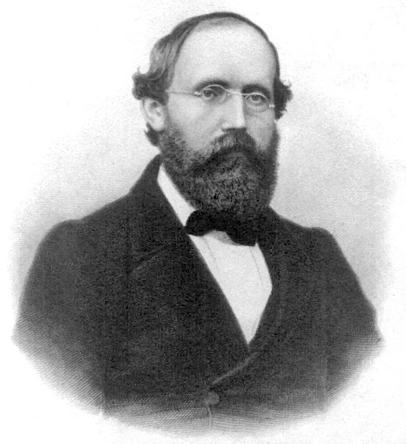

[**Bernhard Riemann**](http://en.wikipedia.org/wiki/Bernhard_Riemann) (1826 –1866)

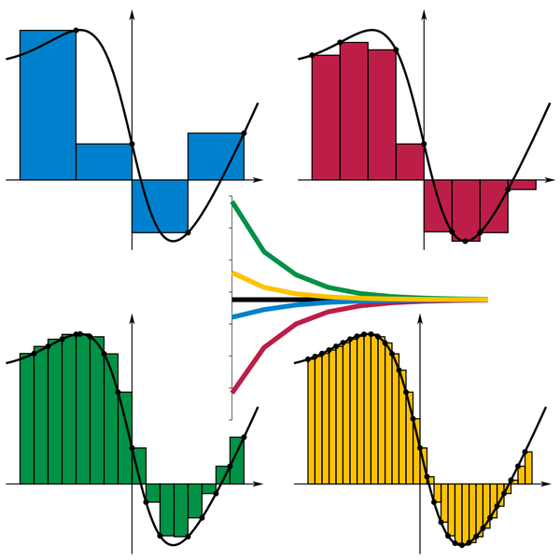

**1.** Charlotte, the spider, lives on the x-axis. Suppose that, at time t = 1 minute, she is at x = 5 cm, and that her velocity (in cm/minute) at time *t* is given by:

(a) v(t) = 3 cm/min *Where* is Charlotte at time *t = 4 minutes*? 9 minutes? 11.5 minut3s?

(b) $v\left(t\right)=\left\{\begin{aligned}3 if 0<t<2 \\ 5 if 2<t<7 \\ 1 if t>7\end{aligned}\right.$

*Where* is Charlotte at time *t = 2 minutes*? 5 minutes? 13 minut3s?

(c) v(t) = 4t + 1. *Where* is Charlotte at time t = 1 minute?, *t = 5 minutes*? t = 11 minutes?

**2.** For each of the following functions and associated partitions, compute the left-endpoint sum, the right-endpoint sum, and the midpoint sum:

(a) f(x) = 2x + 5; P = {-2, -1, 0, 1}

(b) f(x) = 2x2 + 1; P = {-1, 0, 1, 2}

(c) f(x) = 1/x2; P = {1, 3/2, 2, 5/2, 3}

(d) f(x) = sin x; P = {0, /4, /2, 3 /4, }

(e) f(x) = x3; P = {1, 2, 3, 4}

**3.** Compute each of the following sums:







**4.** Find a formula for





**5.** Using [Archimedes](http://www-history.mcs.st-and.ac.uk/Biographies/Archimedes.html)’ *Method of Exhaustion*, find the area under the parabola f(x) = x2 that lies above the interval [0, 1] on the x-axis.

**6.** Suppose that  and that ****. Find:

(a) 

(b) 

(c) 

(d) 

**7.** Swann’s old rowboat has sprung a leak. Water is flowing into the boat at a rate, *r(t)*, given in the following table. Compute *upper and lower estimates* for the volume of water that has flowed into Swann’s boat during the 15 minutes of recorded data. Draw a graph to illustrate the lower estimate.

|  |  |  |  |  |  |  |  |  |  |  |
| --- | --- | --- | --- | --- | --- | --- | --- | --- | --- | --- |
| |  |  |  |  |  | | --- | --- | --- | --- | --- | | *t* minutes | 0 | 5 | 10 | 15 | | r(t) liters/min | 12 | 20 | 24 | 16 | |

**8**. Albertine launches a model rocket from the ground at time t = 0. The rocket starts by traveling straight up in the air. The graph below illustrates the upward velocity of the rocket as a function of time.

(a) Sketch a graph of the *acceleration* of the rocket as a function of time.

1. Sketch a graph of the *height* of the rocket as a function of time.

(c) Give an estimate of the *maximum height* the rocket achieved.

**9.** The graph below shows the *RATE OF CHANGE* of the quantity of water in the Water Tower of OZ, in liters per day, during the month of April, 2017. The tower contained 12,000 liters of water on April 1. *Estimate* the quantity of water in the tower on April 30. Show your work.



**10.** How would you define the *average value* of a continuous function f(x) on an interval [a, b]? Using your definition, find (or estimate) the *average value* of each of the following functions:

(a) f(x) = x2 over [0, 1]

(b) g(x) = 3x + 1 over [7, 11]

(c) h(x) = |x – 2| over [0, 3]

(d) F(x) = sin x over [0, ]

**11.** *[Review]*Verify the following indefinite integral formula (by differentiating):



12. *[Review]*Verify the following indefinite integral formula (by differentiating):



13. A history professor gives a 60 minute lecture, while one eager undergraduate

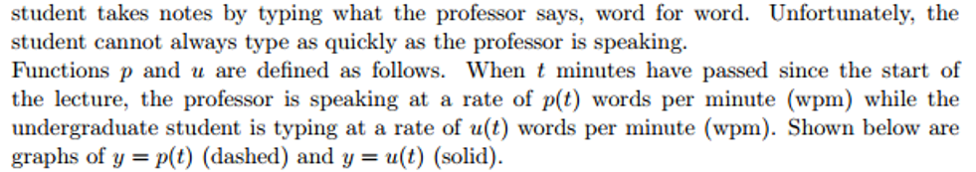

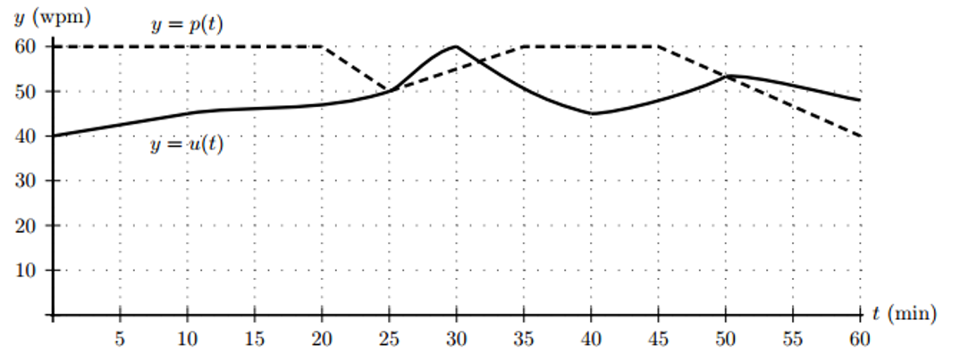

1. How many minutes after the start of the lecture is the student typing most quickly?
2. How many minutes after the start of the lecture is the student furthest behind in typing up the lecture? (In other words, after how many minutes is the difference between the total number of words the professor has spoken and the total number of words the student has typed the greatest?)



*I do hate sums. There is no greater mistake than to call arithmetic an exact science. There are hidden laws of number which it requires a mind like mine to perceive. For instance, if you add a sum from the bottom up, and then again from the top down, the result is always different.*

**- Mrs. La Touche**



[Course Home Page](http://www.math.luc.edu/~ajs/courses/161fall2017/index.pdf)          [Department Home Page](http://www.math.luc.edu/)        [Loyola Home Page](http://www.luc.edu/)