**WORKSHEET XVIII**

**the FTC**

1. State the two versions of the *Fundamental Theorem of Calculus*.

2. Find the *area beneath the given curve lying above the given interval:*

(a) f(x) = x3 above [1, 3]

(b) g(x) = sin x over [0, ]

(c) z(x) = (x – 1)2 over [0, 3]

(d) h(x) = (ln x) / x over [1, 4]

(e) s(t) = t3(2 + 3t4)3 over [0, 1]

3. For each function in (2), find the *average value* over the given interval.

4. Using the FTC, compute g′(e) given that



5. Using the FTC compute:



6. Let 0 < k < 1 and consider the Elliptic Integral:



Find dE/dx.

7. Using the FTC and the Chain Rule, calculate dF/dx given that:



8. Consider the function defined by:



Calculate dH/dt by:

1. Using the FTC and the Chain Rule.
2. By first performing the integration.
3. Compare the two answers that you have obtained.

9. A particle is moving along a line so that its velocity is given by:

*v(t) = (t – 1)(t – 4)(t – 5) = t3 – 10t2 + 29t – 20* ft/sec at time *t* seconds.

1. Find the *displacement* of the particle over the time interval [1, 5].
2. Find the *total distance* traveled by the particle over the time interval [1, 5].

10. Find the *area* of the region bounded by the graphs of the given functions. Sketch!

(a) y = x2 + 2, y = -x, x = 0, and x = 1.

(b) y = 2 – x2 and y = x

(c) y = sin x and y = cos x over [/4, 5/4]

(d) y = 3x3 – x2 – 10x and y = 2x – x2

(e) y = x3 and y = x6

(f) y = x3 – x and y = 0

(g) y = x2 – 4x + 3 and y = 3 + 2x – x2

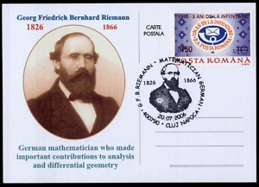

[Course Home Page](http://www.math.luc.edu/~ajs/courses/161fall2017/index.pdf)          [Department Home Page](http://www.math.luc.edu/)        [Loyola Home Page](http://www.luc.edu/)