**WORKSHEET II**

**limits & continuity**



[***Fractal tree***](http://rosettacode.org/wiki/Fractal_tree)

**I** Evaluate each of the following limits or explain why the limit fails to exist.

**

**

**

**

**

**

**

**

**

**

**II**  State the *limit laws*.

**III** Define *continuity* of a function y = f(x) at x = a. What does it mean for a function to be *continuous*?

**IV** (a)For each of the four types of discontinuity (*removable, infinite, jump, essential*) give several examples.

(b) For the graph below, characterize each of the four discontinuities.

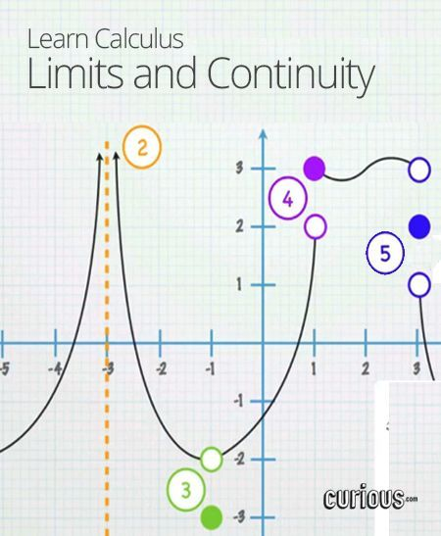

(c) Give an example of an *essential discontinuity.*

**V** Consider each of the following functions and the given point on the x-axis. Does the function have a *continuous extension* at the given point? Explain.

**

**

**

**

**VI** For which value of *a* is the following function *continuous everywhere?*

**

**VII** For which values of *a* and *b* is the following function *continuous everywhere?*

**

**VIII** State the *Intermediate Value Theorem.* Using the IVT, prove that the polynomial

f(x) = x4 + 4x3 – 20x + 11 must have a root between x = 0 and x = 1 .

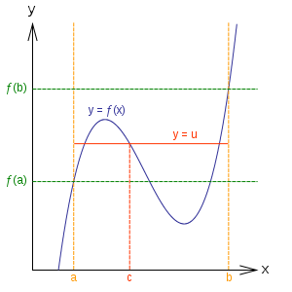

**IX** State the *Squeeze Theorem (a.k.a. Sandwich Theorem, Pinching Theorem, Two Gendarmes Theorem, Two Policemen and a Drunk Theorem)*.

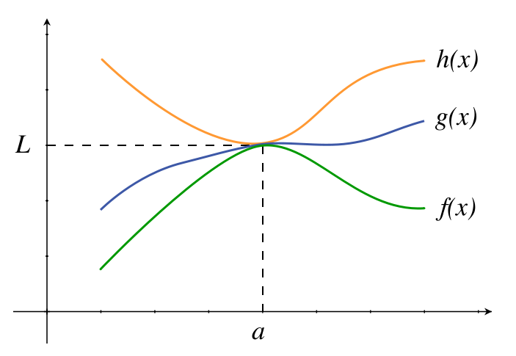

**X** (a) Is the function f(x) = (sin x)/x *even* or *odd* or neither?

(b) Using the Sandwich Theorem prove that

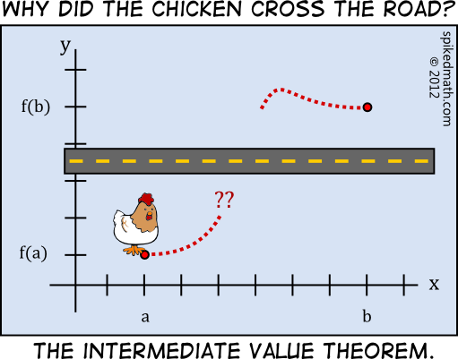

[Course Home Page](http://www.math.luc.edu/~ajs/courses/161fall2017/index.pdf)          [Department Home Page](http://www.math.luc.edu/)        [Loyola Home Page](http://www.luc.edu/)