WORKSHEET IV
Interpreting the Derivative
- Which of the following graphs (a) – (d) could represent the slope at every point of the function graphed below, labeled Figure 2.6?
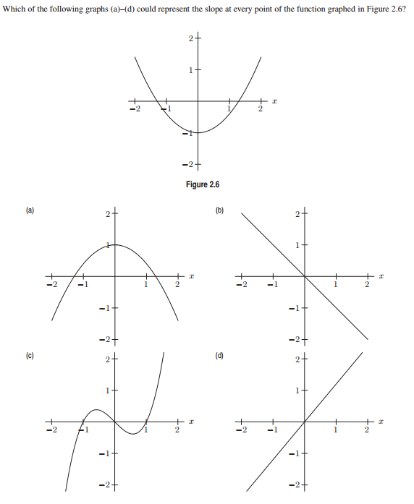
- Give an example of a continuous function which is not everywhere differentiable.

- Let f(x) = x|x|. Is f differentiable at x = 0?

4.
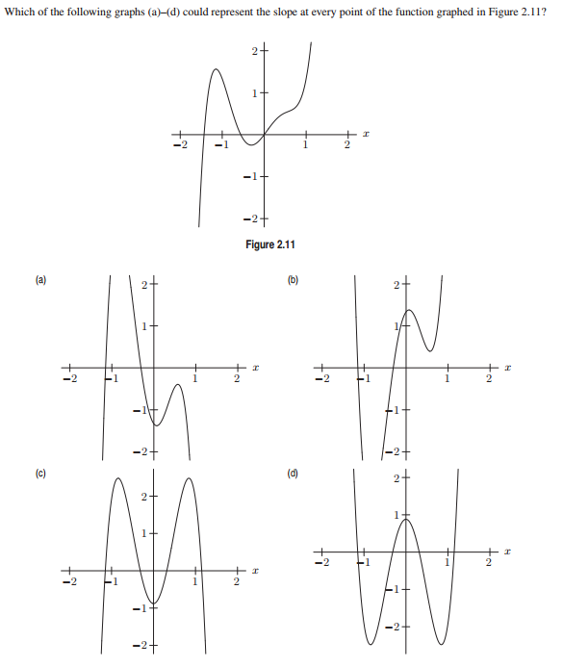
5. Find an equation of the tangent line to the given curve at the given point.
- y = x², x = 1
- F(x) = 2x² + x + 2, x = 2
- G(x) = 1/x, x = 3
- y = x^{1/2}, x = 4
- y = ax² + bx + c, x = x₀
- y = sin x, x = 0
- y = 1/(x – 3)², x = 4

6.
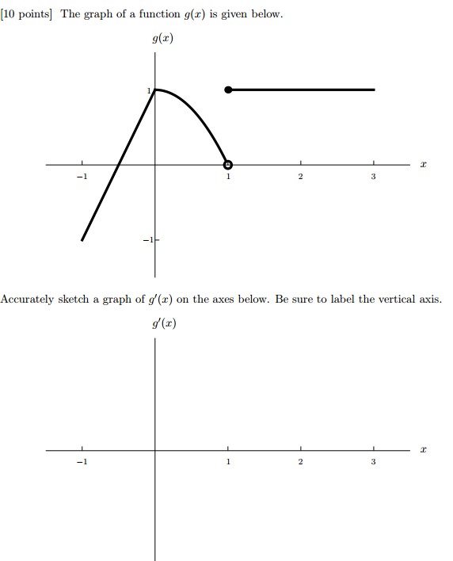

7. The function C(r) is the total cost, in dollars, of paying off a car loan borrowed at an interest rate of r % per year.
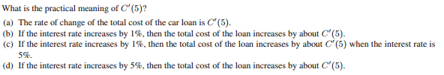
8. The temperature, Y, in Fahrenheit, of a cold yam placed in a hot oven is given by Y = g(t), where t is the time in minutes since the yam was placed into the oven.

(a) What is the sign of g′(t)? Why?

(b) What are the units of g′(20)? What is the practical meaning of the statement
g′(20) = 2?

9. For some painkillers, the size of the dose, D, given depends upon the weight of the patient, W. Thus, D = H(W), where D is in milligrams and W is in pounds.

(a) Interpret the statements H(140) = 120 and H′(140) = 3 in terms of this painkiller.

(b) Use the information in the statements in part (a) to estimate H(145).

10. Suppose that C(T) is the cost of heating Albertine’s house, in dollars per day, when the outside temperature is T degrees Fahrenheit.

(a) What does C(19) = 8.67 mean in practical terms? (Use appropriate units.)

(b) What does C ′(19) = - 0.55 mean in practical terms? (Use appropriate units.)

(c) If C(19) = 8.67 and C ′(19) = - 0.55, approximately what is the cost of heating Albertine’s house when the outside temperature is 16 degrees Fahrenheit? (Use appropriate units.)

11. The cost C (in thousands of dollars) of building a house that is x square feet is given by the function C = F(x).
(a) Explain the meaning of the statement: F(1600) = 140.

(b) Give the practical interpretation of the statement: F′(1600) = 0.1.

(c) Using the information given in parts (a) and (b), estimate the cost of building a house that is 1680 square feet.

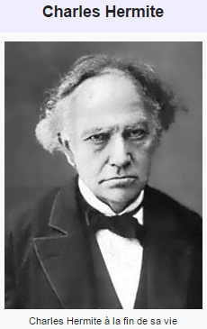

I turn away with fright and horror from the lamentable evil of functions which do not have derivatives.

- Charles Hermite (in a letter to Thomas Jan Stieltjes)

Course Home Page Department Home Page Loyola Home Page

