**WORKSHEET VII**

**Higher-Order Derivatives**



1. Find the first *three* derivatives of each of the following functions.

**

**

**

**

**

**

2. (A) If (d/dx)e4x = 4e4x, find (d199/dx199) e4x.

(B) If (d/dx) sin 5x = 5 cos 5x, and (d/dx) cos 5x = - 5 sin 5x, find (d2017/dx2017) sin 5x.

3. If f(x) = x1/2, find f(4)(x).

4. If *x(t) = 3t3 – 4t + 1* is the position (measured in meters) of Charlotte on the x-axis at time *t* (measured in hours), find Charlotte’s *velocity* and *acceleration* at time t = 2 hrs.

5. If *F(x) = xm*, find F(m)(x). (Assume that *m* is a positive integer.)

6. Let y = ln x. Given that dy/dx = 1/x, find d4y/dx4. Can you find d10y/dx10 ?

7. *(University of Michigan)*  Consider the following table giving values, rounded to three decimal places, of a function *f*(*x*).

|  |  |  |  |
| --- | --- | --- | --- |
| *x* | 0 | 0.5 | 1 |
| *f*(*x*) | 0 | 0.247 | 0.841 |

* 1. Estimate $f'(1)$. Be sure it is clear how you obtain your answer.
  2. Estimate $f''(1)$. Again, be sure that it is clear how you obtain your answer.
  3. Estimate $f(1.25)$ being sure your work is clear.
  4. Based on your work in (a) and (b), is your estimate in (c) an over- or underestimate? Explain.

1. *(University of Michigan)* A paperback book (definitely not a valuable calculus textbook, of course) is dropped from the top of Mertz hall (which is 40 m high) towards a very large, upward pointing fan. The average velocity of the book between time *t* = 0 and later times is shown in the table of data below (in which *t* is in seconds and the velocities are in m/s).

|  |  |  |  |  |  |
| --- | --- | --- | --- | --- | --- |
| between *t* = 0 seconds and *t* = | 1 | 2 | 3 | 4 | 5 |
| the average velocity is | −5 | −10 | −11*.*67 | −9 | −7*.*2 |

* 1. Fill in the following table of values for the height *h*(*t*) of the book (measured in meters). Show how you obtain your values.

|  |  |
| --- | --- |
| *t* | 0 1 2 3 4 5 |
| *h*(*t*) | 40 |

* 1. Based on your work from (a), is *h*′′(1) *>* 0, *<* 0, or = 0? Is *h*′′(3) *>* 0, *<* 0, or = 0? Explain.

1. For each of the descriptions of a function *f* that follow, indicate which of the graphs below match the description. For each description there may be no, one, or several graphs that match; write **none** if no graphs match the description. You may need to use a graph more than once. In each case you should assume that *f* is defined only on the domain [0*,* 2].
   1. $f^{''}\left(x\right)<0$ for *x <* 1 and $f^{''}\left(x\right)$*>* 0 for *x >* 1; $f^{'}\left(x\right)<$ 0 for *x <* 1 and $f^{'}$ (*x*) *>* 0 for *x >* 1; and *f*(*x*) is continuous everywhere except at *x* = 1.
   2. $f^{''}\left(x\right)$*>* 0 for all *x* < 1; $f^{''}$ (*x*) *<* 0 for all *x* > 1 ; and *f*(*x*) is differentiable everywhere except at *x* = 1.
   3. $f^{''}\left(x\right)$*<* 0 for all *x* < 1; $f^{'}\left(x\right)$*<* 0 for *x <* 1 and $f^{'}\left(x\right)$*>* 0 for *x >* 1; and *f* (*x*) *<* 0 for all *x* = 1.
   4. $f^{''}\left(x\right)$*<* 0 for *x <* 1 and $f^{''}\left(x\right)>0$ for *x >* 1; $f^{'}\left(x\right)$*<* 0 for *x <* 1 and $f^{'}\left(x\right)>0$ for *x >* 1; and *f*(*x*) is differentiable everywhere except at *x* = 1.

**A.**

−

1

1

2

1

**B.**

−

1

1

2

1

**C.**

−

1

1

1

2

**D.**

−

1

1

2

1

**E.**

−

1

1

2

1

**F.**

−

1

1

1

2

10.

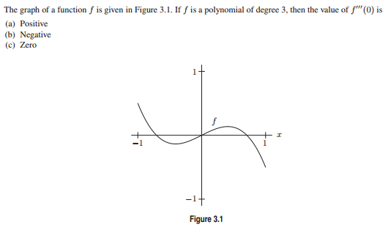

11.

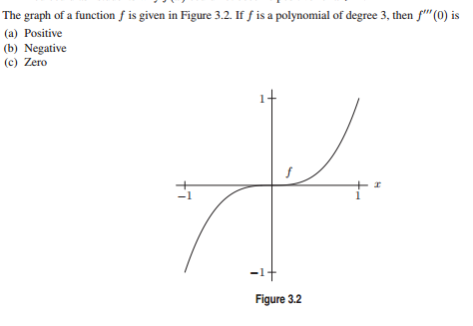

12.

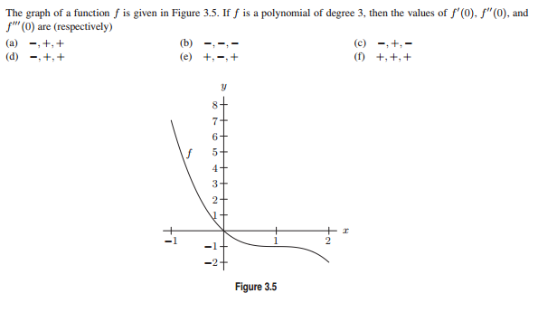

13.

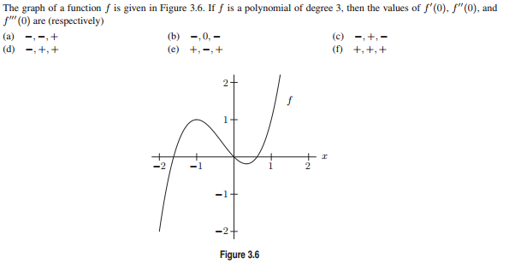

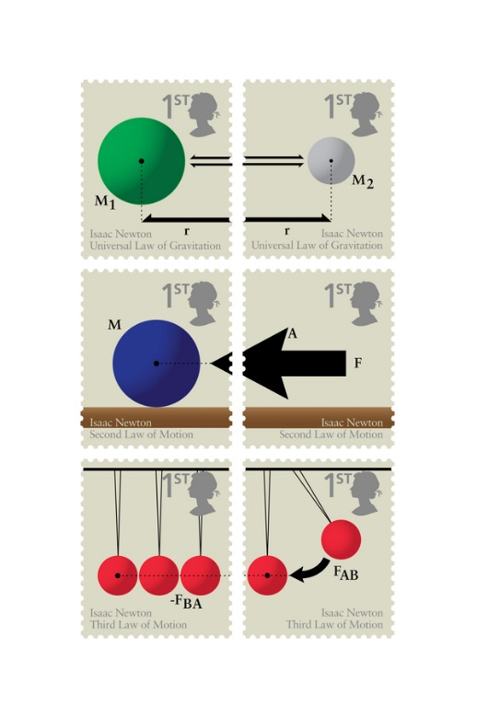

[Course Home Page](http://www.math.luc.edu/~ajs/courses/161fall2017/index.pdf)         [Department Home Page](http://www.math.luc.edu/)        [Loyola Home Page](http://www.luc.edu/)