WORKSHEET VIII
Curve sketching: a prelude (revised)
1.
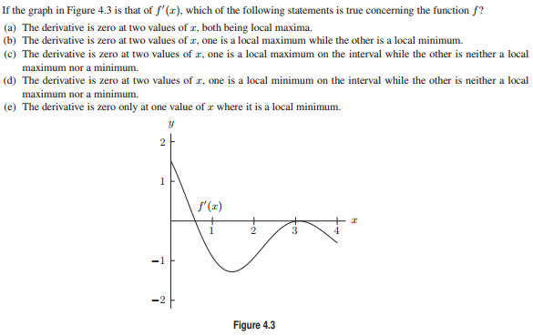
2.
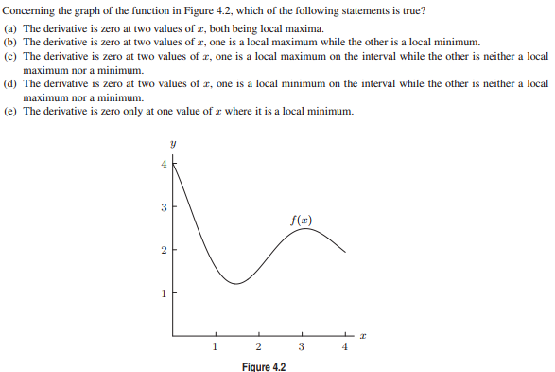
3. Consider the graph of the function below.
(a) How many critical points does f have?
(b) How many local minima does f have? Where are they located?
(c) How many local maxima does f have? Where are they located?
(d) Where is the global max of f(x)?
(e) Where is the global min of f(x)?

4. State the Compactness Theorem (aka Extreme Value Theorem).

5. True or False? A global max is always a critical point.

6. True or False? A function defined on a closed interval [a, b] must have a global maximum and a global minimum.

7.
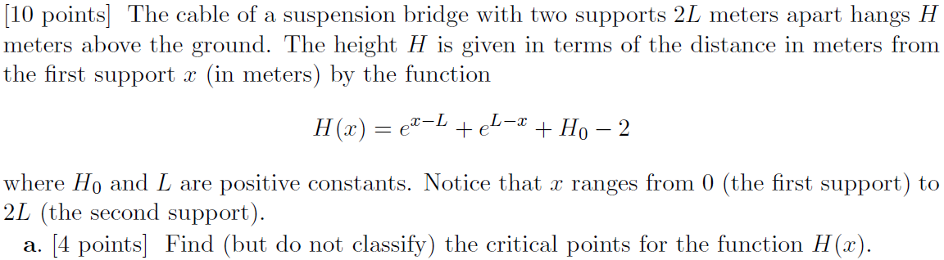

8. Find the critical points of the function f(x) = (x – 3)⁵(x + 4)⁹. Sketch the curve.

Stewart exercises:
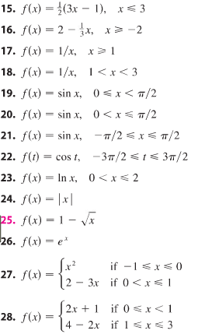
Stewart exercises:

Find the critical points of each function defined below:
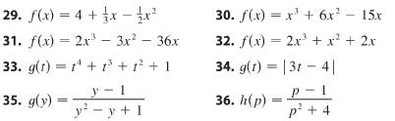
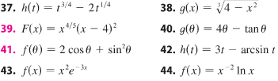

Find the global extrema of each of the following functions:
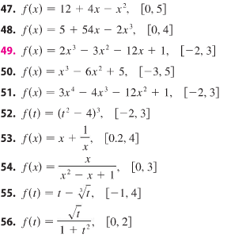

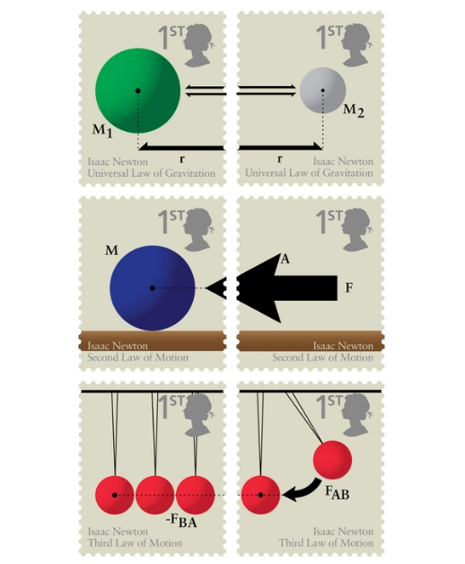

Course Home Page Department Home Page Loyola Home Page

