Math 161: DISCUSSION SHEET, 27 Aug 2018

Riddles [Raymond Smullyan, What is the Name of this Book?, Dover (1978)]

- What goes up when the rain comes down?
- How can you give someone $83 using exactly 7 bills, without using any one-dollar bills?
- Who is in the portrait?
- Boris was looking at a portrait. Someone asked him, "Whose picture are you looking at?" He replied: "Brothers and sisters have I none, but this man's father is my father's son."
Whose picture was the Boris looking at?
- What if the statement had been: "Brothers and sisters have I none, but this man's son is my father's son."

A question of international law. If a plane crashes right on the border of the United States and Canada, in which country would you bury the survivors?

I have five and take away two, yet I am left with four. How is this possible?

There are two fathers and two sons. They walk into a candy store, and each buys a candy bar for 50 cents. The total for all of the candy bars was $1.50. How is that possible?

I gurgle but never speak, run but never walk, have a bed but never sleep. What am I?

What English word sounds the same even after you take away four of its five letters?

Albertine is sitting in her hotel room when there is a knock at the door. She opens the door to find a man whom she has never seen before. The man said, “Oh, I’m sorry, I thought this was my room.” He then went down the hallway and took the elevator. Albertine went back into her room and phoned security. Why?

- The Lion and the Unicorn. When Albertine entered the Forest of Forgetfulness, she did not forget everything; only certain things. She often forgot her name, and the one thing she was most likely to forget was the day of the week. Now, the Lion and the Unicorn were frequent visitors to the forest. These two are strange creatures. The Lion lies on Mondays, Tuesdays, and Wednesdays, and tells the truth on the other days of the week. The Unicorn, on the other hand, lies on Thursdays, Fridays, and Saturdays, but tells the truth on the other days of the week.
One day Albertine met the Lion and the Unicorn resting under a tree. They made the following statements:
Lion: Yesterday was one of my lying days.
Unicorn: Yesterday was one of my lying days too.
From these two statements, Albertine (who is a bright Loyola first-year student) was able to deduce the day of the week. What day was it?

Precalculus: Final Exam, University of Michigan

December 17, 2015
- An animal shelter takes care of abandoned cats and dogs. Consider the following functions and constants:
    - The function F(c) gives the amount of pounds of cat food consumed by c cats in one day at the animal shelter.
    - The function S(p) gives the cost (in dollars) of p pounds of cat food.
    - There were k cats in the animal shelter on December 17.
    - On December 17, the animal shelter spent d dollars on dog food.
  - Find a practical interpretation for each of the following mathematical expressions.
      - S⁻¹(13)
      - S(F(15))
  - Write a mathematical expression for each of the following quantities.
      - The average amount of cat food needed per cat in one day if there are c cats in the animal shelter.
Answer:
      - The cost (in hundreds of dollars) of z ounces of cat food (recall that 1 pound equals 16 ounces).
Answer:
      - The amount of dollars the animal shelter spent on dog and cat food on December 17.
Answer:
- The population of aliens on planet Maize increases at a constant rate of 10 aliens every two years. We know that in 2005 there were 120 aliens on planet Maize.
- Find a formula for M(t), the function which gives the number of aliens on planet Maize t years after 2000.
M(t) = .
- Suppose that the population of aliens on planet Yellow in any given year is a thousand more the population of aliens on planet Maize ten years earlier. Find a formula for Y (t), the population of planet Yellow t years after 2000, in terms of the function M.
Y (t) = .
- The population of aliens on the planet Blue decreases at a continuous percent rate of 10 % per year. We know that in 2002 there were 100 aliens on planet Blue. Find a formula for B(t), the function which gives the number of aliens on planet Blue t years after 2000.
B(t) = .
- The alien population on planet Navy t years after 2000 is given by the function N(t), where
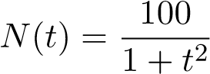.
Find the average rate of change of N(t) over the interval [1,3] and give a practical interpretation of your result.
Average rate of change: Interpretation:

- The values of the functions f(x), g(x) and h(x) are given below.
x | 0 | 4 | 8 | 12
f(x) | 100 | 20 | 4 | 0.8
g(x) | 3.6 | 4.7 | 5.8 | 6.9
h(x) | −4 | −3.6 | −3 | −0.9
  - Which of the following functions could be linear? Circle all that apply.
f(x) g(x) h(x) None of these
  - Which of the following functions could be exponential? Circle all that apply.
f(x) g(x) h(x) None of these
  - Which of the following functions could be concave up? Circle all that apply.
f(x) g(x) h(x) None of these

- The graph of the function f(t) is shown below
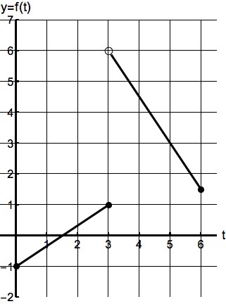
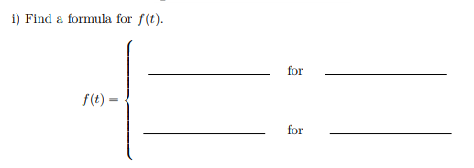
Does the function f(t) have an inverse function for 0 ≤ t ≤ 6? Circle your answer.
YES NO It is not possible to be determined.
  - Find the value of the following limits.
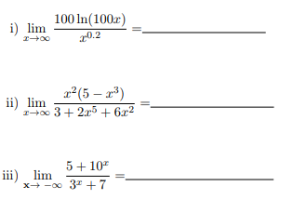
- Let
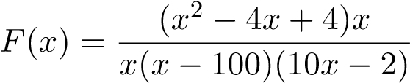
  - Does the graph of y = F(x) have any vertical asymptotes? If so, write their equations, otherwise write None.
Vertical asymptote(s):

  - Does the graph of y = F(x) have any horizontal asymptotes? If so, write their equations, otherwise write None
Horizontal asymptote(s):
  - Find the zeros of the function F(x). If the function does not have zeros, write None.

Zeros:

5. (a) The temperature T (in degrees Fahrenheit) at a point next to a campfire is inversely proportional to the square of its distance d (in meters) from the fire. If the temperature at a point 0.5 meters away from the fire is 500◦ F, what is the temperature (in degrees Fahrenheit) at 1.5 meters away from the fire? Show all your work to receive full credit.

  - Let H(x) =${(x^{3}+1)}^{2}$ Find two functions K(x) and J(x) such that K(J(x)) = H(x). Your functions should satisfy K(x) ≠ x and J(x) ≠ x.

K(x) =
J(x) =

  - The shadow (the segment BC) made by a 150-foot-tall building has a length of 200 feet. Find the value, in radians, of the angle ABC.
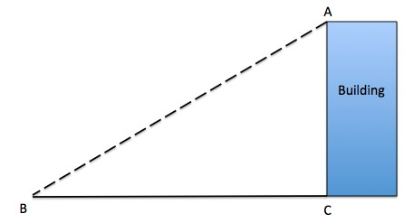
Angle ABC=

- The following table gives some values of the two functions f(x) and g(x).
x | 2 | 8
f(x) | 20 | 160
g(x) | 4 | 12
  - Suppose the function f(x) is an exponential function. Find a formula for f(x). Your answer must be in exact form. Show all your work.
f(x) =
  - Suppose that g(x) is a power function. Find a formula for g(x). Your answer
must be in exact form. Show all your work.
g(x) =
- The graph of the polynomial p(x) is given below.
−
1
1
2
−
3
−
2
−
1
1
2
  - What are the zeros of the polynomial p(x)?
Answer: .
  - What is the vertical intercept of the graph of p(x)?
Answer: .
  - Assume that the polynomial p(x) has degree six. Use the vertical intercept to find a formula for p(x) .
p(x) = .
- Jemma and Sarah want to design a website for the winter sale of the store Fritz. The sale will start at 8 am and close at 8 pm on December 23. To build the website, they have to be able to predict the number of online customers that day. Each one has different predictions for the number of online customers that day.

  - Sarah believes that the number of online customers will start at a minimum of 2 thousand online customers at 8 am and then it will increase to a maximum of 12 thousand customers at 2 pm. Let S(t) be the sinusoidal function which gives the amount of online customers on the website (in thousands) t hours after 8 am on December 23 according to Sarah’s predictions.
      - What are the amplitude and the midline of S(t)?
Amplitude= Midline:
      - Find a formula for the function S(t) for 0 ≤ t ≤ 12.
S(t) =
b. On the other hand, Jemma believes that there will be 3 thousand online customers at 8 am. She expects that the number of online customers will reach a maximum of 10 thousands at 2 pm. Let J(t) be the quadratic function which gives the amount of online customers on the website (in thousands) t hours after 8 am on December 23 according to Jemma’s predictions.
- What is the vertex of J(t)?
Vertex:
- Find a formula for J(t) for 0 ≤ t ≤ 12.
J(t) =

- (a) Find all the values of −4 ≤ x ≤ 20 that satisfy the following equation. Find
your answers algebraically. Your answer(s) must be in exact form. Show all your work.
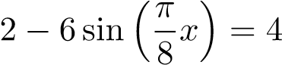
x =

- Let w = F(s), where F(s) = 4 + ln(3^{s} + 1). Find a formula for F⁻¹(w). Show all your work.

F⁻¹(w) = .

