Math 161 Class discussion: 31 august 2018
The following problems are taken from a precalculus final exam at the University of Michigan.
Problem 1
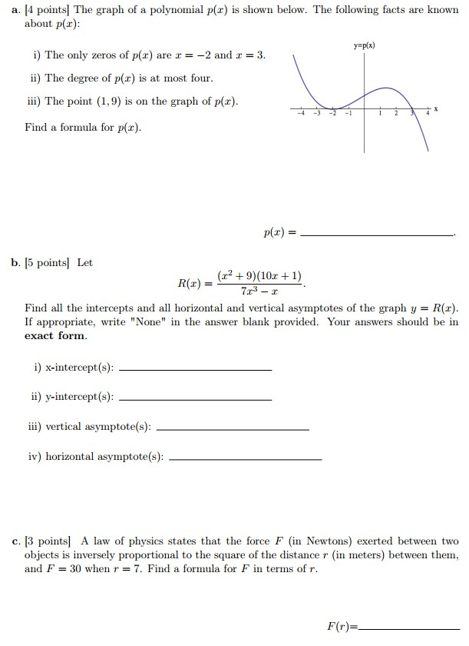
Problem 2
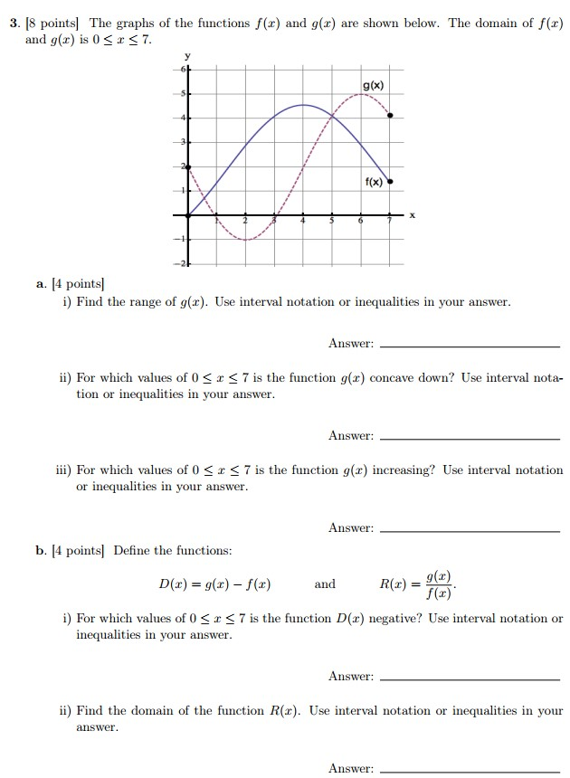

Problem 3
