**Class discussion: 12 November 201**

**Veteran’s Day**

**The Riemann integral**

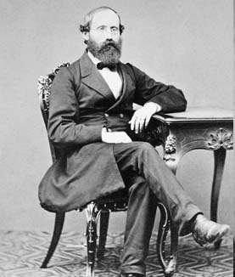

### [Georg Friedrich Bernhard Riemann](http://www-history.mcs.st-and.ac.uk/Biographies/Riemann.html)

### (1826 – 1866)

1. Using the *area interpretation* of the Riemann integral, evaluate each of the following:

1. 
2. 
3. 
4. 
5. 

2. Suppose that  Evaluate 

3. Let *g* be a continuous function on the interval [-5, 5]. Suppose that



Evaluate each of the following Riemann integrals:









4. Find the constants *a* and *b* that *maximize* the value of the definite integral:



Justify your answer!

5. By using an appropriate Riemann sum, determine:



6. Find a formula for 

7. Express the *average value* of each of the following functions as a Riemann integral. *(Do not try to evaluate.)*

(a) f(x) = sin x over [0, ]

(b) g(x) = (x – 1)2 over [0, 3]

(c) h(x) = (ln x) / x over [1, 4]

(d) s(t) = cosh t over [0, ln 2]

8. State the major properties of the Riemann integral.

9. Suppose that *h* is integrable and that 

Find:





10. Suppose that *f* and *h* are integrable and that



Find:









11. Given the formula for , find the *average value* of:

(a) f(x) = x2 – 1 over [2, 4]

(b) g(x) = (x – 2)2 over [0, 2]

(c) h(x) = 5 – 3x – 4x2 over [0, 2]

*I'm very good at integral and differential calculus,*

*I know the scientific names of beings animalculous;*

*In short, in matters vegetable, animal, and mineral,*

*I am the very model of a modern Major-General.*

*About binomial theorems I'm teeming with a lot of news,*

*With many cheerful facts about the square on the hypotenuse.*

- W. S. Gilbert, **The Pirates of Penzance** (1879)

[Course Home Page](http://www.math.luc.edu/~ajs/courses/161summer2017/index.pdf)          [Department Home Page](http://www.math.luc.edu/)        [Loyola Home Page](http://www.luc.edu/)