**Class discussion: 14 November 2018**

**The Riemann integral**



1. Using the *area interpretation* of the Riemann integral, evaluate each of the following:

1.  (b)   (c)  (d) 

(e)  

2. Suppose that  Evaluate 

3. Let *g* be a continuous function on the interval [-5, 5]. Suppose that



Evaluate each of the following Riemann integrals:

 

 

4. Find the constants *a* and *b* that *maximize* the value of the definite integral:



Justify your answer!

5. By using an appropriate Riemann sum, determine:



6. Find a formula for 

7. Express the *average value* of each of the following functions as a Riemann integral. *(Do not try to evaluate.)*

(a) f(x) = sin x over [0, ]

(b) g(x) = (x – 1)2 over [0, 3]

(c) h(x) = (ln x) / x over [1, 4]

(d) s(t) = cosh t over [0, ln 2]

8. State the major properties of the Riemann integral.

9. Suppose that *h* is integrable and that 

Find:

 

10. Suppose that *f* and *h* are integrable and that



Find:

 

 

11. Given the formula for , find the *average value* of:

(a) f(x) = x2 – 1 over [2, 4]

(b) g(x) = (x – 2)2 over [0, 2]

(c) h(x) = 5 – 3x – 4x2 over [0, 2]

12. State the two versions of the *Fundamental Theorem of Calculus*.

13. Find the *area beneath the given curve lying above the given interval:*

(a) f(x) = x3 above [1, 3]

(b) g(x) = sin x over [0, ]

(c) z(x) = (x – 1)2 over [0, 3]

(d) h(x) = (ln x) / x over [1, 4]

(e) s(t) = t3(2 + 3t4)3 over [0, 1]

14. For each function in (2), find the *average value* over the given interval.

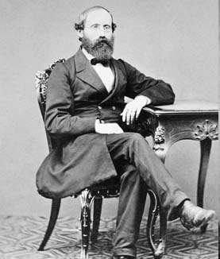

### [Georg Friedrich Bernhard Riemann](http://www-history.mcs.st-and.ac.uk/Biographies/Riemann.html)

### (1826 – 1866)

*I'm very good at integral and differential calculus,*

*I know the scientific names of beings animalculous;*

*In short, in matters vegetable, animal, and mineral,*

*I am the very model of a modern Major-General.*

*About binomial theorems I'm teeming with a lot of news,*

*With many cheerful facts about the square on the hypotenuse.*

- W. S. Gilbert, **The Pirates of Penzance** (1879)