**Class discussion: 26th November**



**University of Michigan problems**

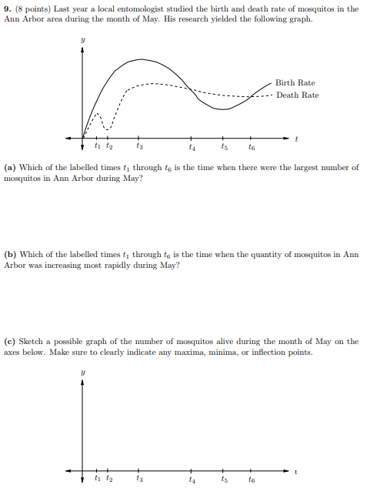

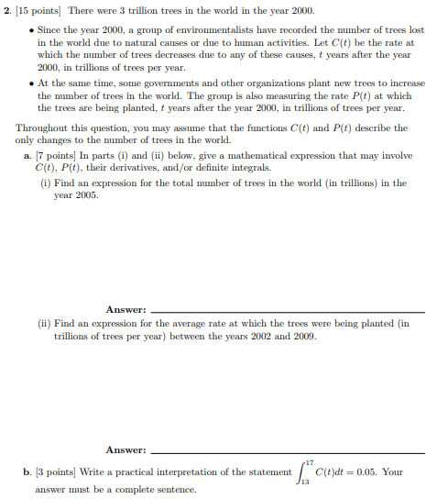

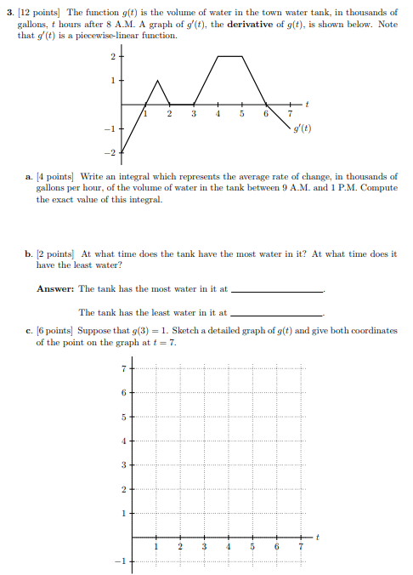

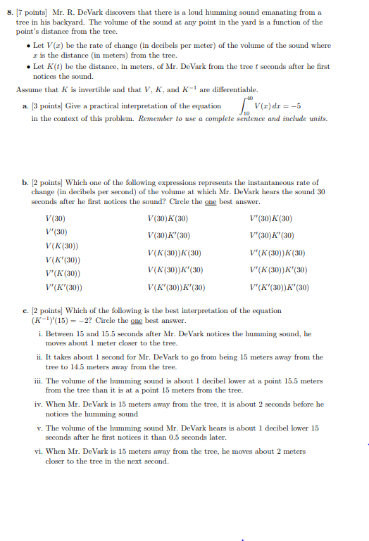

**Area bounded by curves**

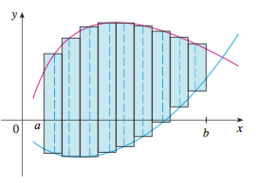

1. Find the area of the region enclosed by the parabola y = 2 – x2 and the line y = -x.
2. Find the area of the region in the first quadrant bounded above by y = x1/2 and below by the x-axis and the line y = x – 2.
3. Repeat exercise (2) above, but this time integrate with respect to *y*.
4. Find the area of the crescent-shaped region in the first quadrant that is bounded by y = x13 and y = x15.
5. Find the area of the region bounded by y = 7 – 2x2 and y = x2 + 4.
6. Find the area of the region enclosed by y = x4 – 4x2 + 4 and y = x2.
7. Find the area of the region enclosed by y = x4 – 4x2 + 4 and y = x2.
8. Find the area of the region enclosed by y = x(a2 – x2)1/2 , where a > 0, and y = 0.
9. Find the area of the region enclosed by y = (|x|)1/2 and 5y = x + 6.
10. Find the area of the region enclosed by x = y3 – y2 and x = 2y.
11. Find the area of the region bounded by 4x2 + y = 4 and x4 – y = 1.
12. Find the area of the region enclosed by y = 2 sin x and y = sin (2x), 0 ≤ x ≤ .
13. Find the area of the region enclosed by y = cos( x/2) and y = 1 – x2.
14. Find the area of the region enclosed by y = sin( x/2) and y = x.
15. Find the area of the “triangular” region in the first quadrant that is bounded above by the curve y = e2x, below by the curve y = ex, and on the right by the line x = ln 3.

**Differentiating Integrals**

Differentiate with respect to x each of the following integrals using the FTC and Leibniz’s Formula:













**Using integrals to approximate Riemann SUms**

Evaluate each of the following limits:









*The nicest child I ever knew*

*Was Charles Augustus Fortescue.*

*He never lost his cap, or tore*

*His stockings or his pinafore:*

*In eating Bread, he made no Crumbs,*

*He was extremely fond of sums.*

- [Hilaire Belloc](http://en.wikipedia.org/wiki/Hilaire_Belloc), **Cautionary Tales** (1907)