**Class Discussion: 5th November 2018**

**MVT, Anti-derivatives, Indefinite integrals &**

**initial value problems**

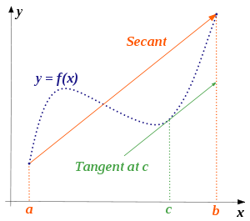



**Math Bridge in Beijing**

**I**  (a) State ***Rolle’s Theorem***.

(b) State the ***Mean Value Theorem***, and explain its geometric meaning.

(c) How is the MVT derived from Rolle’s Theorem?

(d) Using the Mean Value Theorem, prove that if df/dx = dg/dx on (a, b), then there exists a constant *C* for which f(x) = g(x) + C for all x∈(a,b).

(e) Let f(x) = x3 – 2x + 3 be defined on the interval [1, 3]. Apply the MVT to this function and find the corresponding value of *c*.

(f) Let g(x) = 1 + 3 sin 2x be defined on the interval [0, /12]. Apply the MVT to this function and find the corresponding value of *c*.

(g) Watch the YouTube video: The [*Theorem of the Mean Policeman*](https://www.youtube.com/watch?v=gVP5Sy4g9hc)

**II** Evaluate each of the following *indefinite integrals* (using the method of “judicious guessing”):













*(g) $\int{\frac{\cos{\frac{1}{x}}}{x^{2}}}dx$*







**III** Solve each of the following *differential equations* (using the method of “judicious guessing”).







$\left(d\right) \frac{dy}{dx}=\frac{π}{4}\sec^{2}\left(\frac{π}{4}x\right)-\frac{2\ln{x}}{x}$ =

**IV** Solve each of the following *initial value problems* (using the method of “judicious guessing”):











**V** Charlotte the spider is traveling along the x-axis with acceleration, a(t), given by:



Assume that at time t = 0 minute her velocity, v(0), is 4/3 cm/min and her position, x(0), is – 4/15 cm. Where is Charlotte at time t = 5 minutes?

**VI** A grapefruit thrown upward has an initial velocity of 64 ft/sec from an initial height of 80 feet. (Recall that the acceleration due to gravity is -32 ft/sec2.)

1. Find the position, s(t), of the grapefruit as a function of time *t*.
2. When does the grapefruit hit the ground?

**VII** Verify the following integration formula:



**VIII** *[University of Michigan]* The entire graph of a function g(x) is shown below. Note that the graph of g(x) has a horizontal tangent line at x = 1 and a sharp corner at x = 4.

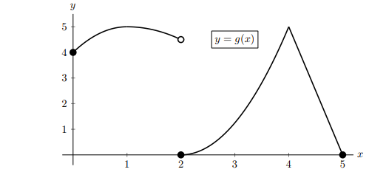

For each of the questions below, circle all of the available correct answers. (Circle none of these if none of the available choices are correct.)

1. At which of the following values of x does g(x) appear to have a critical point?

x = 1 x = 2 x = 3 x = 4 none of these

1. At which of the following values of x does g(x) attain a local maximum?

x = 1 x = 2 x = 3 x = 4 none of these

1. Let L(x) be the local linearization of g(x) near x = 3. Circle all of the statements that are true.

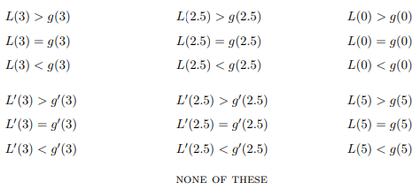

1. On which of the following intervals does g(x) satisfy the hypotheses of the Mean Value Theorem?

[0, 2] [0, 4] [3, 5] [4, 5] none of these

1. On which of the following intervals does g(x) satisfy the conclusion of the Mean Value Theorem? [0, 2] [0, 4] [3, 5] [4, 5] none of these

**Stewart exercises on the MVT:** 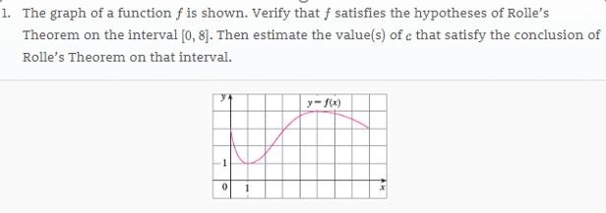

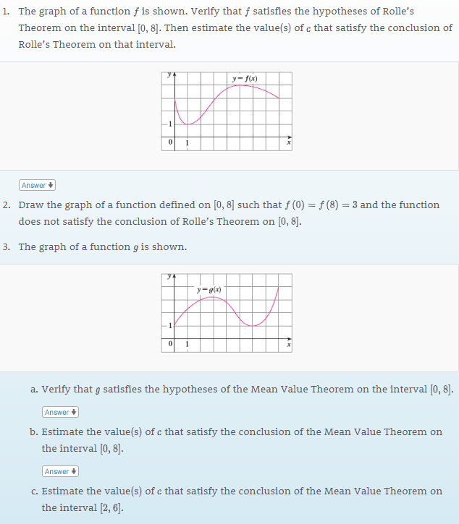

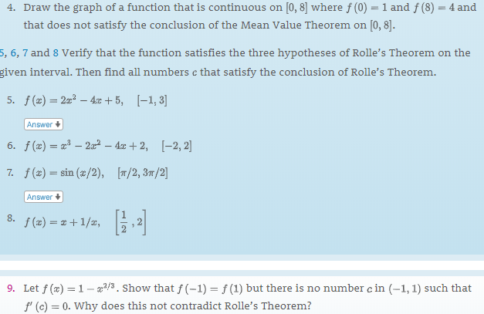

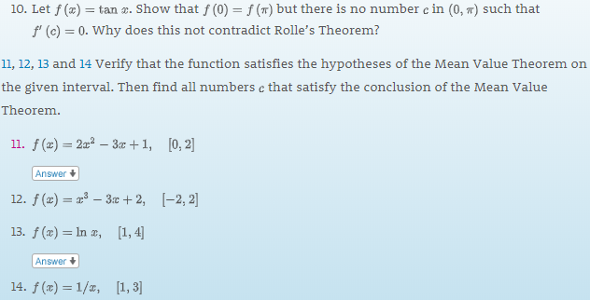

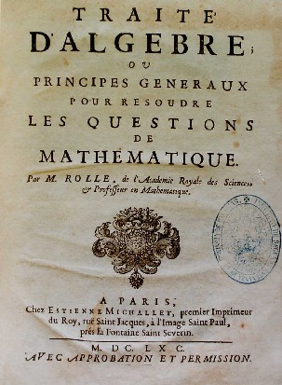

Michel Rolle (1652 –1719)

[Course Home Page](http://www.math.luc.edu/~ajs/courses/161fall2018/index.pdf)         [Department Home Page](http://www.math.luc.edu/)        [Loyola Home Page](http://www.luc.edu/)