**Discussion questions: 16 October 2019**

**logarithmic differentiation**



1. (a) Can you find a formula for d/dx (f (x) g(x) h(x))? (Called *Leibniz rule*.)

(b) Can you extend this result to a product rule for four or more factors?

(c) Using your result from (b), compute d/dx {5(x3) (cos x) (ln x) ex }

(d) Find any and all critical points of the function: y = (x2 + 3) (x – 5) ex

1. *(UC Davis)* *Logarithmic* *differentiation* is a means of differentiating algebraically complicated functions or functions for which the ordinary rules of differentiation do not apply. For example, if you wish to differentiate expressions where a variable is raised to a variable power, logarithmic differentiation is an invaluable technique.
2. Differentiate $g\left(x\right)=x^{2x+3}.$
3.  An example of two **COMMON INCORRECT SOLUTIONS** are: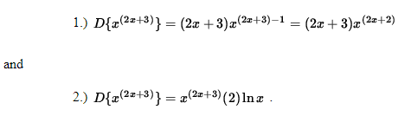

*BOTH OF THESE SOLUTIONS ARE WRONG* because the ordinary rules of differentiation do not apply. Logarithmic differentiation will provide a way to differentiate a function of this type. It requires deft algebra skills and careful use of the following unpopular, but well-known, properties of logarithms. Though the following properties and methods are true for a logarithm of any base, only the natural logarithm, ln x, will be used in this problem set.



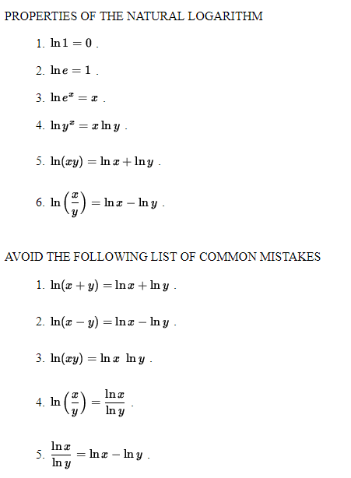

1. **Avoid the following FALSE FRIENDS:**



1. *(UC Davis)* The following problems range in difficulty from average to challenging.

* *PROBLEM 1:* Differentiate *y* = *xx*.
* *PROBLEM 2:* Differentiate *y* = *x*(*ex*).
* *PROBLEM 3 :* Differentiate *y* = (3*x*2+5)1/*x*
* *PROBLEM 4 :* Differentiate

$ y = (\sin x)^{x^3} $

* *PROBLEM 5 :* Differentiate

$ y = 7x (\cos x)^{x/2} $

* *PROBLEM 6 :* Differentiate

$ y = \sqrt{x}^{ \sqrt{x} } e^{ x^2 } $

* *PROBLEM 7 :* Differentiate

$ y = x^{ \ln x } (\sec x)^{3x} $

* *PROBLEM 8 :* Differentiate

$ y = \displaystyle{ ( \ln x )^x \over 2^{ ^{3x+1} } } $

* *PROBLEM 9 :* Differentiate

$ y = \displaystyle{ x^{2x} (x-1)^3 \over (3+5x)^4 } $ .

* *PROBLEM 10:* Consider the function

$ f(x) = \displaystyle{ x^{5} e^x (4x+3)
\over 5^{ \ln x } (3-x)^{2} } $.

Find an equation of the line tangent to the graph of *f* at *x* = 1.

* *PROBLEM 11:* Consider the function

$ f(x) = \displaystyle{ \pi^2 + 2^x + x^{2 } + x^{1/x} } $

Determine the slope of the line perpendicular to the graph of *f* at *x* = 1.

* *PROBLEM 12:* Differentiate $f(x)=x^{\left(x^{\left(x^{4}\right)}\right)}$. Then determine the slope of the normal line to the graph of *f* at *x*=1.

**Additional exercises:**

1. Find $\frac{dy}{dx} if x^{y}=y^{x}$. Hint: Use logarithmic differentiation.
2. Using *logarithmic differentiation*, find dy/dx if:
3. 
4. 
5. 
6. 
$f\left(x\right)={(5-3x^{2})}^{7}\sqrt{6x^{2}+8x-2019}$

7. 