MATH 161 Class discussion 26th – 29th October 2018

*For since the fabric of the universe is most perfect and the work of a most wise Creator, nothing at all takes place in the universe in which some rule of maximum or minimum does not appear.*

- Leonhard Euler

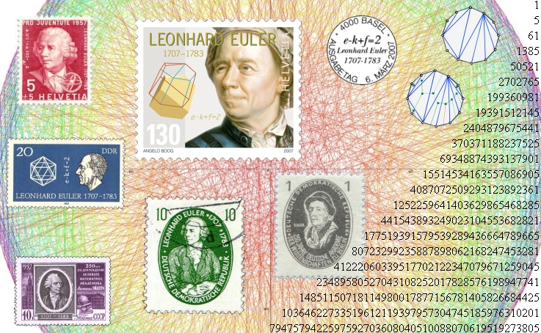

1. State the “*second-derivative test*” for local extrema.
2. For each of the following functions, discuss concavity and locate any and all inflection points. Apply the second derivative test for local extrema. Sketch!
3. y = x3 – 6x
4. y = x4 – 2x3
5. y = 2x – x1/3
6. y = x2e-x
7. Applying the **Extreme Value Theorem**, find the global max and min values of each of the following functions defined on the given closed and bounded interval:
8. y = 1/x + ln x on [½, 4]
9. y = x – 2 ln x on [1, 3]
10. y = x(x – 2)(x – 5) on [0, 5]
11. y = 3x4 – 4x3 – 8 on [-1, 2]
12. y = 2 cos x – x on [0, 2]
13. y = -2x3 + 3x2 + 12x + 4 on [-2, 3]

**4**. Given f(x) = x6 – 3x5 on the interval [-1, 4].

1. Find all critical points of *f*.

(b) Determine on which intervals *f* is increasing.

(c) Find and classify all local and global extrema of *f*.

(d) On which interval(s) is *f* concave up? Find all the points of inflection.

(e) Sketch the graph of *f* using the above information.

**5**. Below is the graph of the derivative, F′(x), of a function F(x).

1. Sketch the graph of F′′[x].
2. Sketch the graph of F[x]. Indicate local max/min, regions of increase/decrease, regions where *F* is concave up/down, and all inflection points.



**6**. Albertine is 2 miles offshore in a boat and wishes to reach a coastal village 6 miles down a straight shoreline from the point nearest the boat. She can row 2 mph and walk 5 mph. Where should she land her boat to reach the village in the least amount of time?

**7.** Find the point on the line x/a + y/b = 2 that is *closest* to the origin.

**8.** Swann is designing a rectangular poster to contain 50 in2 of printing with a 4-inch margin at the top and bottom and a 2-inch margin at each side. Which overall dimensions minimize the amount of poster board used?

**9.** Find an *anti-derivative* for each of the following functions:

1. x7 – 8x-2 + 2018
2. 1/(x+1)
3. (x – 5)2018
4. sin(5x+13)
5. sec2 (3x)
6. 1/(1 + x2)
7. sec(4x) tan(4x)
9. e1789x
10. (x2 – 5)2

**10**. A rectangle is to be inscribed in a semicircle of radius 2 cm. What is the largest area the rectangle can have and what are its dimensions?

1. You are planning to make an open rectangular box from an 8-inch-by-15-inch piece of tin by cutting congruent squares from the corners and folding up the sides.

What are the dimensions of the box of largest volume you can construct this way and what is its volume?

1. (MIT practice test problem) A new junk food — NoKarb PopKorn — is to be sold in large cylindrical metal cans with a removable plastic lid instead of a metal top. The metal side and bottom will be of uniform thickness, and the volume is fixed to be 64 cubic inches. What base radius r and height h for the can will require the least amount of metal? Show work, and include an argument to show your values for r and h
2. A plasma TV screen of height 36 inches is mounted on a wall so that its lower edge is twelve inches above eye-level of an observer. How far from the wall should the observer stand so that the viewing angle ** subtended at her eye by the TV screen is as large as possible?



1. A grain silo has the shape of a right circular cylinder surmounted by a hemisphere. If the silo is to have a volume of 504 π ft3, determine the radius and height of the silo that *requires the least amount of material* to build. 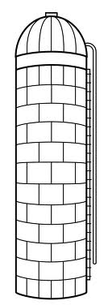

**MIT 18.01 practice problems**

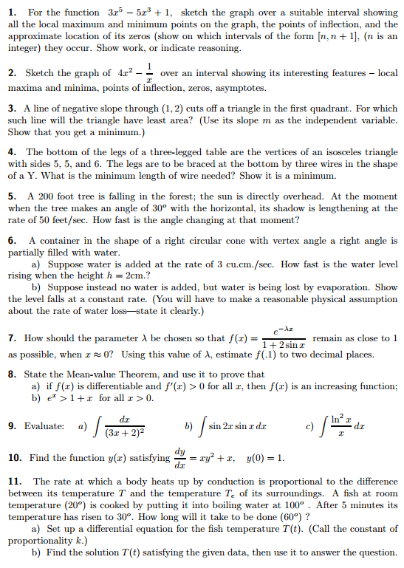

Problems from Stewart:

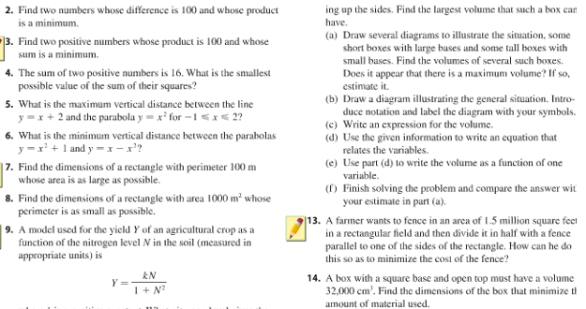



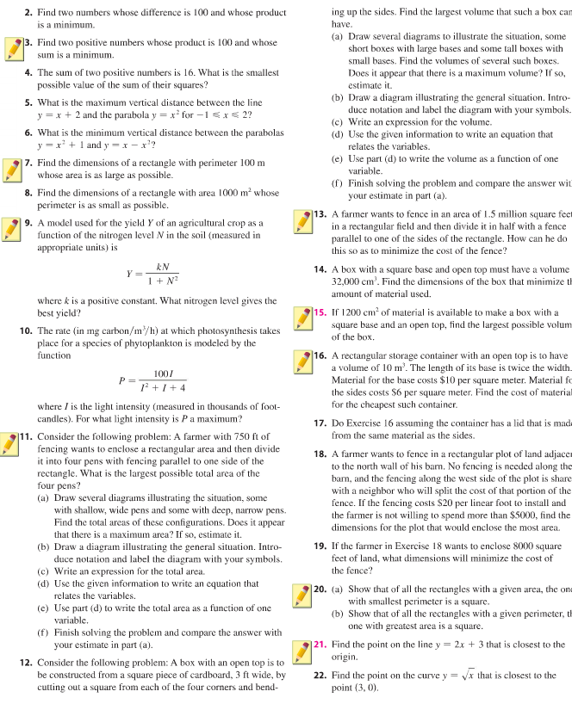

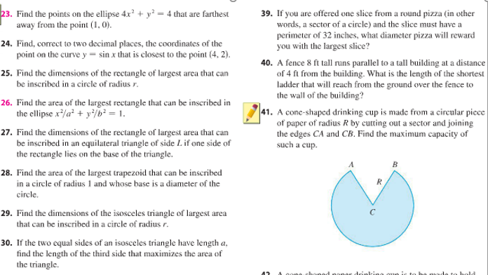

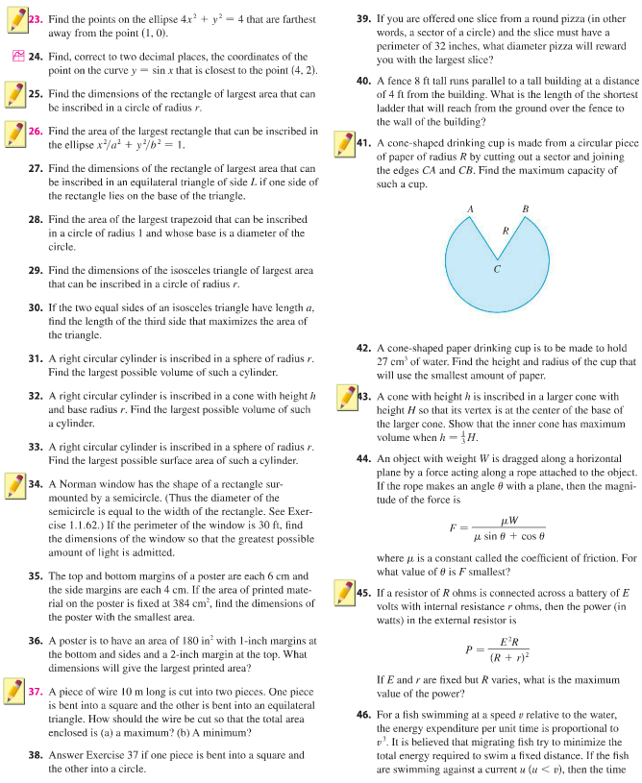

*"...at about the age of sixteen, I was offered a choice which, in retrospect, I can see that I was not mature enough, at the time, to make wisely. This choice was between starting on the calculus and, alternately, giving up mathematics altogether and spending the time saved from it on reading Latin and Greek literature more widely. I chose to give up mathematics, and I have lived to regret this keenly after it has become too late to repair my mistake. The calculus, even a taste of it, would have given me an important and illuminating additional outlook on the Universe, whereas, by the time at which the choice was presented to me, I had already got far enough in Latin and Greek to have been able to go farther with them unaided. So the choice that I made was the wrong one, yet it was natural that I should choose as I did. I was not good at mathematics; I did not like the stuff... Looking back, I feel sure that I ought not to have been offered the choice; the rudiments, at least, of the calculus ought to have been compulsory for me. One ought, after all, to be initiated into the life of the world in which one is going to have to live. I was going to live in the Western world...and the calculus, like the full-rigged sailing ship, is one of the characteristic expressions of the modern Western genius."*

- Arnold Toynbee, **Experiences**