ClASS DISCUSSION: 3 oCTOBER
Linear approximations
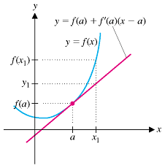
- Find the linearization of the function $f\left(x\right)=\sqrt{x+3}$ at the point x = 1 and use it to approximate$\sqrt{3.98} and \sqrt{4.05}$ . For each approximation, is it an underestimate or an overestimate? Explain. (Here you may use the power rule short cut.)

- Find the linearization of the function f(x) = sin x at the point x = π/6.

- Find the linearization of the function $f\left(x\right)={(1+x)}^{-3}$at the point x = 0 and use it to approximate the value of $\frac{1}{{1.003}^{3}} . Is your$approximation an underestimate or an overestimate? Explain.

- (U. Michigan) Given below is the graph of a function h(t). Suppose j(t) is the local linearization of h(t) at t = 7/8.
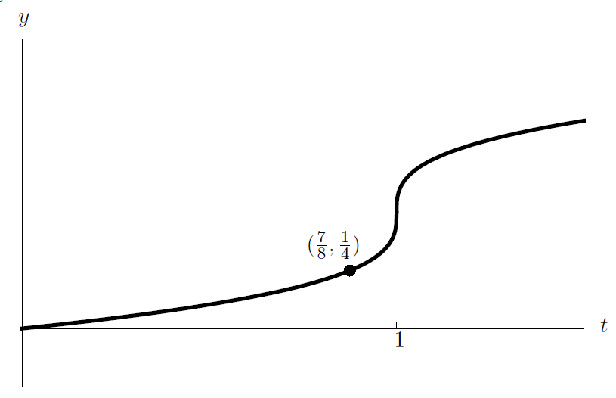
- Given that $h^{'}\left(\frac{7}{8}\right)=\frac{2}{3},find an expression$for j(t).
- Use your answer from (a) to approximate h(1).
- Is the approximation from (b) an over- or under-estimate? Explain.
- Using j(t) to estimate values of h(t), will the estimate be more accurate at t=1 or t = ¾? Explain.

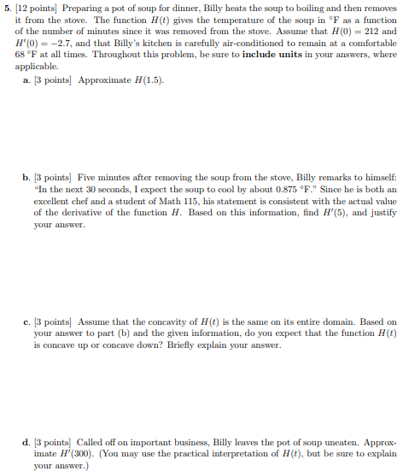

Problem 6
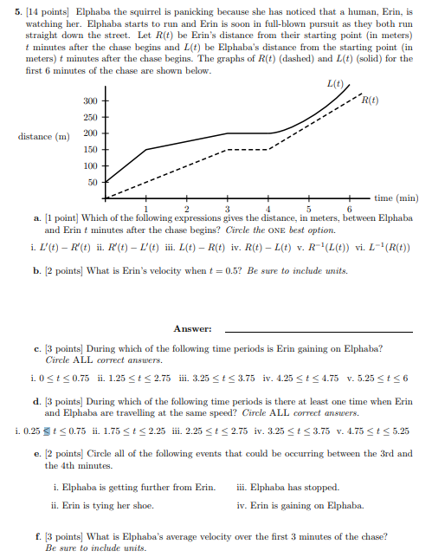

- (U. Michigan)
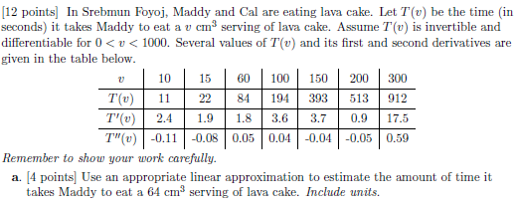
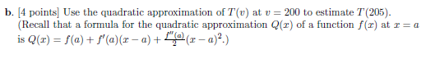
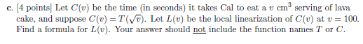
Problem 8
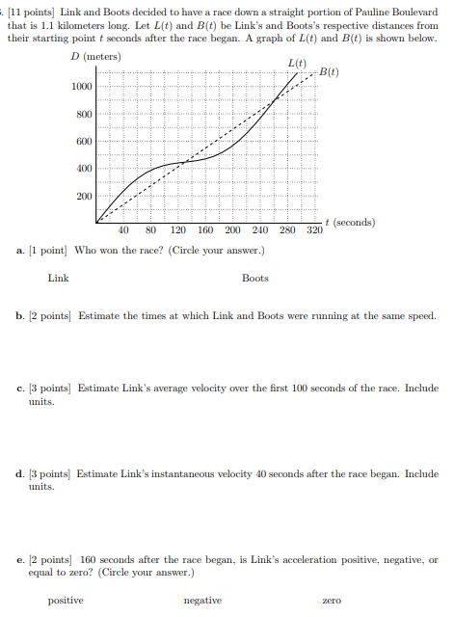

The Game of Anti-Derivatives:
Find an anti-derivative of each of the following functions:
- x⁹⁹ (b) $\frac{3}{x^{2}}$ (c) $\frac{1+x}{\sqrt{x}}$ (d) $x(x+7)$ (e) (x³ + x + 1)(x³ – 2x)
Course Home Page Department Home Page Loyola Home Page

