MATH 161 Class discussion 31 October 2018

 

Review

1. For each of the following functions, discuss concavity and locate any and all inflection points. Apply the second derivative test for local extrema. Sketch!
2. y = x3 – 6x
3. y = x4 – 2x3
4. y = 2x – x1/3
5. y = x2e-x
6. Applying the **Extreme Value Theorem**, find the global max and min values of each of the following functions defined on the given closed and bounded interval:
7. y = 3x4 – 4x3 – 8 on [-1, 2]
8. y = 2 cos x – x on [0, 2]
9. y = -2x3 + 3x2 + 12x + 4 on [-2, 3]

**3**. Given f(x) = x8 – 3x5 on the interval [-1, 4].

1. Find all critical points of *f*.

(b) Determine on which intervals *f* is increasing.

(c) Find and classify all local and global extrema of *f*.

(d) On which interval(s) is *f* concave up? Find all the points of inflection.

(e) Sketch the graph of *f* using the above information.

**4**. Sketch the curve $f\left(x\right)={\left(2x-1\right)}^{13}{(x-7)}^{18}$ locating and classifying all critical points. Do not examine concavity.

**5**. Albertine is 2 miles offshore in a boat and wishes to reach a coastal village 6 miles down a straight shoreline from the point nearest the boat. She can row 2 mph and walk 5 mph. Where should she land her boat to reach the village in the least amount of time?

**6.** Find the point on the line x/a + y/b = 2 that is *closest* to the origin.

**7.** Swann is designing a rectangular poster to contain 50 in2 of printing with a 4-inch margin at the top and bottom and a 2-inch margin at each side. Which overall dimensions minimize the amount of poster board used?

**8**. A rectangle is to be inscribed in a semicircle of radius 2 cm. What is the largest area the rectangle can have and what are its dimensions?

**9.** You are planning to make an open rectangular box from an 8-inch-by-15-inch piece of tin by cutting congruent squares from the corners and folding up the sides.

What are the dimensions of the box of largest volume you can construct this way and what is its volume?

1. (MIT practice test problem) A new junk food — NoKarb PopKorn — is to be sold in large cylindrical metal cans with a removable plastic lid instead of a metal top. The metal side and bottom will be of uniform thickness, and the volume is fixed to be 64 cubic inches. What base radius r and height h for the can will require the least amount of metal? Show work, and include an argument to show your values for r and h .

1. A plasma TV screen of height 36 inches is mounted on a wall so that its lower edge is twelve inches above eye-level of an observer. How far from the wall should the observer stand so that the viewing angle ** subtended at her eye by the TV screen is as large as possible?



1. A grain silo has the shape of a right circular cylinder surmounted by a hemisphere. If the silo is to have a volume of 504 π ft3, determine the radius and height of the silo that *requires the least amount of material* to build. 0

**MIT 18.01 practice problems**

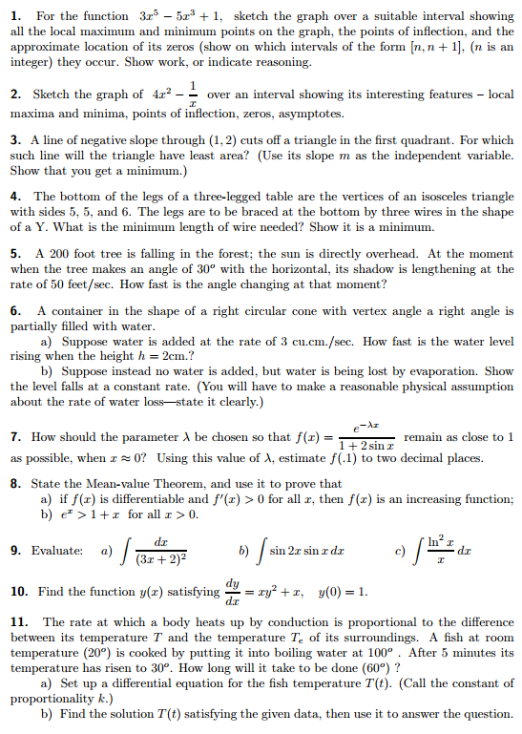

Problems from Stewart:

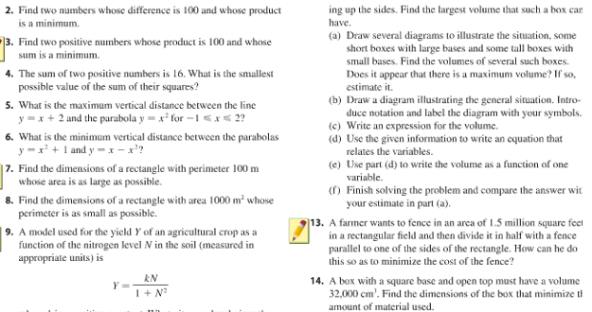

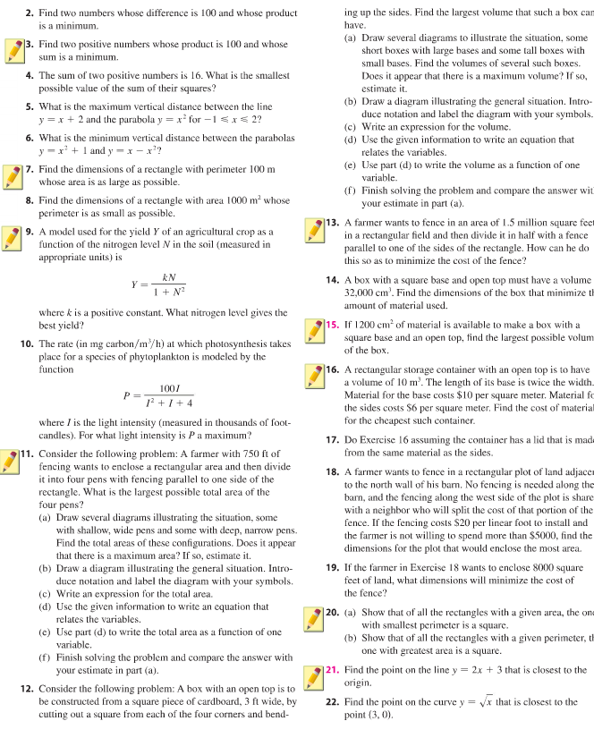

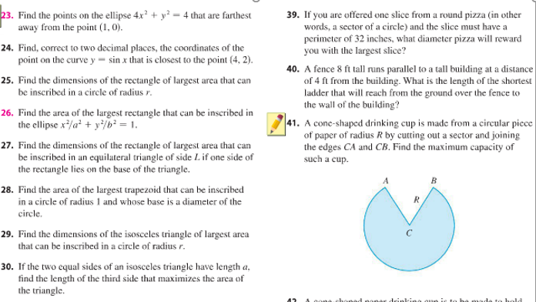

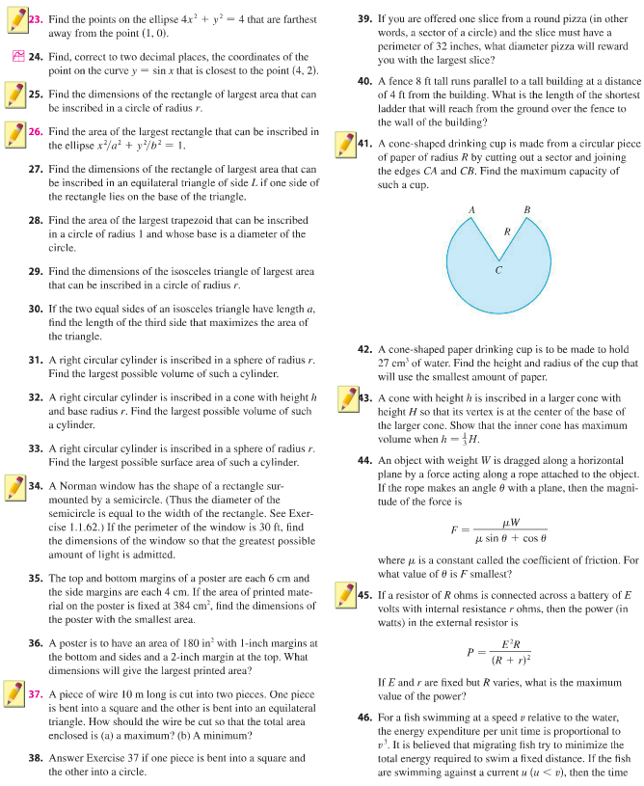

University of Michigan

**1.** Saruman, the new U. S. Secretary of the Interior, is creating an army of orcs to cut down all the trees in Fangorn Forest. Saruman is currently trying to decide exactly how large the army should be to destroy the forest as quickly as possible. The trouble is that orcs are not very efficient. In very small armies they tend to work pretty well — one orc will emerge as the leader, and he will have good control over the others. They also organize fairly well in very large armies, once a military structure is established. In medium-sized armies, though, the orcs spend a lot of time fighting for dominance, and as a result, they cannot work very efficiently. Saruman has noticed this, of course. His research indicates that an army of x thousand orcs, will be able to cut down.



1. If Saruman is capable of producing an army of up to 3000 orcs, how many should he produce to maximize the hourly destruction of trees? (Saruman does not have a graphing calculator and must be convinced by the methods of calculus.)
2. Does your answer change if Saruman can produce up to 4000 orcs? If so, how many should he produce now?
3. Does your answer change if Saruman can produce up to 6000 orcs? If so, how many should he produce now?
4. Elphaba has found a corrupt prison guard, Mert, to sell her metal piping to use to dig a tunnel out of prison. Mert can sell Elphaba steel piping and copper piping, and he provides the following information.

* The number of kilograms (kg) of soil that Elphaba can dig with steel piping is proportional to the number of centimeters (cm) of steel piping that she buys. She can dig 50 kg of soil per cm of steel piping, and her cost (in dollars) of buying x cm of steel piping is given by A(x) = x2 + x.
* The number of kilograms (kg) of soil that Elphaba can dig with copper piping is proportional to the number of centimeters (cm) of copper piping that she buys. She can dig 30 kg of soil per cm of copper piping, and her cost (in dollars) of buying y cm of copper piping is given by B(y) = 2y.

1. How many kilograms of soil can Elphaba dig with *x* cm of steel piping?

For parts (b) and (c) below, suppose Elphaba buys *w* cm of steel piping and *k* cm of copper piping and that this is exactly the right amount of piping so that she can dig through 2700 kg of soil to dig her escape tunnel.

1. Write a formula for *k* in terms of *w*.
2. Let T(w) be the total cost (in dollars) of all the piping Elphaba buys to dig her escape tunnel. Find a formula for the function T(w). The variable *k* and the function names A and B should not appear in your answer. (Note that T(w) is the function one would use to minimize Elphaba’s costs. You should *not* do the optimization in this case.)
3. What is the domain of T(w) in the context of this problem?