**Math 161 Discussion: 12 September 2018**

**Part I: trigonometric limits; one-sided lmits**

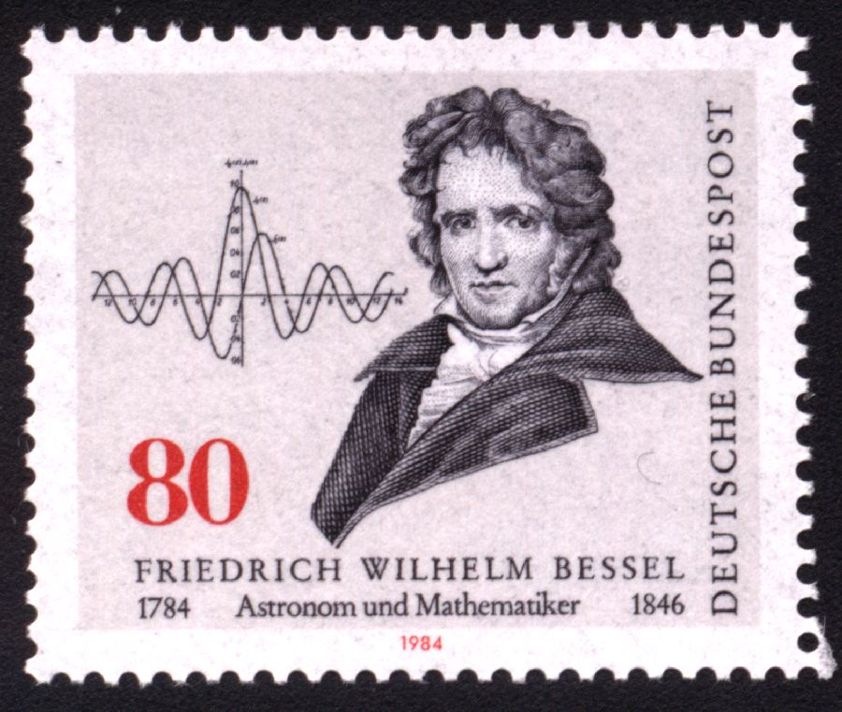

**A** Evaluate each of the following limits or explain why the limit fails to exist.

** ** ** **

*       *

*   *

* * 19. $\lim_{n→1+}{\frac{x-1}{|x-1|}}$ 20. $\lim_{n→1-}{\frac{x-1}{|x-1|}}$

**B**1*.* Prove that

2. Prove, using (1) and a trigonometric identity, that $\lim_{x→0}{\frac{1-\cos{x}}{x}}=0.$

**PART II: average rate of change**

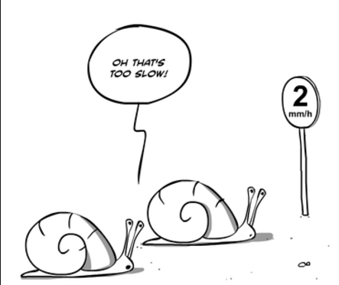

1. Suppose that Albertine travels from Hell, Michigan, to Paradise, Michigan, on the Upper Peninsula. Along the way, every few minutes, she records the distance that she has traveled in miles. Suppose that she begins her trip at time t = 0 (corresponding to noon). Let s(t) be the distance she has traveled at time t. The following is Albertine’s graph of position (miles) vs time (hours).

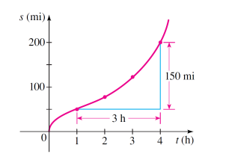

1. Find Albertine’s average speed between 1 pm and 4 pm.
2. Find her average speed between 2 pm and 3 pm.

Note: Be certain to include appropriate units in your answers!

1. Find the *average rate of change* of the function f(x) = x2 + 1 over the interval
2. [0, 2] (b) [2, 3] (c) [-2, 0] (d) [1, 1 + h] where h > 0.

(e) Give a *geometric interpretation* for each of these calculations.



1. If Swann drops a bowling ball from the top of the Eiffel Tower, then the distance it will fall (in feet) after *t* seconds is given by the function

d(t) = 16 t2.

Find the *average* speed of the ball between

(a) t = 1 and t = 4 seconds.

1. t = a and t = a + h seconds, where a and h are positive.
2. Let g(x) = 3x – 19. Find the *average rate of change* of this function from:
3. x = 0 and x = 1
4. x = 1 and x = 4
5. x = a and x = a + h
6. Let f(x) = mx + b. Find the *average rate of change of f* over the interval

x = a and x = a + h.

6.

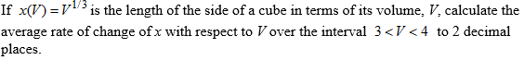

7. The graph below shows the velocity of a lady bug traveling along a straight line on the classroom floor.

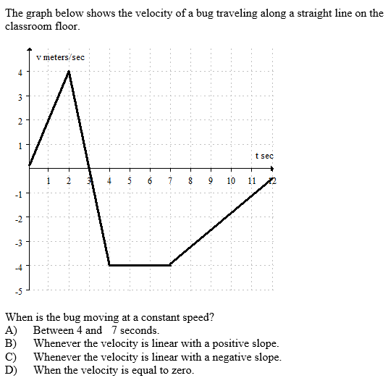

8. Let *L(R)* be the amount of board-feet of lumber produced from a tree of radius *r*

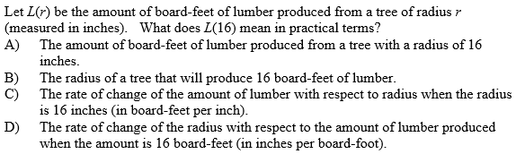

9. Below is the graph of a velocity function. The units on the vertical axis are in *kilometers per hour* and the units on the horizontal axis are in *hours*. Positive velocity means motion away from the starting position; negative velocity means motion toward the starting position.

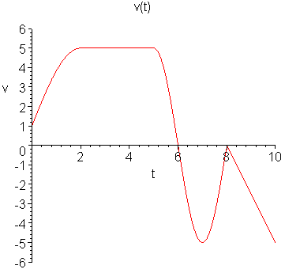

(a) Create a (brief) story about motion of a person or thing whose velocity is represented by this graph. Your story must include all of the "important" information included in the graph above, including position and times t = 0 and t = 10.)

(b) Sketch a possible graph of the position function of the person or thing in your story on the time interval t = 0 to t = 10.

10. Suppose that C(T) is the cost of heating Albertine’s house, in dollars per day, when the *outside* temperature is *T* degrees Fahrenheit. What does C(19) = 8.67 mean in practical terms? (Use appropriate units.)

11. The cost *C* (in thousands of dollars) of building a house that is *x* square feet is given by the function C = F(x). Explain the *meaning* of the statement: F(1600) = 140.

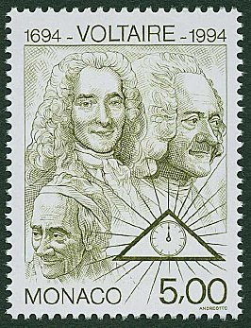

*The more you know, the less sure you are.*

**-** [Voltaire](http://plato.stanford.edu/entries/voltaire/)

*I used to love mathematics for its own sake, and I still do, because it allows for no hypocrisy and no vagueness…*

- Stendhal, **The Life of Henri Brulard**



[Course Home Page](http://www.math.luc.edu/~ajs/courses/161fall2018/index.pdf)         [Department Home Page](http://www.math.luc.edu/)        [Loyola Home Page](http://www.luc.edu/)