**Math 161 Class Discussion: 17 September**

**Review:**

1. Below is the graph of a velocity function of Albertine riding her mountain bike. The units on the vertical axis are in *kilometers per hour* and the units on the horizontal axis are in *hours*. Positive velocity means motion away from the starting position; negative velocity means motion toward the starting position.

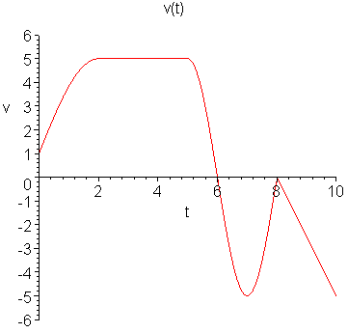

Sketch a possible graph of Albertine’s position function during the time interval t = 0 to t = 10.

2. Suppose that C(T) is the cost of heating Albertine’s house, in dollars per day, when the *outside* temperature is *T* degrees Fahrenheit. What does C(19) = 8.67 mean in practical terms? (Use appropriate units.)

3. The cost *C* (in thousands of dollars) of building a house that is *x* square feet is given by the function C = F(x). Explain the *meaning* of the statement: F(1600) = 140.

**The derivative**

1. Which of the following graphs (a) – (d) could represent the slope at every point of the function graphed below, labeled Figure 2.6?

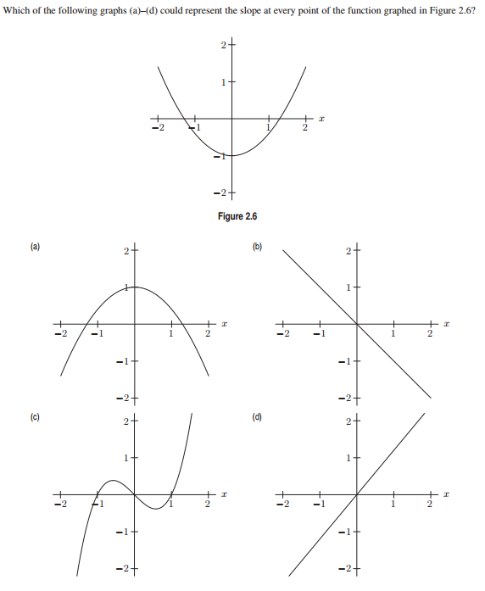

1. Which of the following graphs (a) – (d) could represent the slope at every point of the function graphed in Figure 2.11?

. 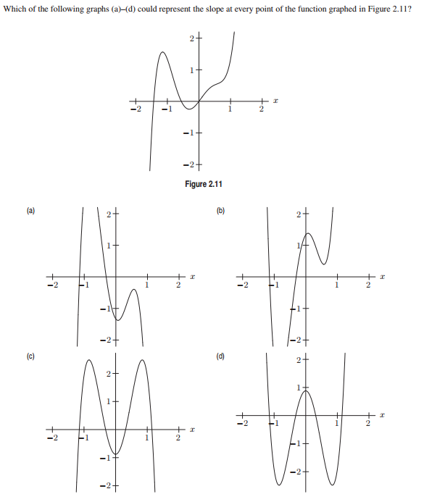

1. Find an equation of the *tangent line* to the given curve at the given point.
2. y = x2, x = 1
3. F(x) = 2x2 + x + 2, x = 2
4. G(x) = 1/x, x = 3
5. y = x1/2, x = 4
6. y = ax2 + bx + c, x = x0
7. y = sin x, x = 0
8. y = 1/(x – 3)2, x = 4
9. The graph of a function g(x) is given below.

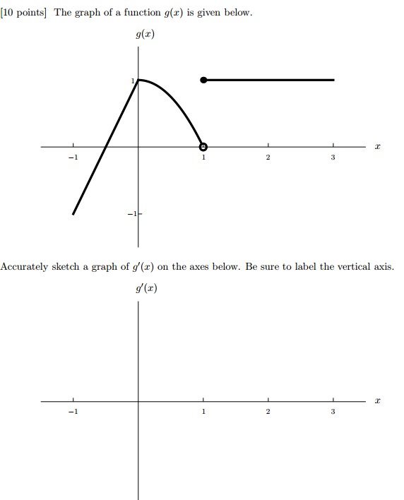

Sketch a graph of

6. The function C(r) is the total cost, in dollars, of paying off a car loan borrowed at an interest rate of r % per year.



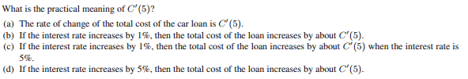

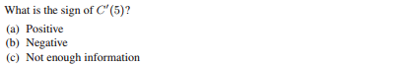

**7.**The temperature, *Y*, in Fahrenheit, of a cold yam placed in a hot oven is given by Y = g(t), where *t* is the time in minutes since the yam was placed into the oven.

(a) What is the sign of g′(t)? Why?

(b) What are the units of g′(20)? What is the *practical meaning* of the statement

g′(20) = 2?

**8.** For some painkillers, the size of the dose, *D*, given depends upon the weight of the patient, *W*. Thus, D = H(W), where *D* is in milligrams and *W* is in pounds.

(a) Interpret the statements H(140) = 120 and H′(140) = 3 in terms of this painkiller.

(b) Use the information in the statements in part (a) to estimate H(145).

**9.** Suppose that C(T) is the cost of heating Albertine’s house, in dollars per day, when the *outside* temperature is *T* degrees Fahrenheit.

(a) What does C(19) = 8.67 mean in practical terms? (Use appropriate units.)

(b) What does C ′(19) = - 0.55 mean in practical terms? (Use appropriate units.)

(c) If C(19) = 8.67 and C ′(19) = - 0.55, approximately what is the cost of heating Albertine’s house when the outside temperature is 16 degrees Fahrenheit? (Use appropriate units.)

**10.** The cost *C* (in thousands of dollars) of building a house that is *x* square feet is given by the function C = F(x).

(a) Explain the *meaning* of the statement: F(1600) = 140.

(b) Give the *practical interpretation* of the statement: F′(1600) = 0.1.

(c) Using the information given in parts (a) and (b), *estimate* the cost of building a house that is 1680 square feet.

**11.** Given the following graph of y = f(x), use “geometric differentiation” to sketch the graph of dy/dx.

(If you are curious, the equation of this curve is y = x5 + sin (21x) – 4x3 )



*I turn away with fright and horror from the lamentable evil of functions which do not have derivatives.*

- Charles Hermite (in a letter to Thomas Jan Stieltjes)

