**Math 161 Class Discussion: 19 September**

**The derivative**

.

1. Find an equation of the *tangent line* to the given curve at the given point.
2. y = sin x, x = 0
3. y = 1/(x – 3)2, x = 4

2. The function C(r) is the total cost, in dollars, of paying off a car loan borrowed at an interest rate of r % per year.



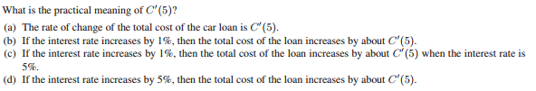

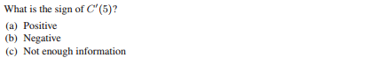

**3.**The temperature, *Y*, in Fahrenheit, of a cold yam placed in a hot oven is given by Y = g(t), where *t* is the time in minutes since the yam was placed into the oven.

(a) What is the sign of g′(t)? Why?

(b) What are the units of g′(20)? What is the *practical meaning* of the statement

g′(20) = 2?

**4.** For some painkillers, the size of the dose, *D*, given depends upon the weight of the patient, *W*. Thus, D = H(W), where *D* is in milligrams and *W* is in pounds.

(a) Interpret the statements H(140) = 120 and H′(140) = 3 in terms of this painkiller.

(b) Use the information in the statements in part (a) to estimate H(145).

**5.** Suppose that C(T) is the cost of heating Albertine’s house, in dollars per day, when the *outside* temperature is *T* degrees Fahrenheit.

(a) What does C(19) = 8.67 mean in practical terms? (Use appropriate units.)

(b) What does C ′(19) = - 0.55 mean in practical terms? (Use appropriate units.)

(c) If C(19) = 8.67 and C ′(19) = - 0.55, approximately what is the cost of heating Albertine’s house when the outside temperature is 16 degrees Fahrenheit? (Use appropriate units.)

**6.** The cost *C* (in thousands of dollars) of building a house that is *x* square feet is given by the function C = F(x).

(a) Explain the *meaning* of the statement: F(1600) = 140.

(b) Give the *practical interpretation* of the statement: F′(1600) = 0.1.

(c) Using the information given in parts (a) and (b), *estimate* the cost of building a house that is 1680 square feet.

**7**. The parabola *y = x2 + x + c* is tangent to the line *y = 3x*.  Find *c*.  (Include a picture in your explanation.)

**8**. Find a parabola, y = ax2 + bx + c, that passes through the point (1, 4) and whose tangent lines at x = -1 and x = 5 have slopes 6 and -2 respectively.

9. Find equations of any (and all) tangent lines to the parabola y = x2 + 1 that have *x-intercept* of -4/3. Sketch.

10. Archy lives on the x-axis. His position at time *t* (hours) is

*s(t) = 4t3 – 15t2 + 12t + 1* (cm).

Assume that Archie was born at time t = 0 and that $\frac{ds}{dt}=12t^{2}-30t+12$

1. What is Archy’s *position* at time t = 1?
2. What is Archy’s instantaneous *velocity* at time t = 1?
3. When is Archy moving *toward the left*? (Give one or more time intervals.)

11. The quantity, *Q* mg, of nicotine in the body *t* minutes after a cigarette is smoked is given by *Q = g(t).*

(a) Using a complete sentence, interpret the statement g(20) = 0.36.

(b) Using a complete sentence, interpret the statement g′(20) = -0.002.

(c) Using the information that you obtained above, estimate g(23).

12. Consider the function $${You may assume that f}^{'}\left(x\right)=6x^{2}-6x-12$$

Find any and all points (only their x-coordinates) at which the tangent line to y = f (x) is horizontal.

13. Given f(x) = x3 – 6x2 + 9x – 5.

(a) Find the slope of the tangent line to the curve at x = -2. (You may assume that df/dx = 3x2 – 12x + 9.)

(b) What is the equation of this tangent line?

(c) What is the equation of the normal line at x = -2.

(d) Find all points where the curve has a horizontal tangent.

14. Does the curve y = x3 + x + 1 ever have a horizontal tangent line? If so, where?

Let G(x) = 2bx, where *b* is a non-zero *constant*. Albertine, our friend, informs us that d/dx (2bx) = b 2bx ln 2.

Find G (2018)(x). *Show your reasoning! An answer with no justification will earn little or no credit.*

15. Let f(x) = x|x| be defined on the real line. Is *f* differentiable at x = 0? True or False? Explain.

16. Assume that Charlotte, who chooses to live on the y-axis, is located at

*y(t) = 3 cos t + 4 sin t* cm at time *t* (measured in minutes).

*You may assume that $\frac{d}{dx}\sin{x=\cos{x and that\frac{d}{dx}\cos{x= -\sin{x}}}}$*

(a) Find her *position* at times t = 0, t = /2, and t = 

(b) Find her *velocity* when t = 0, t = /2, and t =  minutes.

(c) Find her *acceleration* when t = 0, t = /2, and t = 

17. Archy lives on the x-axis. Graphs of his *position*, *velocity* and *acceleration* during the time interval

-0.7 < t < 4.3 appear below. Which is which? Explain.



18. Let *f*(*x*) = *x*4 − *ax*2*.*

* 1. Find all possible critical points of *f* in terms of *a.*
 $${You may assume that f}^{'}\left(x\right)=4x^{4}-2ax.$$

 2. If *a <* 0*,* how many critical points does *f* have?
  3. If *a >* 0*,* find the *x* and *y* coordinates of all critical points of *f.*

19. Given f(x) = x6 – 3x5 on the interval [-1, 4].

* 1. Find all critical points of *f*.
  2. Determine on which intervals *f* is increasing.
  3. Find and classify all local and global extrema of *f*.

(d) Sketch the graph of *f* using the above information.

20. Given f(x) = $g\left(x\right)=\frac{x}{x+1 }$.

$${You may assume that g}^{'}\left(x\right)=\frac{x}{{\left(x+1\right)}^{2}}.$$

1. What is the domain of g?
2. Find all critical points of *g*.
3. Determine on which intervals *g* is increasing.
4. Find and classify all local and global extrema of *g*.
5. Sketch the graph of *f* using the above information.

21.

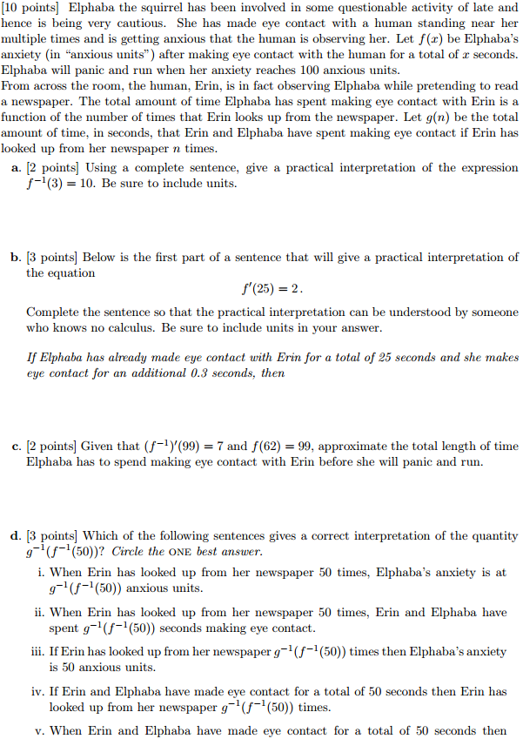



22.

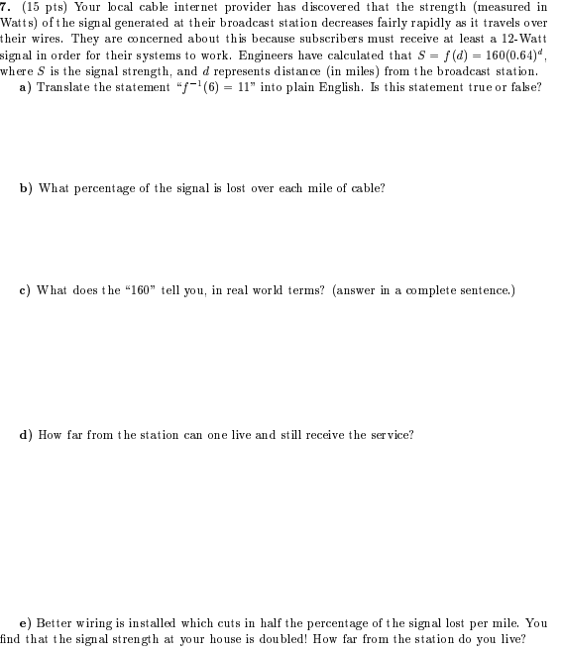

23.

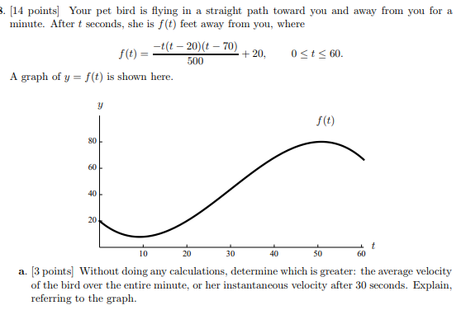



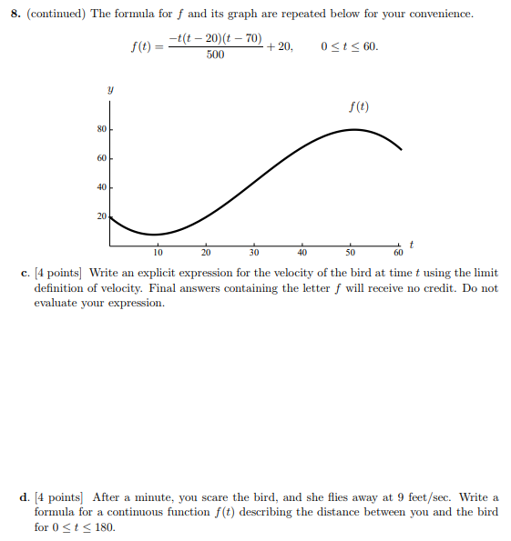

*When I was four years old they tried to test my IQ. They showed me a picture of three oranges and a pear. They asked me, "Which one is different and does not belong?" They taught me different was wrong.*

- Ani DiFranco

*I turn away with fright and horror from the lamentable evil of functions that do not have derivatives.*

- Charles Hermite (in a letter to Thomas Jan Stieltjes)